

**中原大學 雲端計算平台實務**

**12/03-作業報告**

**Create serverless applications**

**資訊四乙 10727211 林彥輝**

**授課教師：鍾武君 教授**

**中華民國一一○年十二月**

# Learning Path Intro

**Create serverless applications**

**https://docs.microsoft.com/en-us/learn/paths/create-serverless-applications/**

# Summary Homework Assignment

## Model 2:Create serverless logic with Azure Functions

1. Create a function app

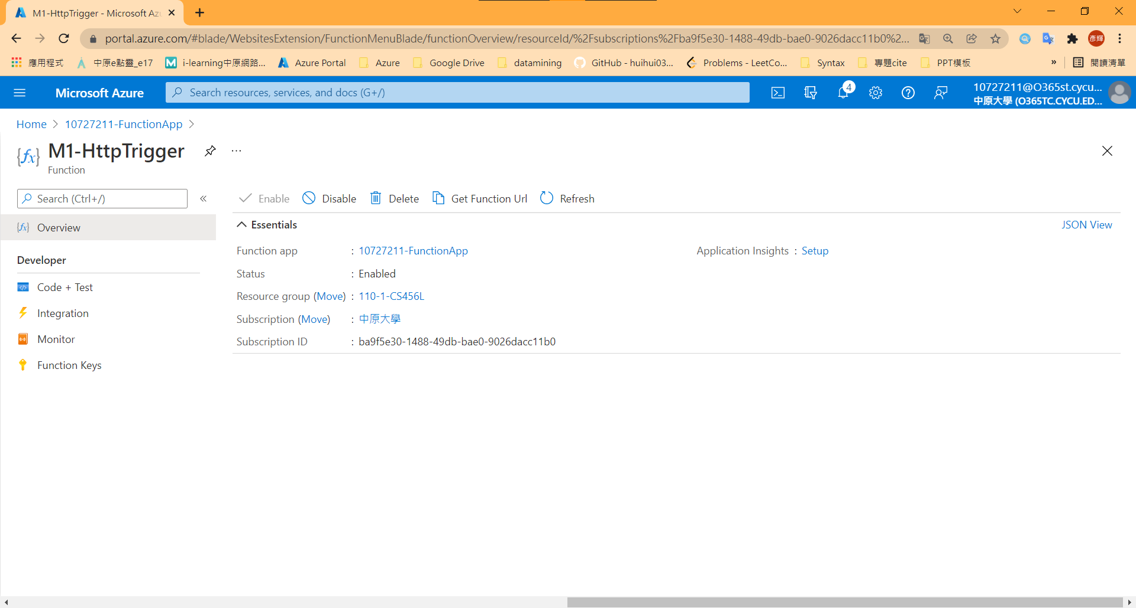

1. Test Function - 1

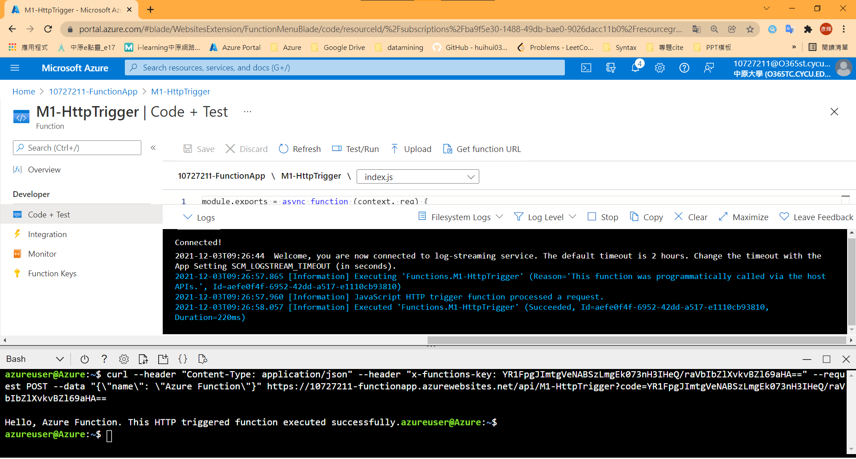

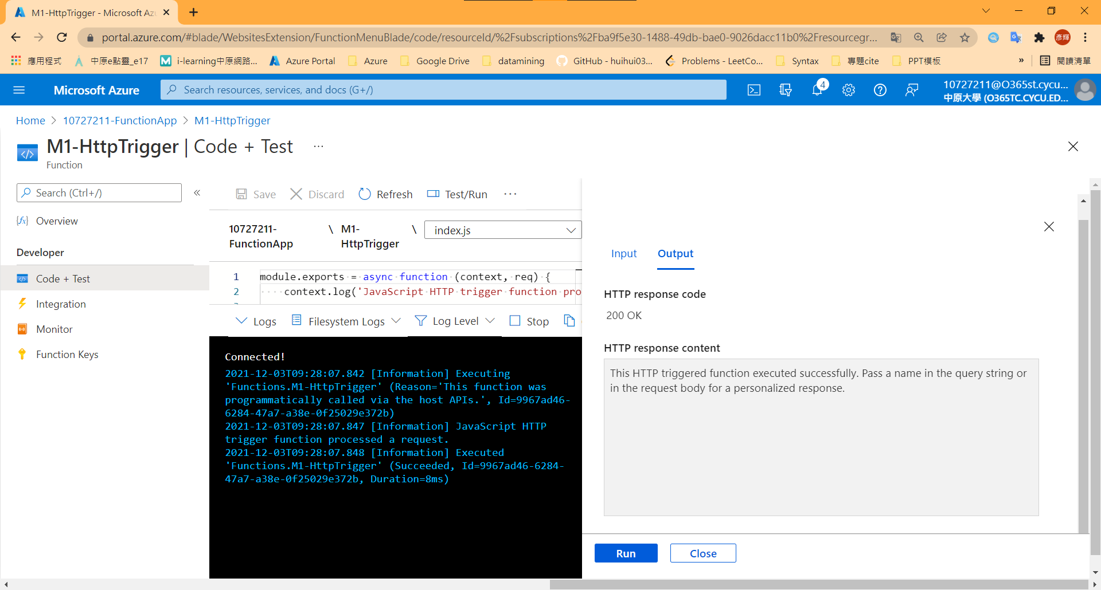

1. Test Function – 2 (IOT temperature)

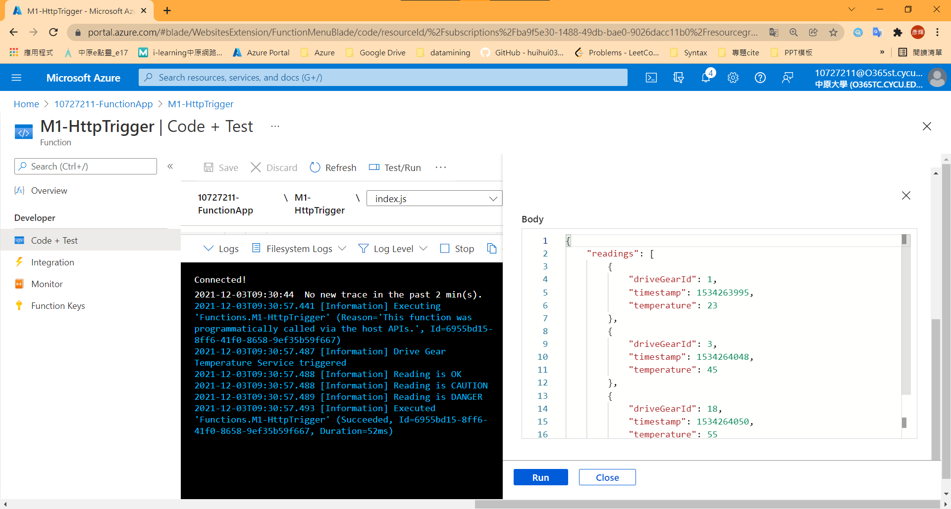

## Model 3: Execute an Azure Function with triggers

1. Create TimerTrigger & Test

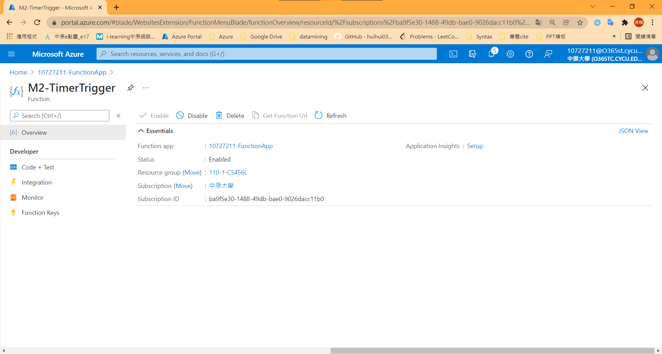

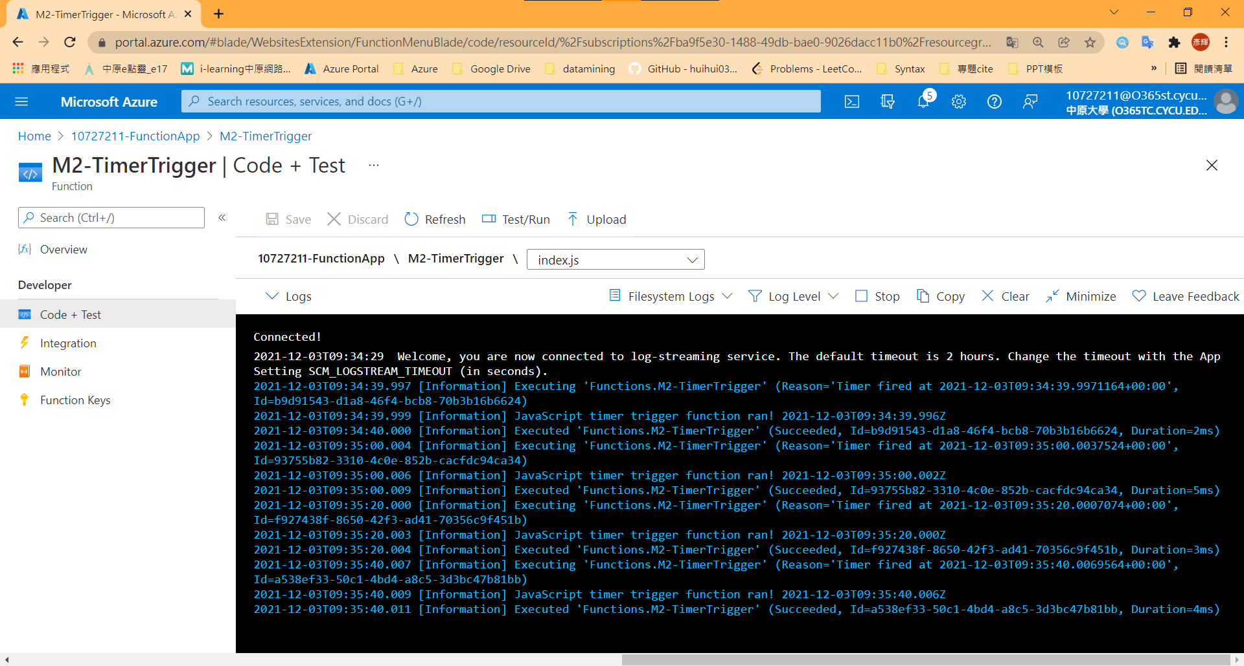

1. Create HttpTrigger & Test

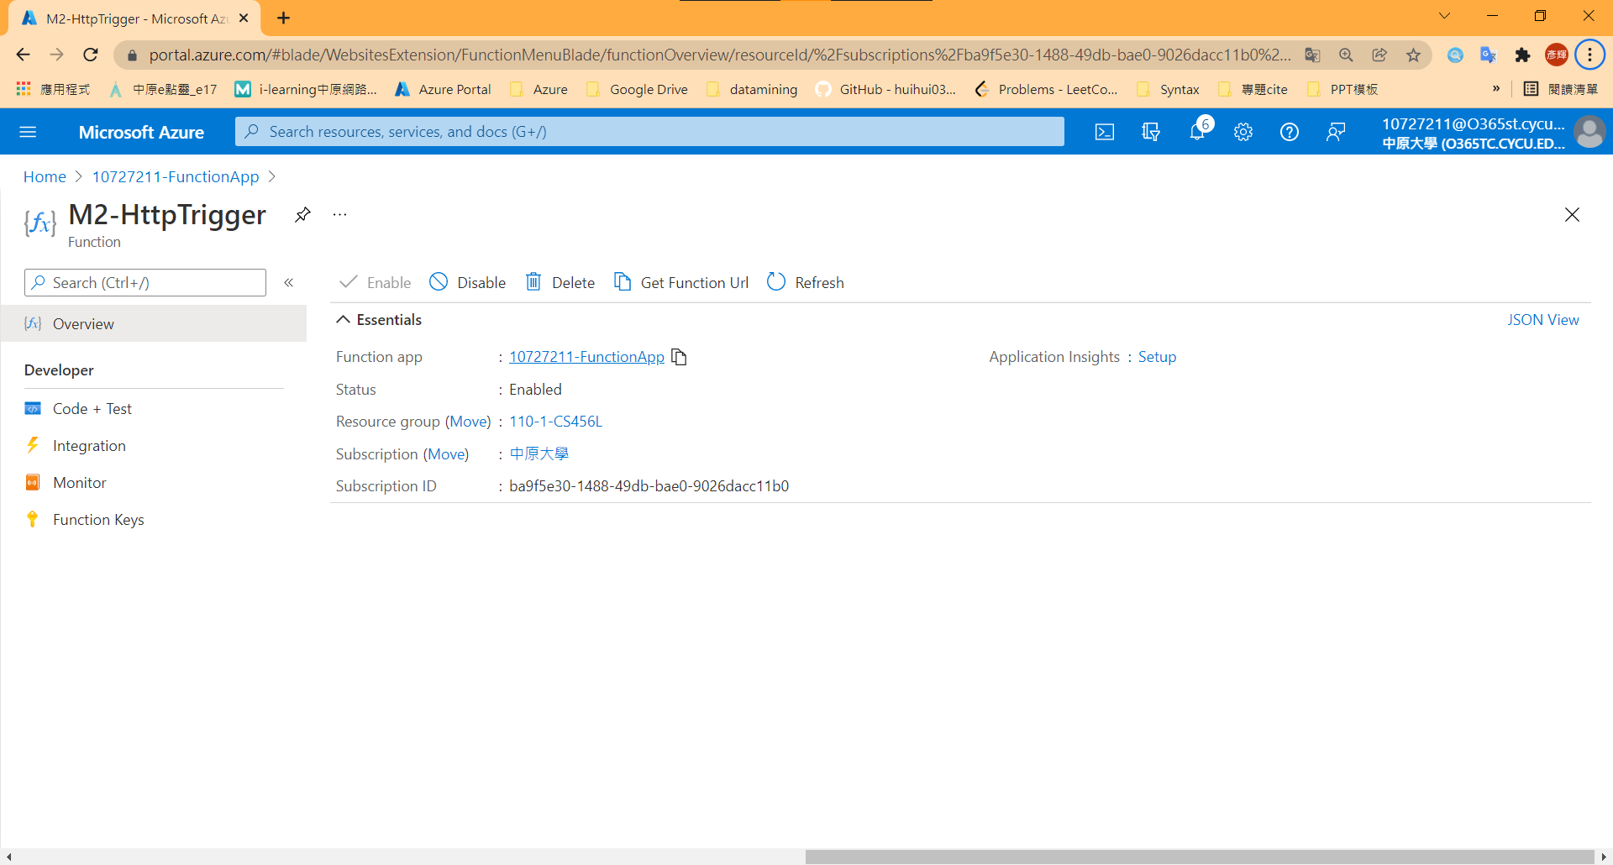

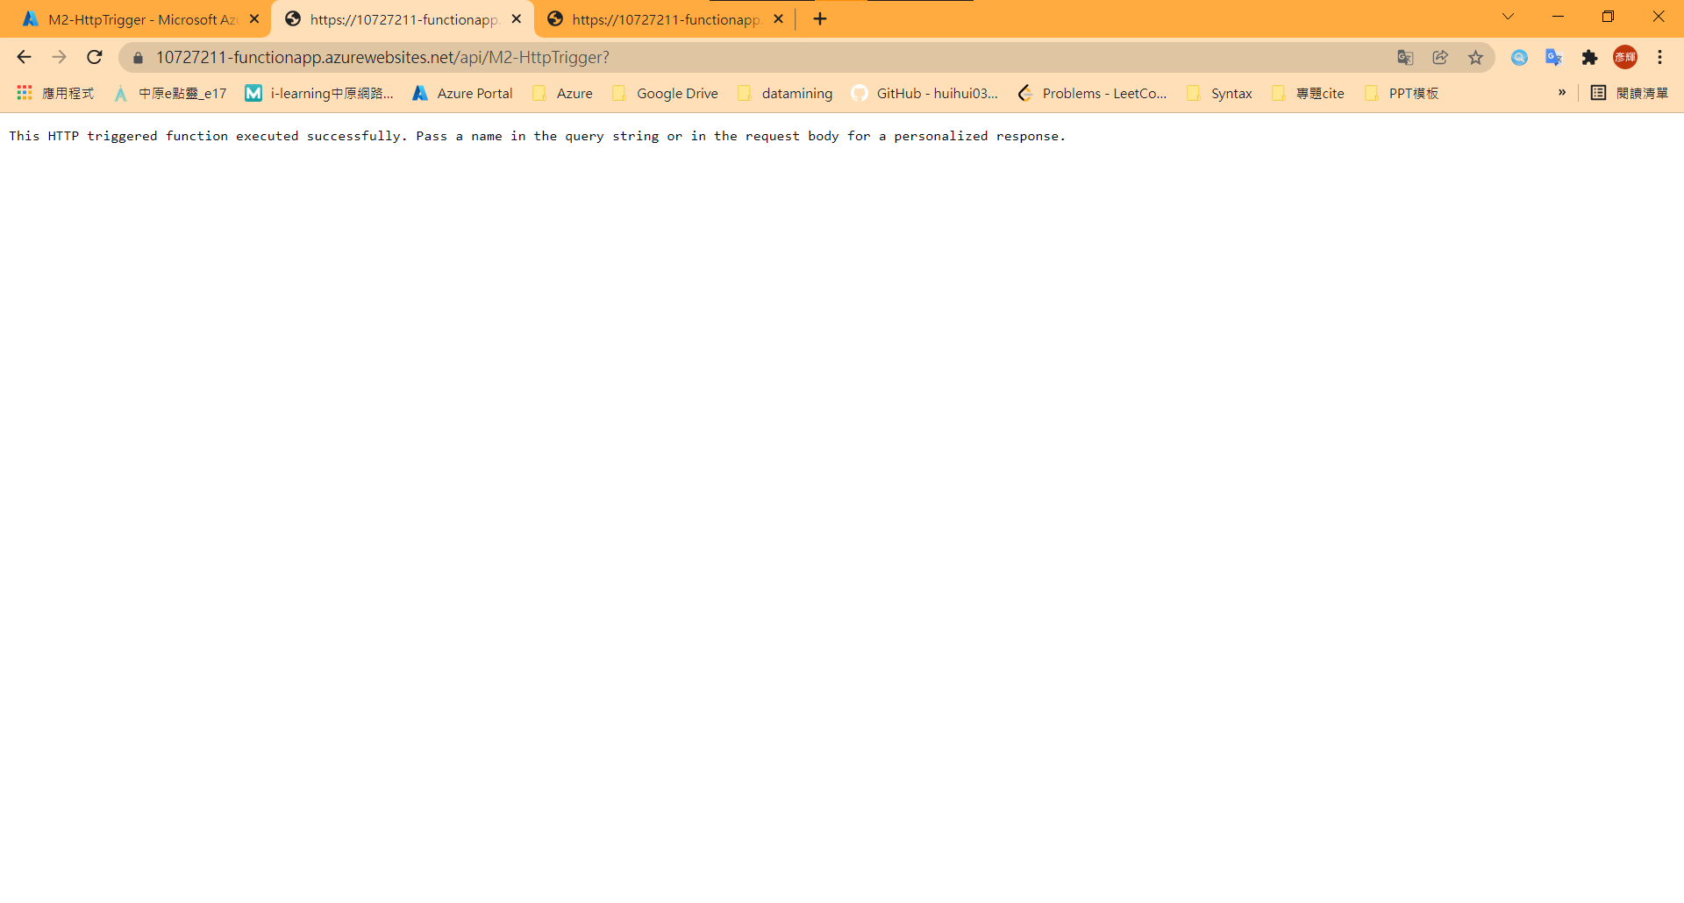

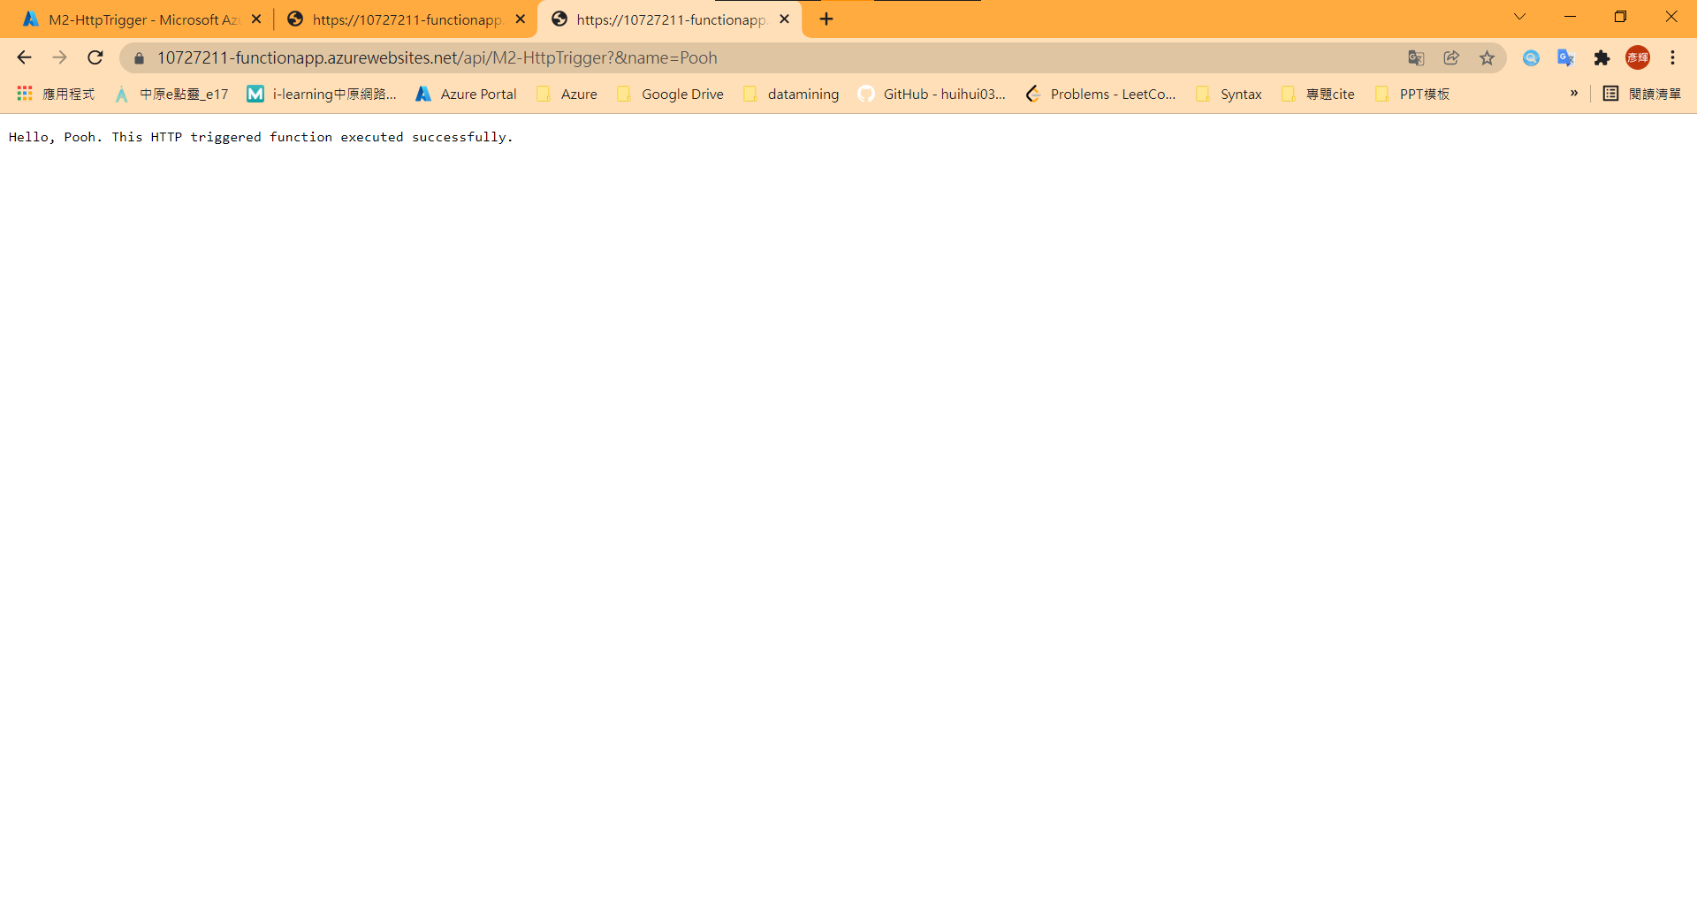

1. Create BlobTrigger & Test

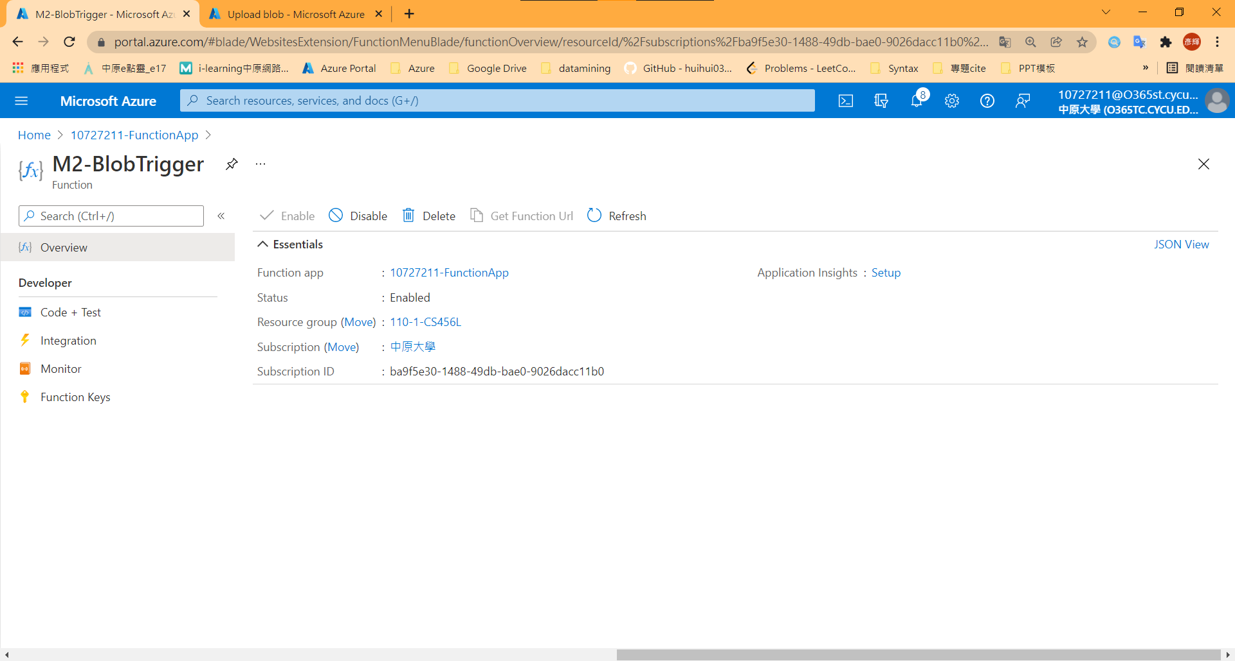

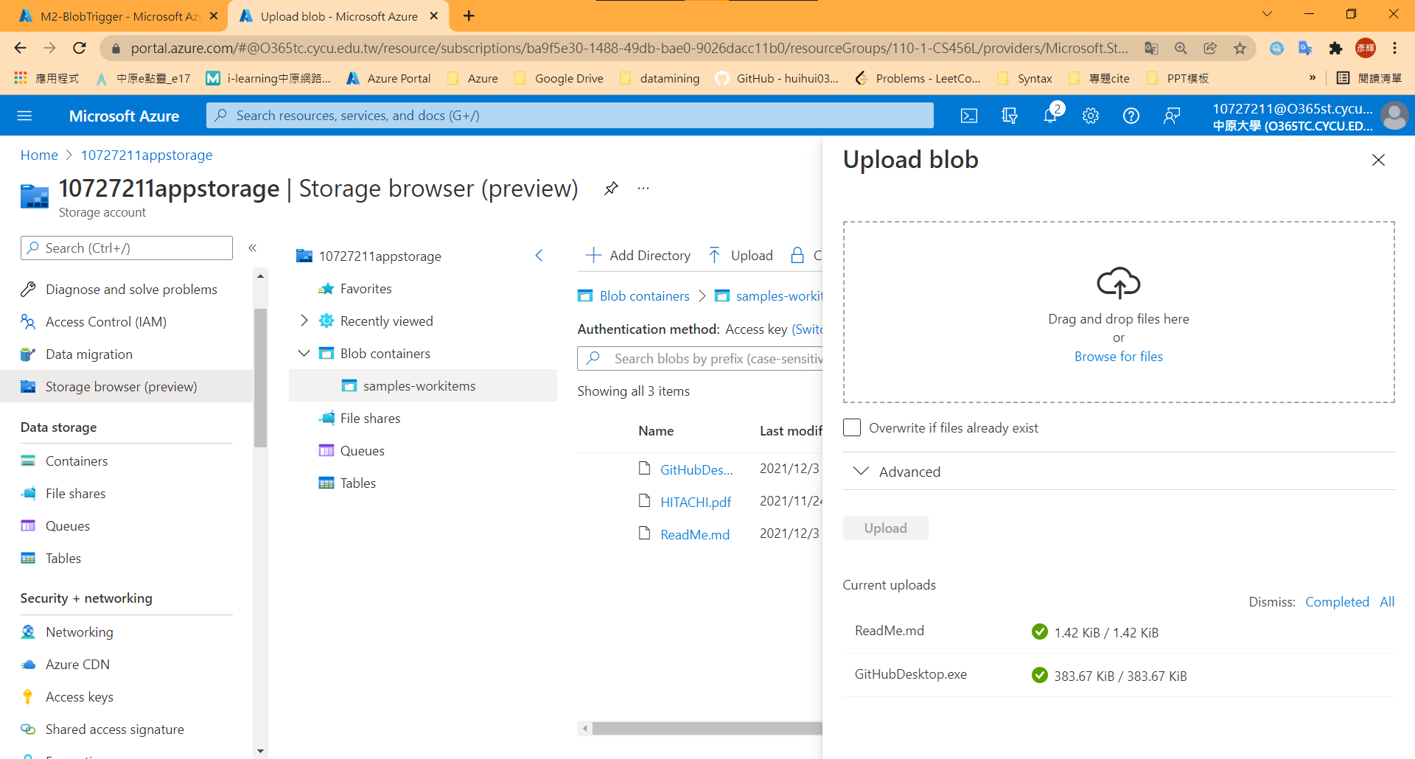

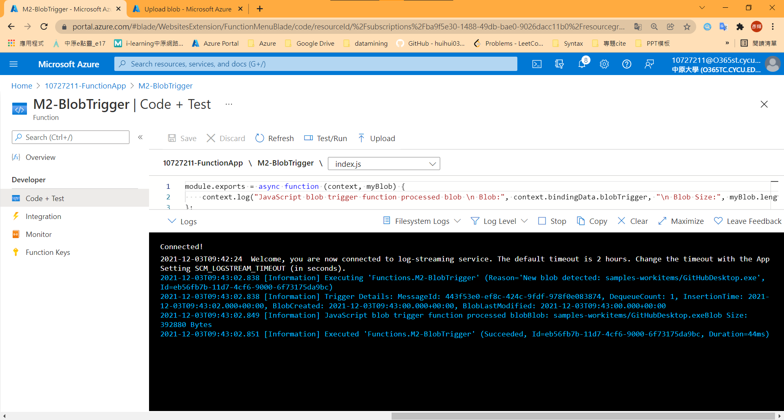

## Model 4: Chain Azure Functions together using input and output bindings

1. Create a HttpTrigger

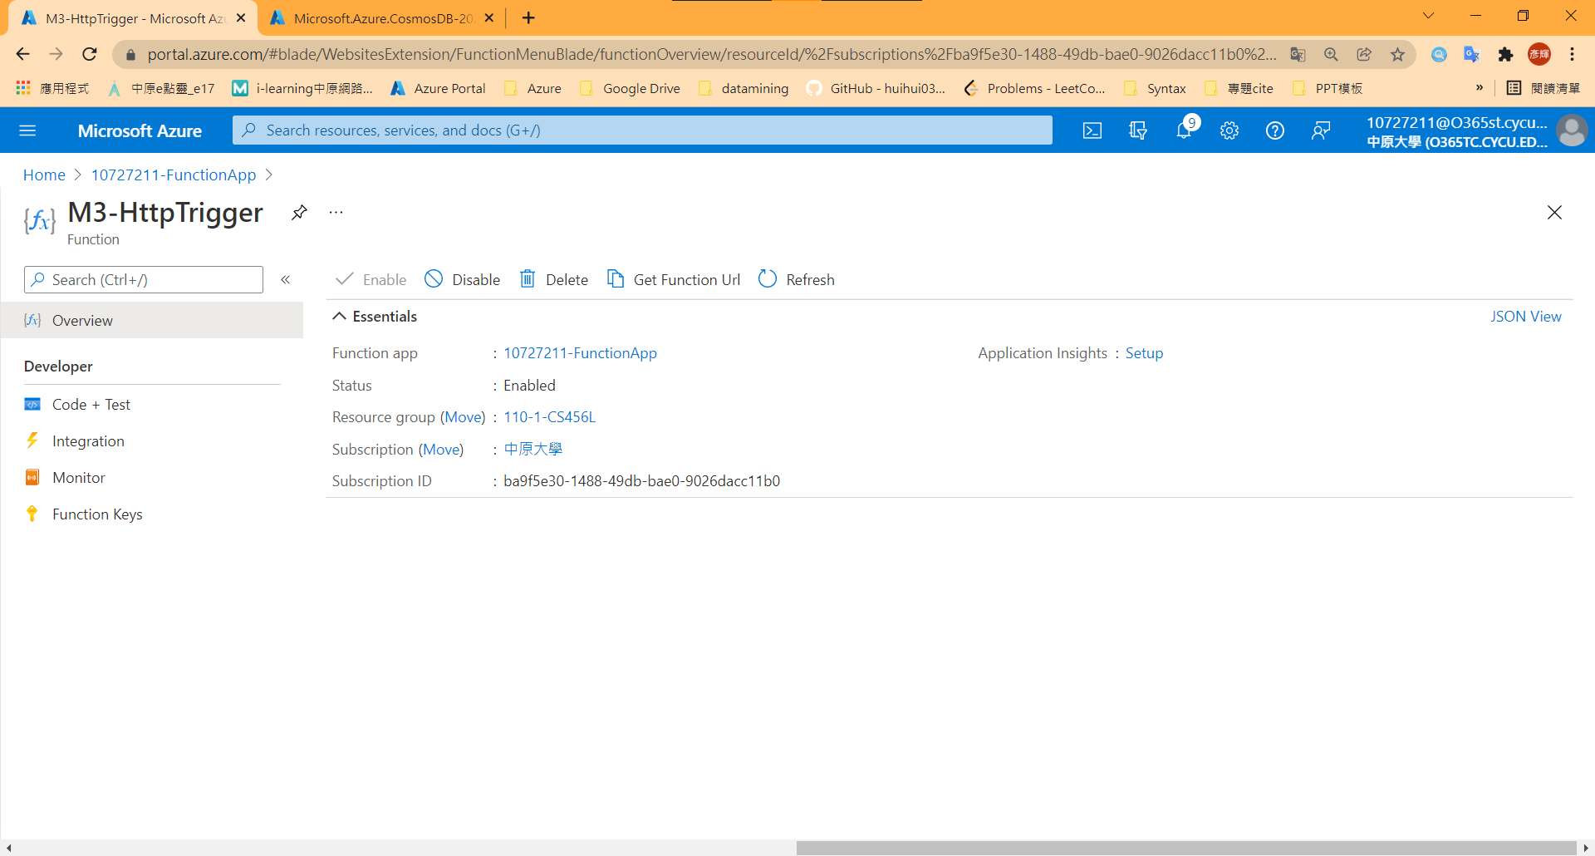

1. Create a cosmosDB

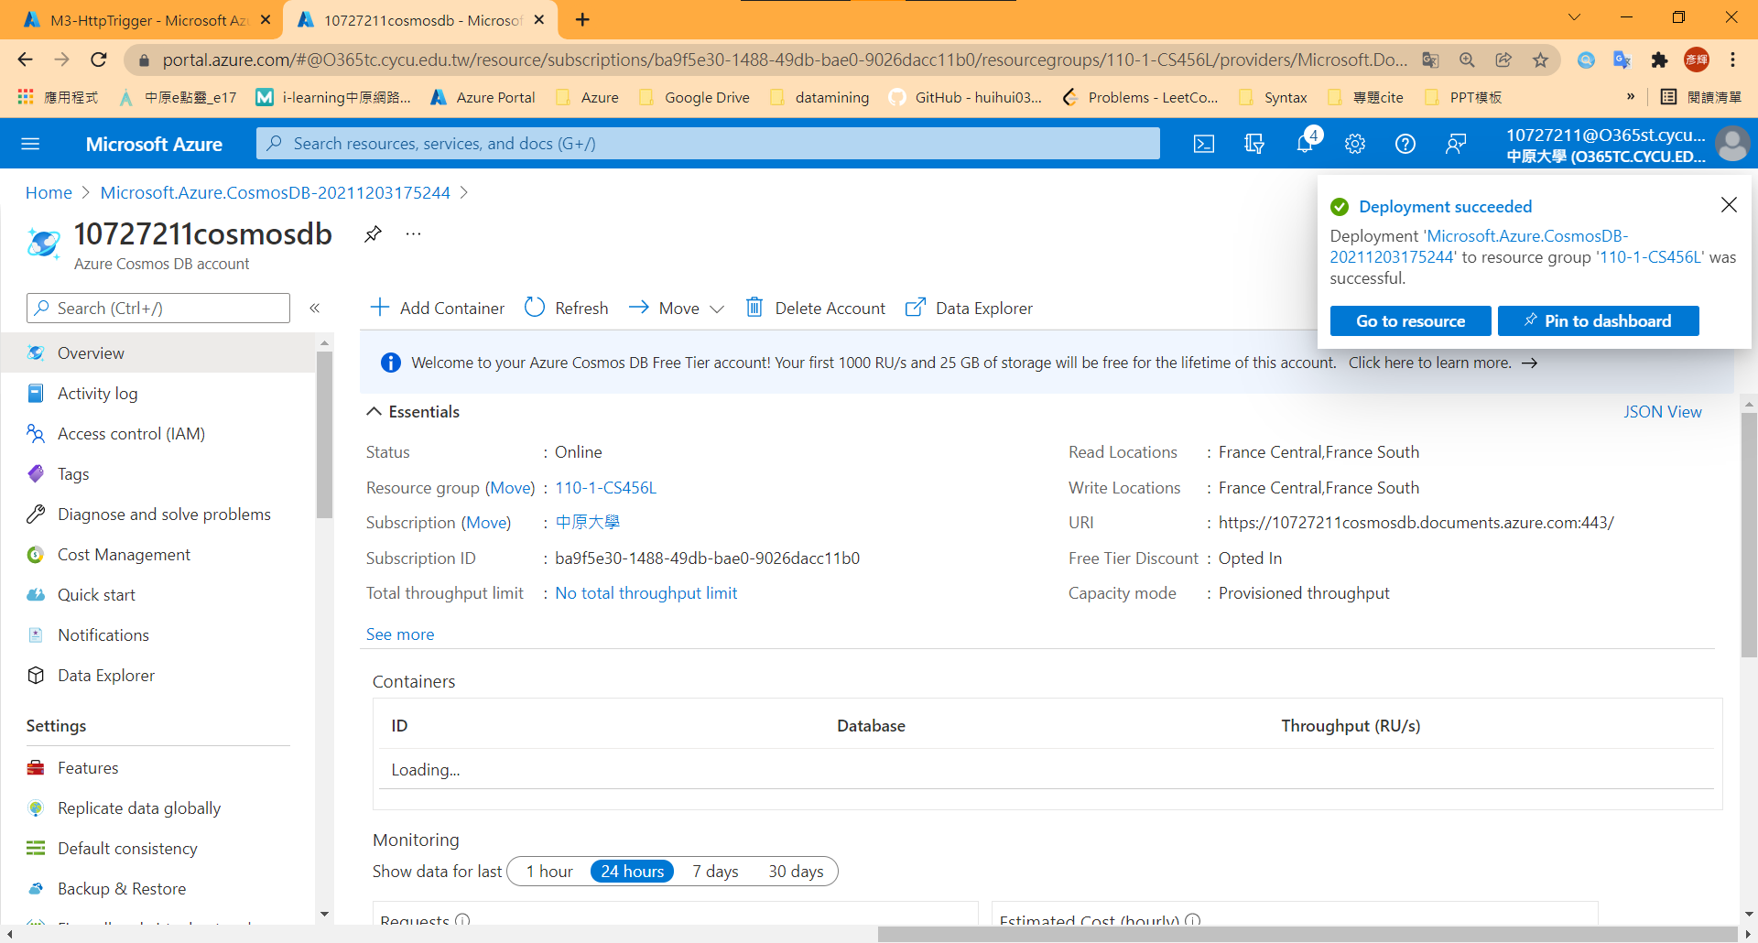

1. Add test data

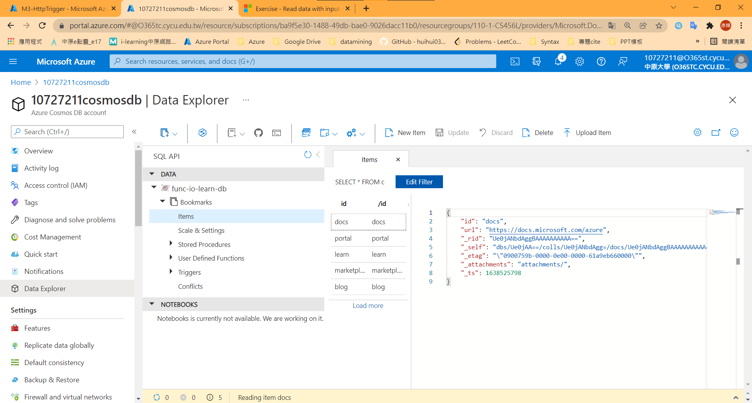

1. Add Azure cosmosDB binding

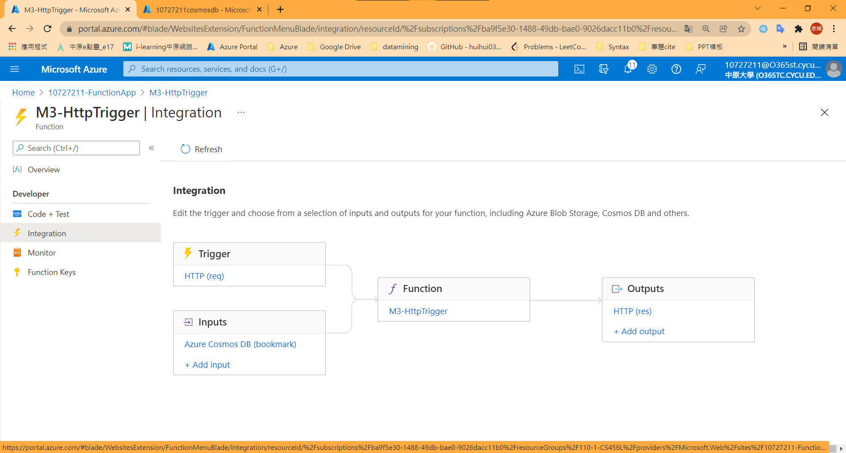

1. Result

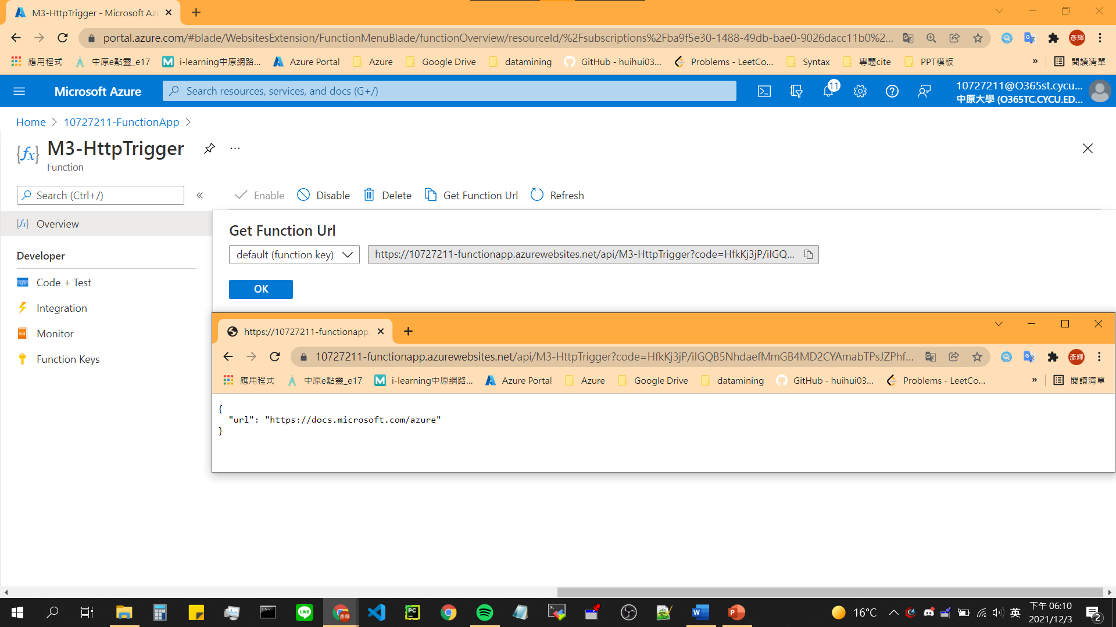

1. Add an Azure Queue Storage and cosmosDB output binding

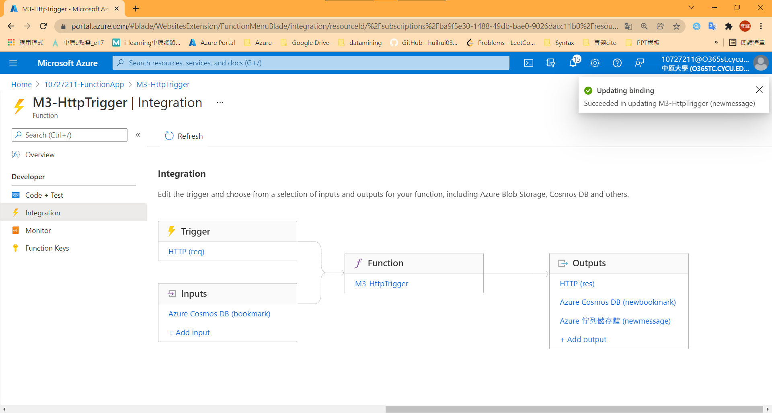

1. Push message to queue storage

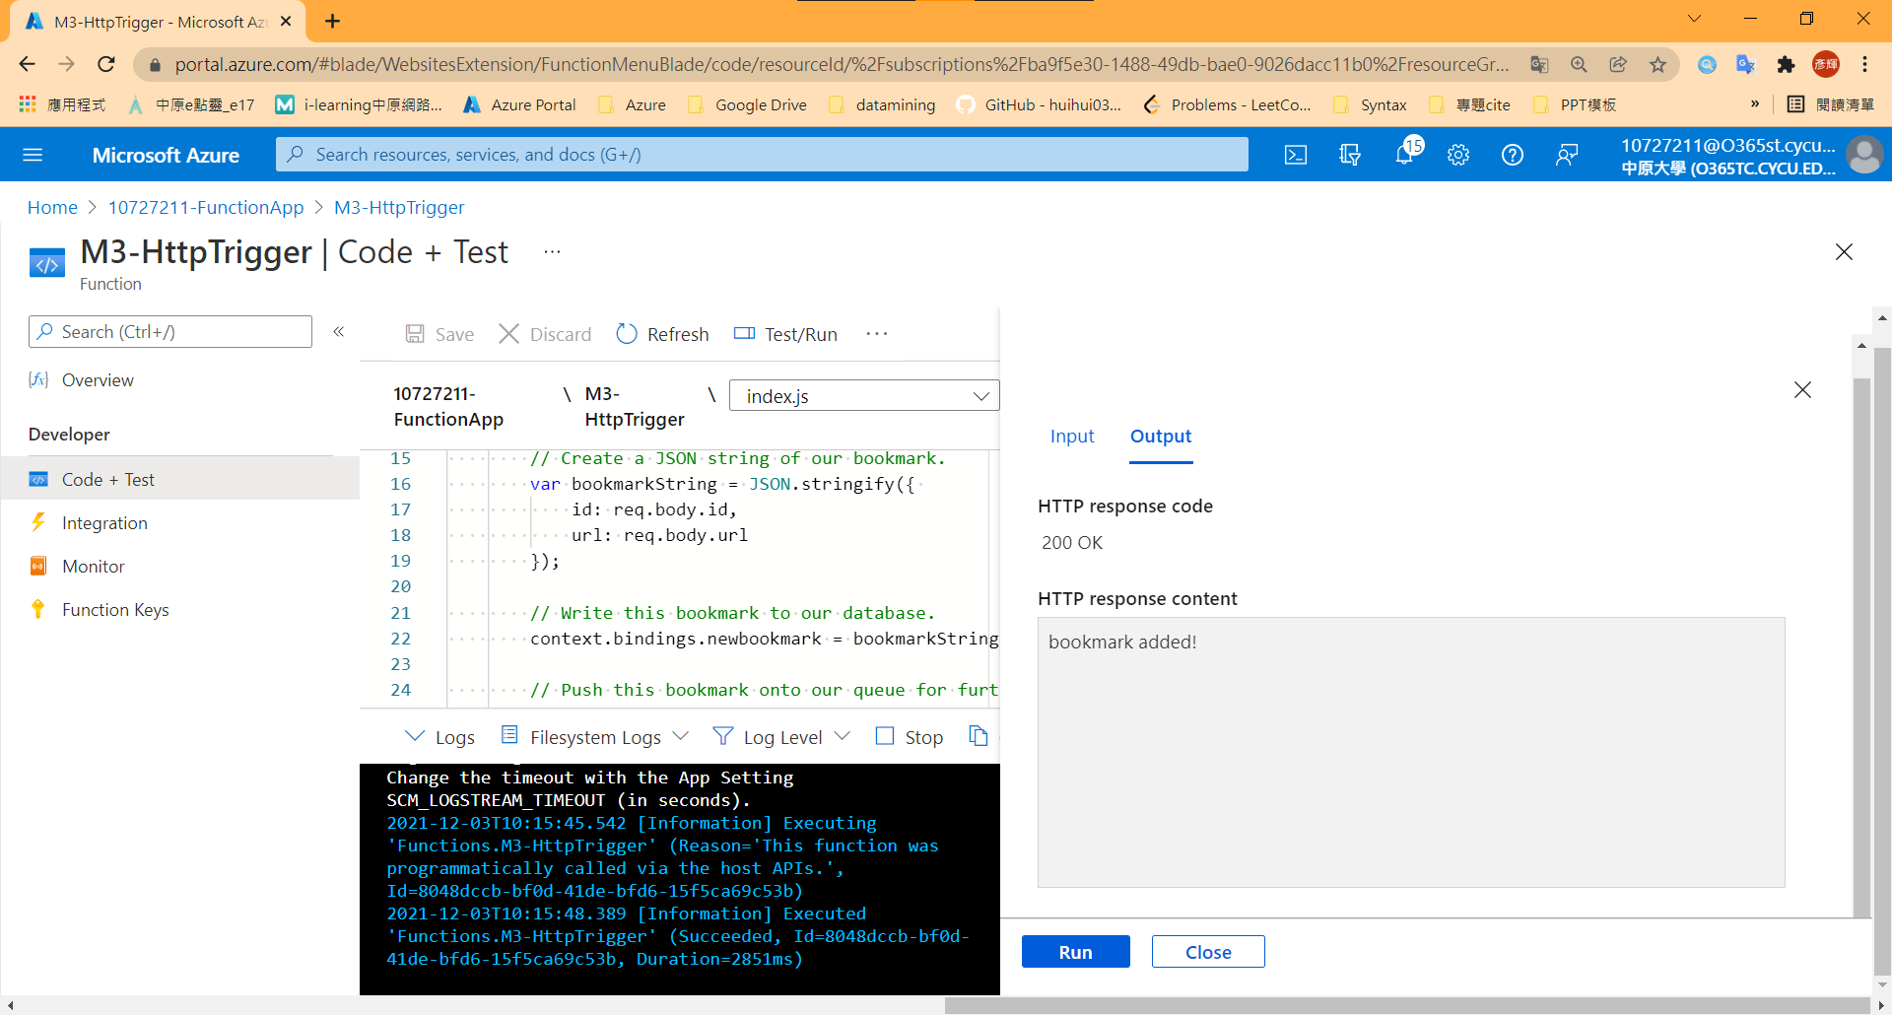

1. Result

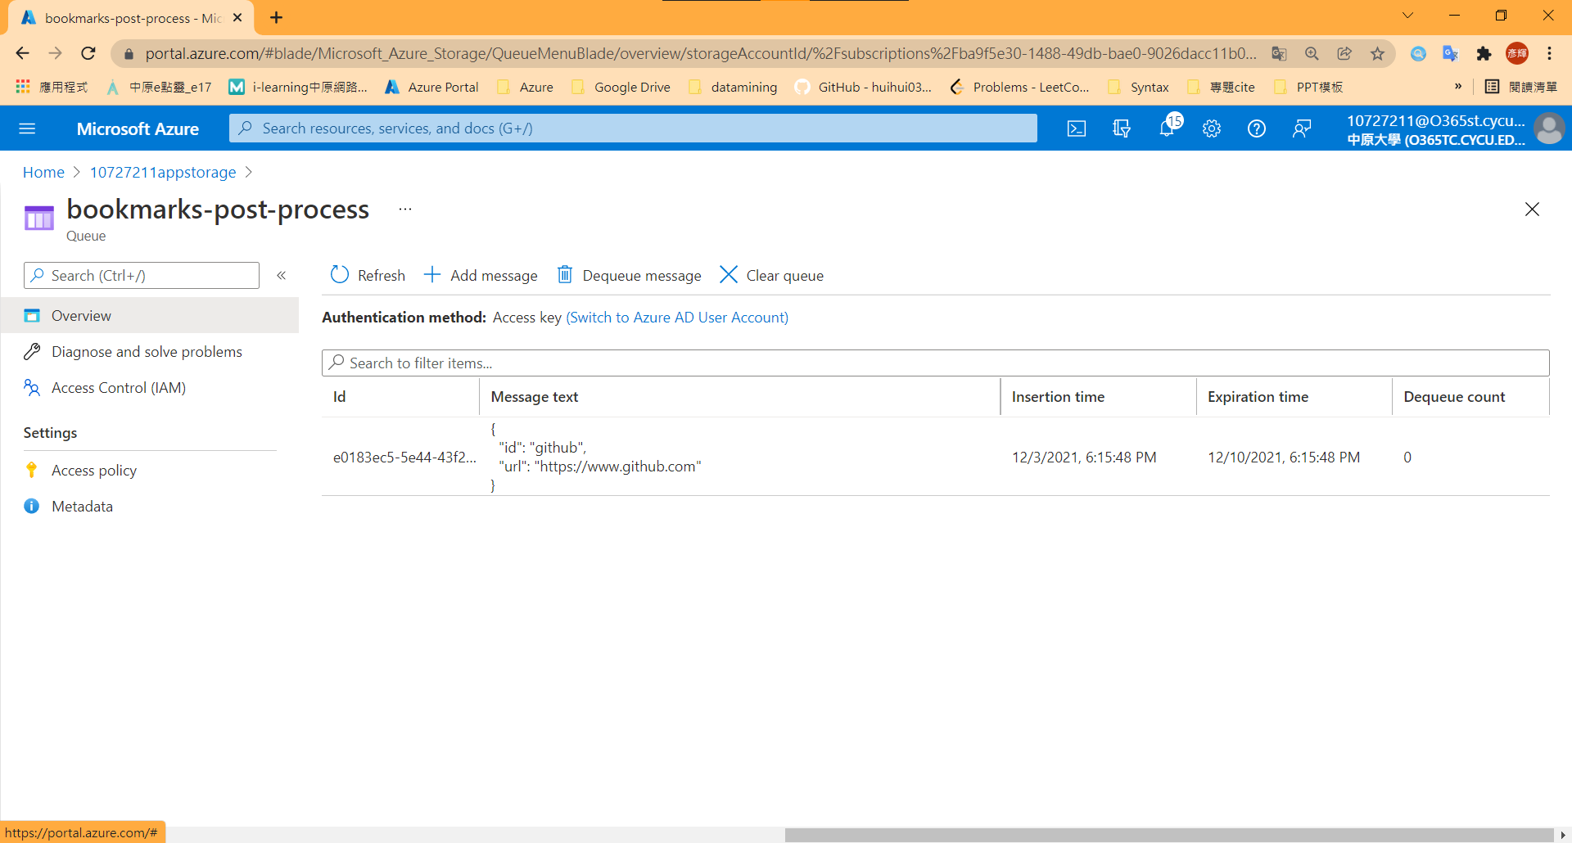

## Model 5: Create a long-running serverless workflow with Durable Functions

1. Install the durable-functions npm package

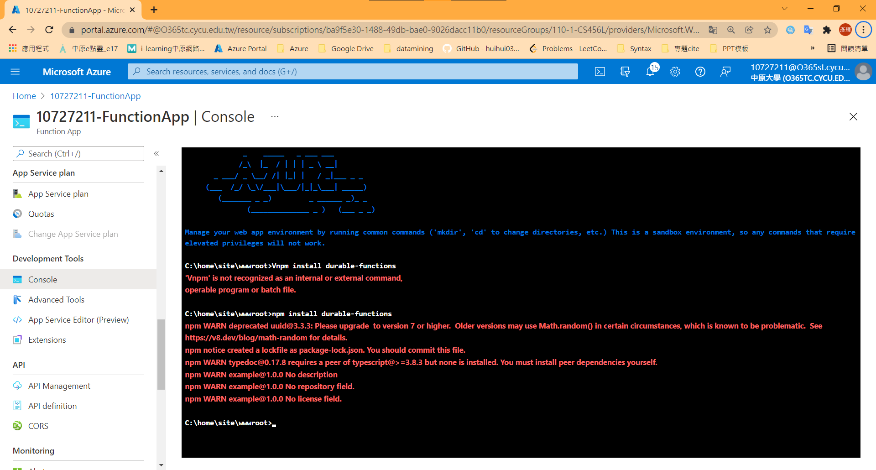

1. Create Durable Functions Http start

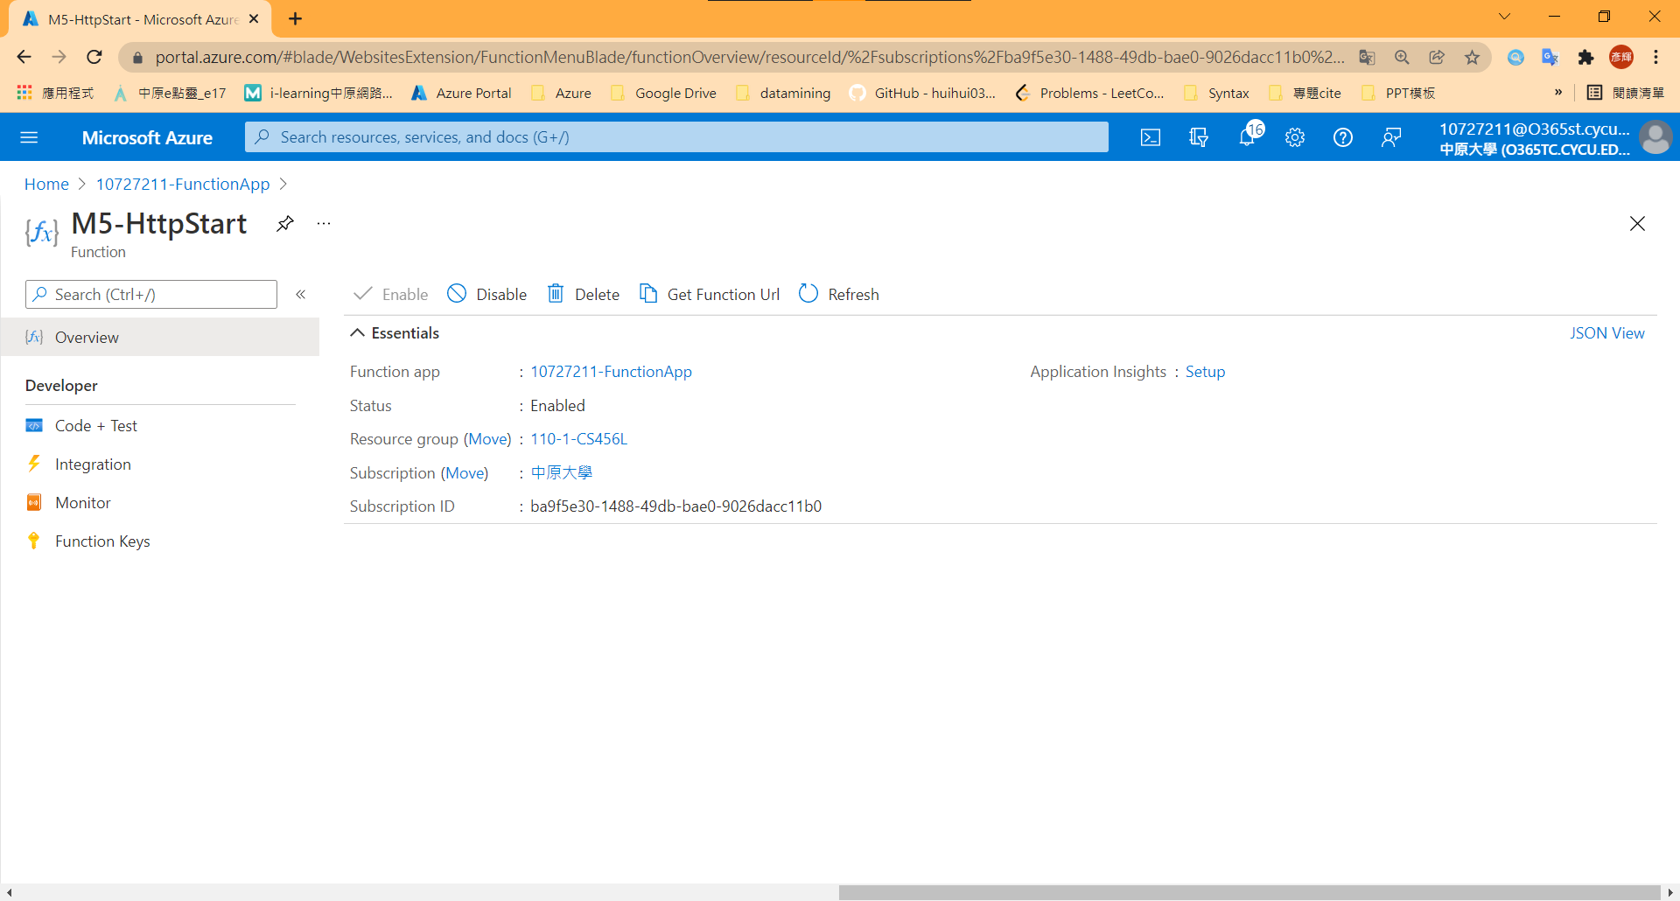

1. Create the orchestrator function

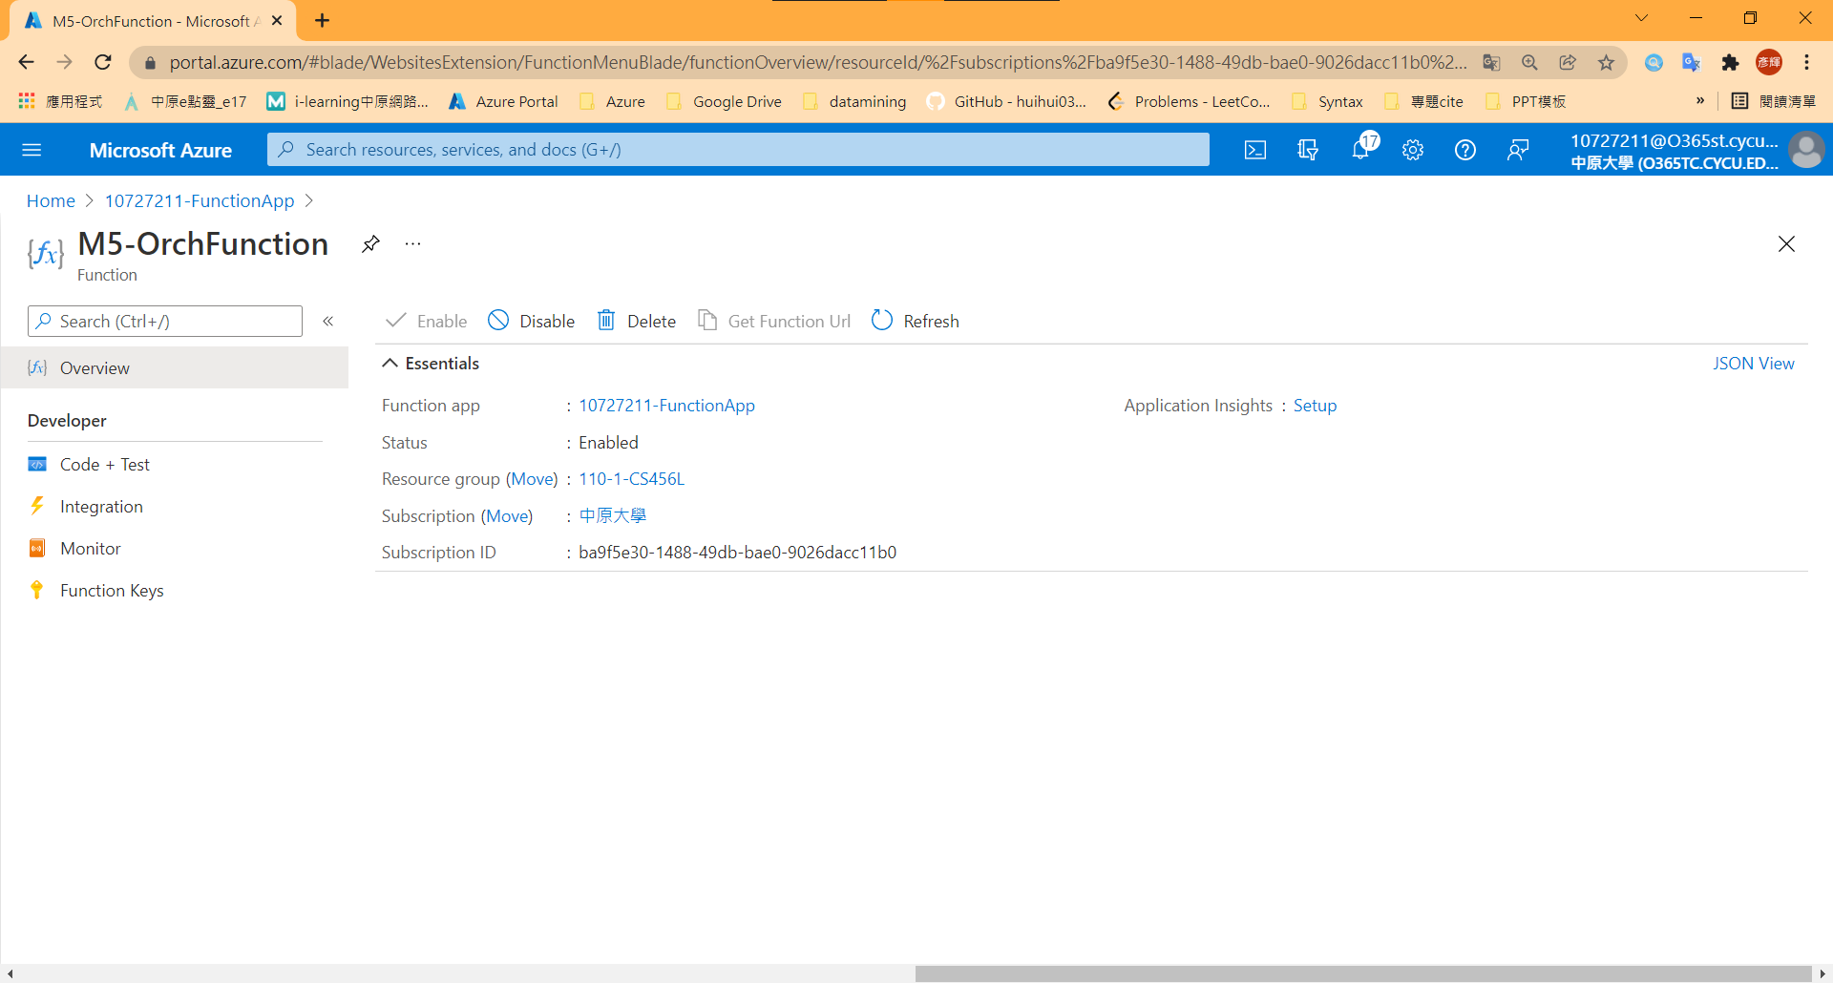

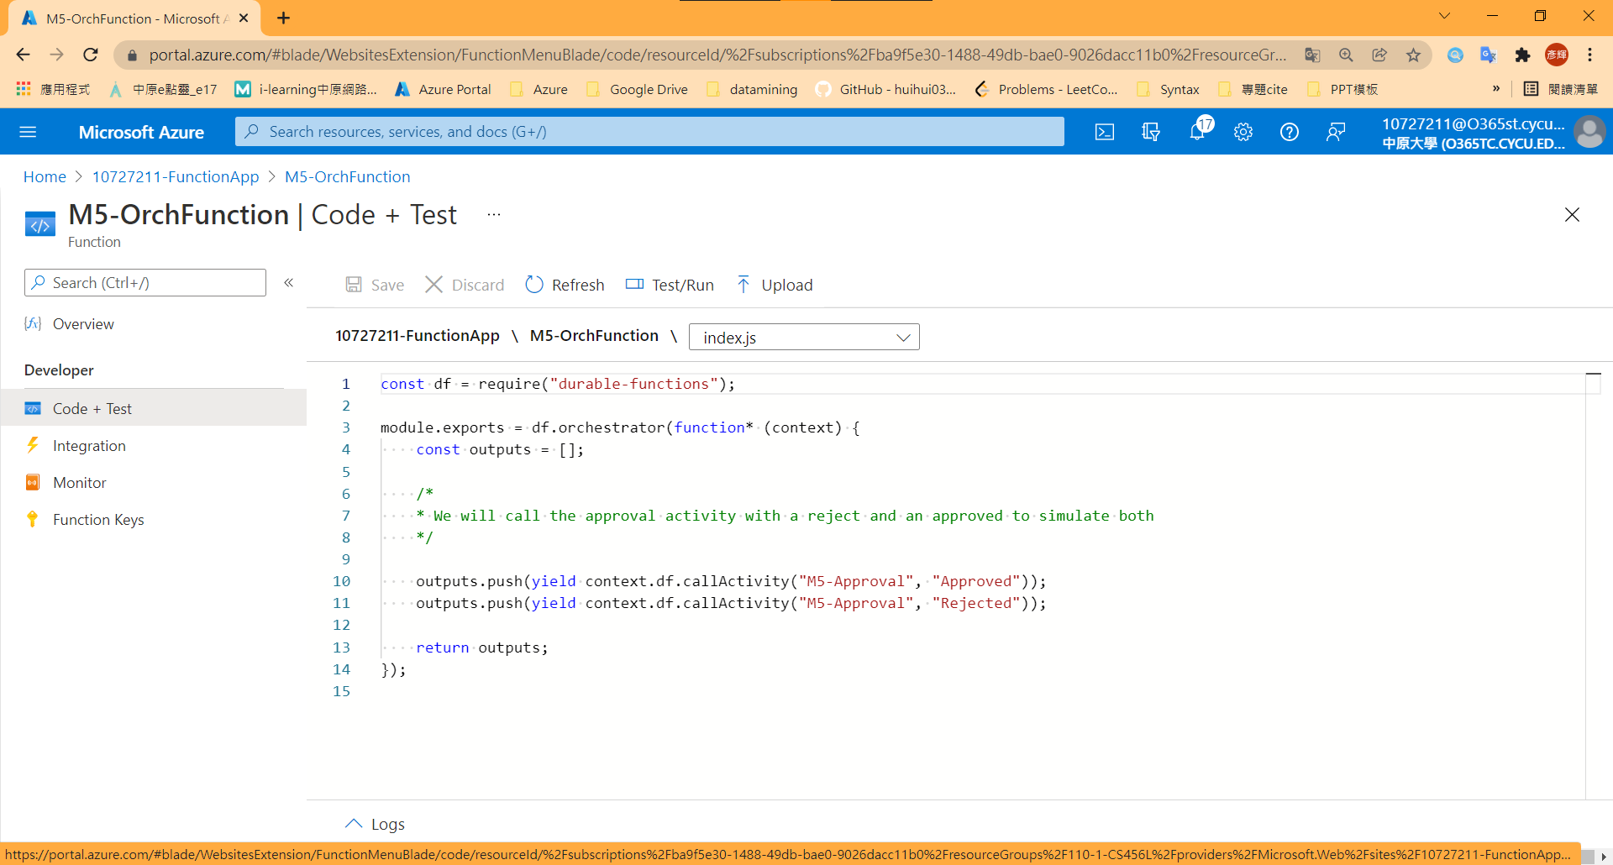

1. Create the activity function

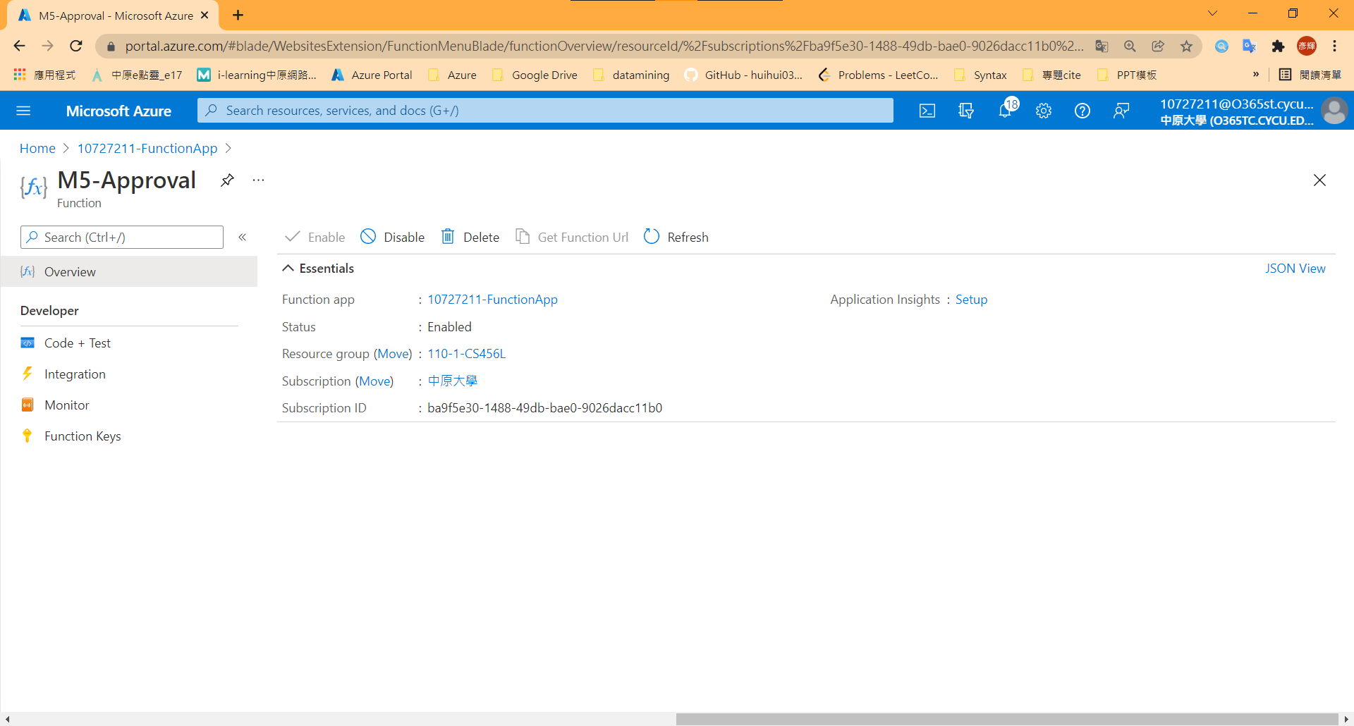

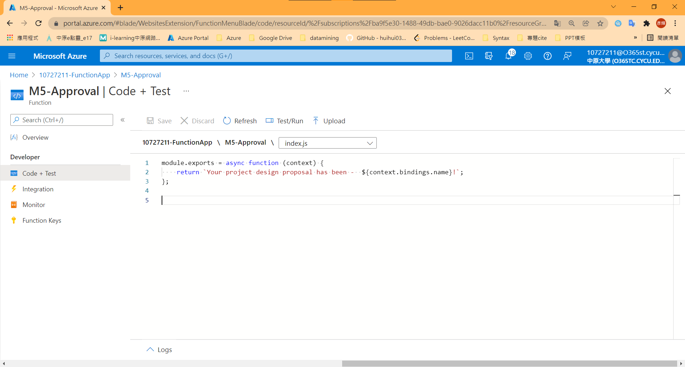

1. Verify that the durable functions workflow starts

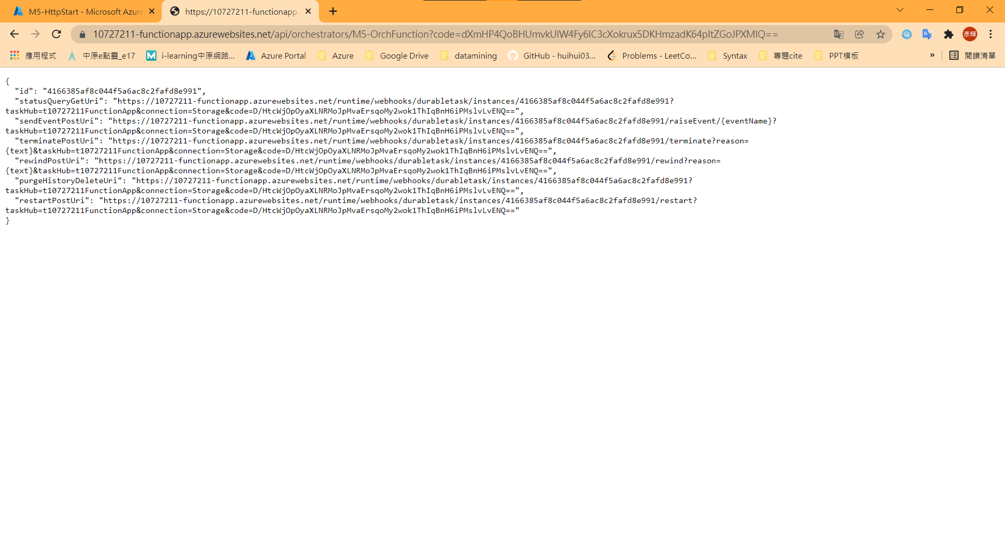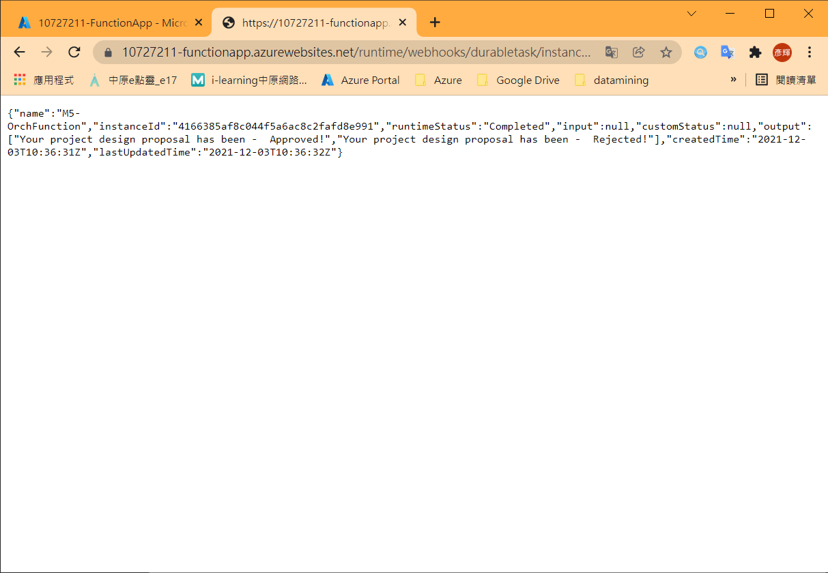

1. Add moment npm package to your function app

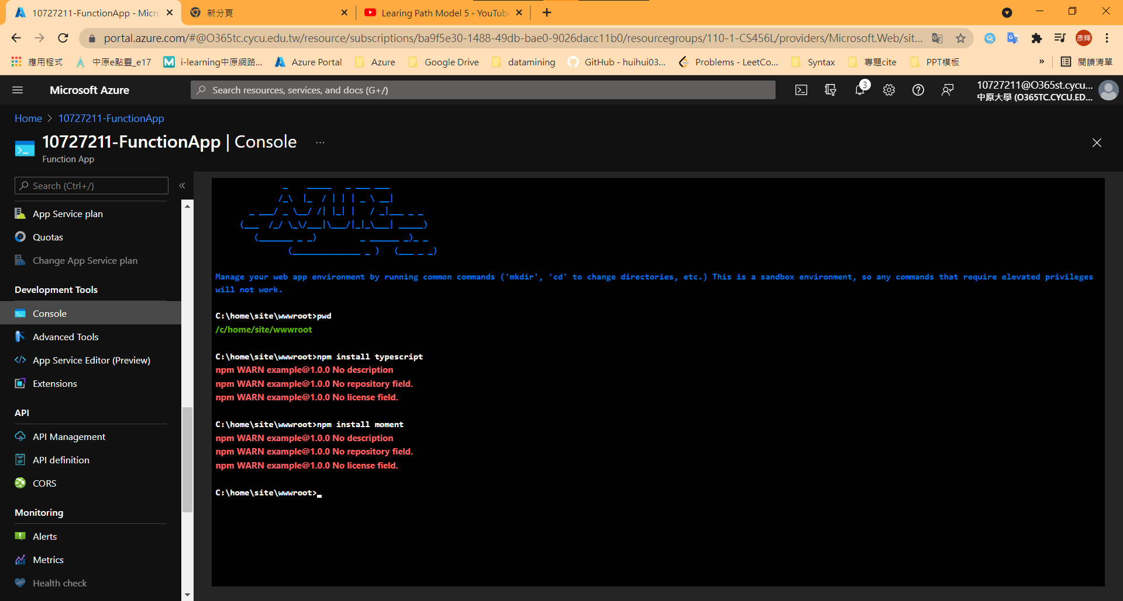

1. Add an escalation activity to your function app

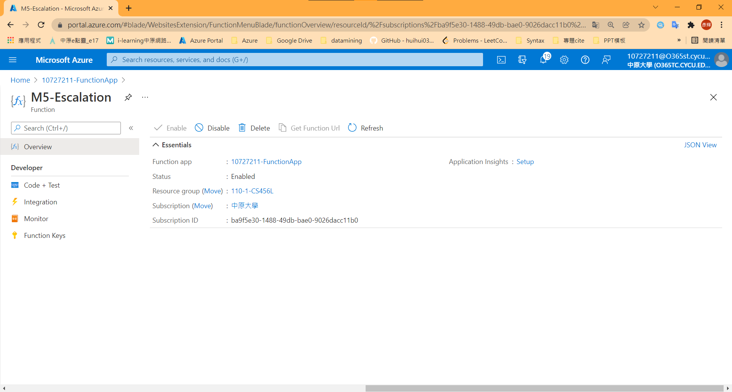

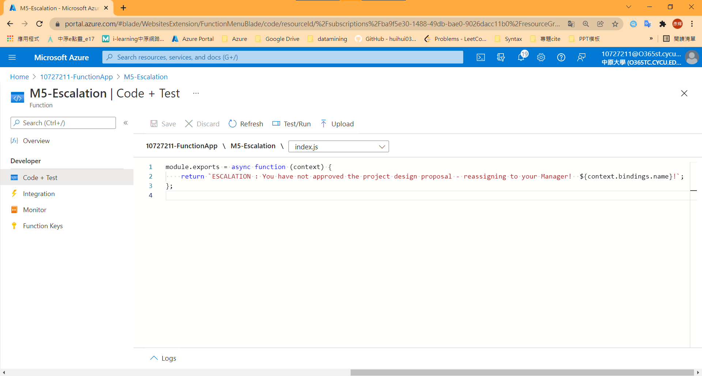

1. Update the orchestration function to use the escalation function

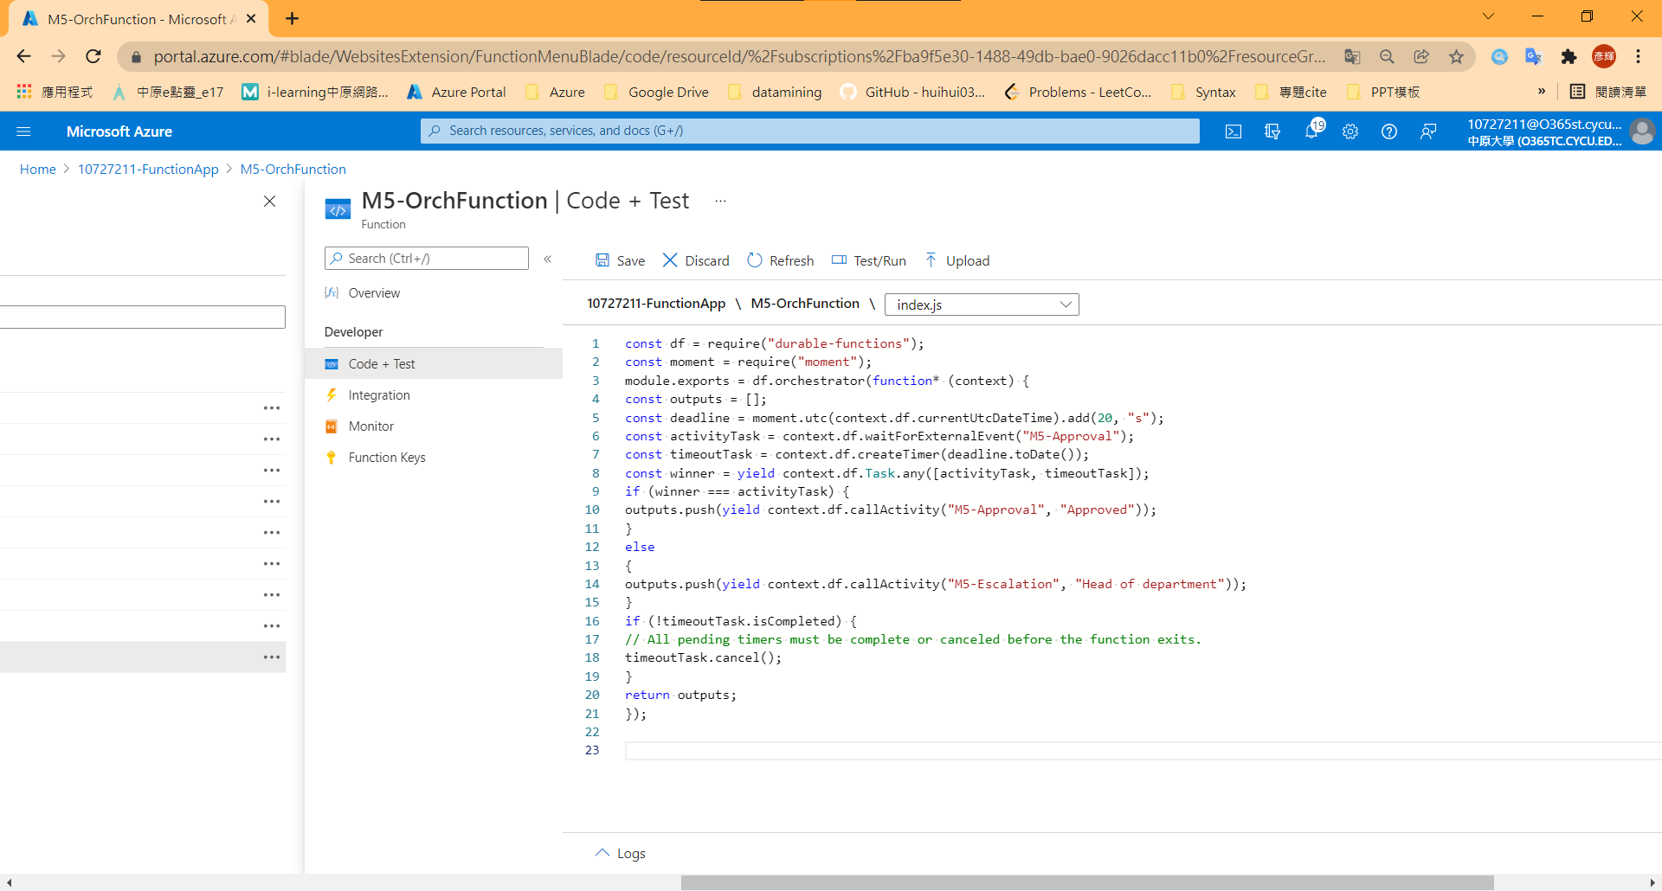

1. Verify that the Durable Functions workflow starts

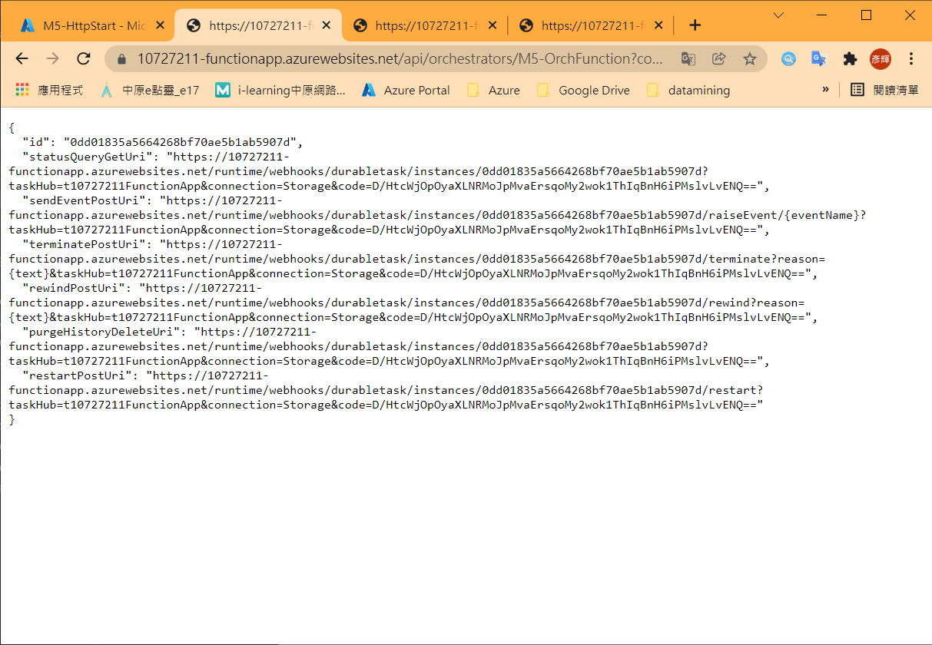

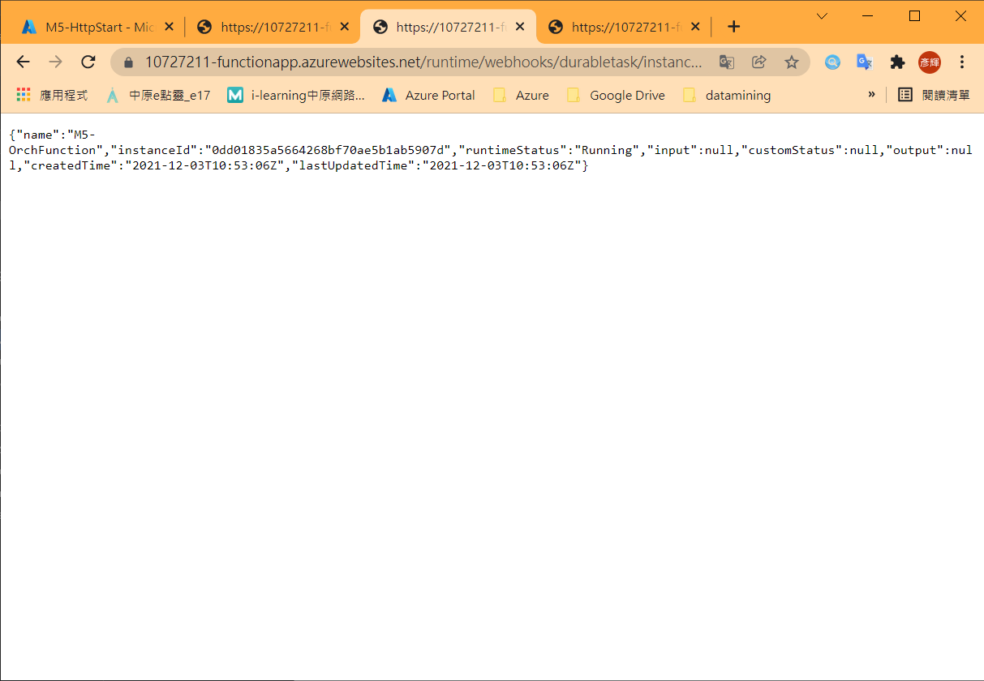

After 20s…

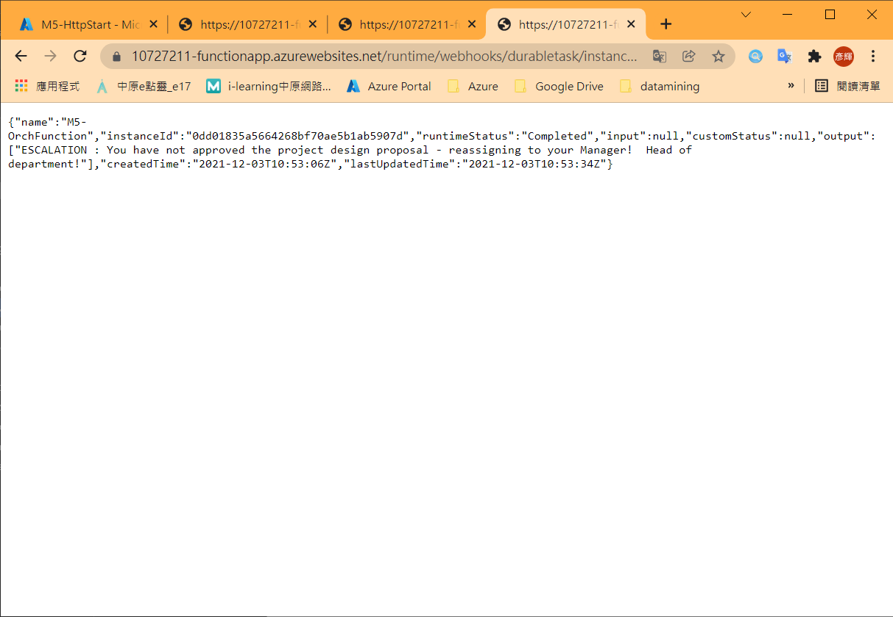

## Model 6: Develop, test, and publish Azure Functions by using Azure Functions Core Tools

1. Create a local Azure Functions project

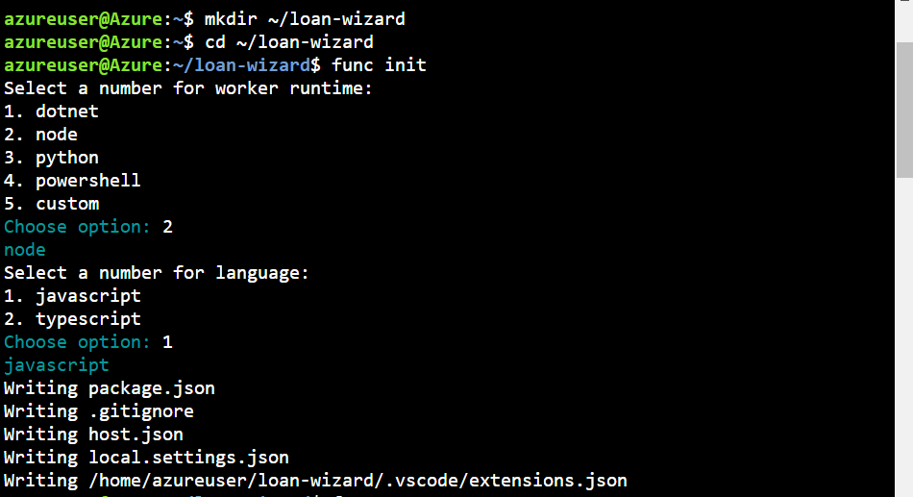

1. Create an HTTP-triggered function

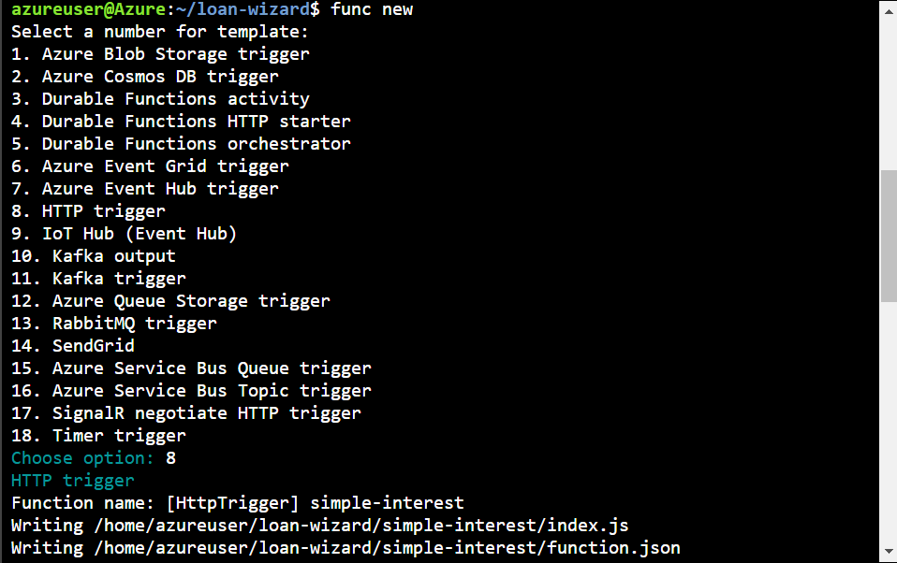

1. Replace index.js

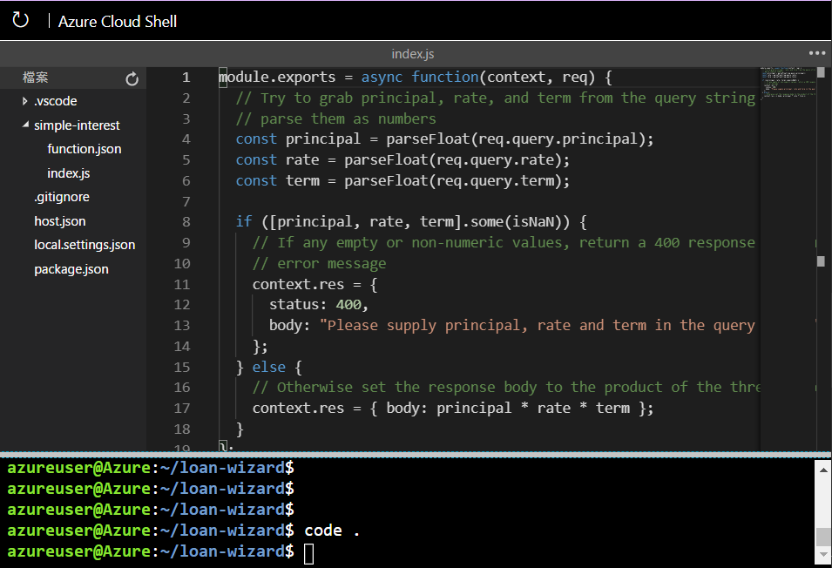

1. Run the function locally

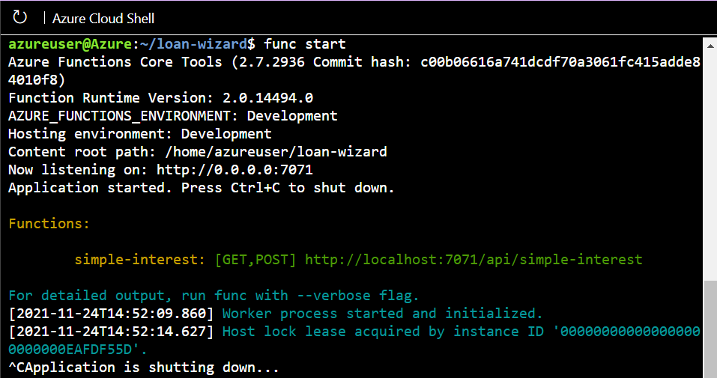

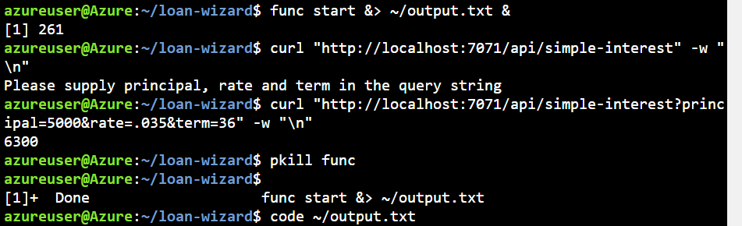

1. See output.txt

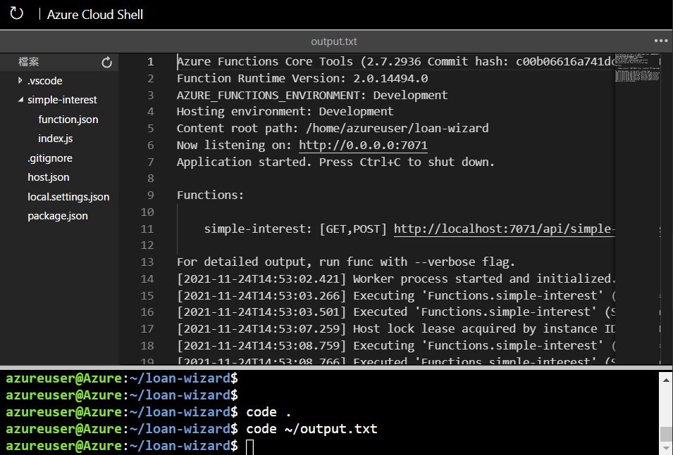

1. Create a function app

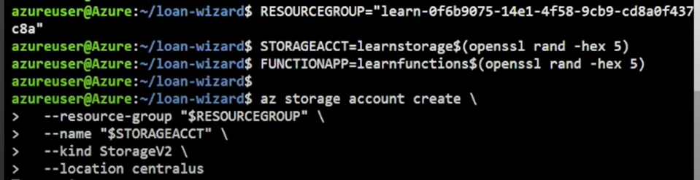

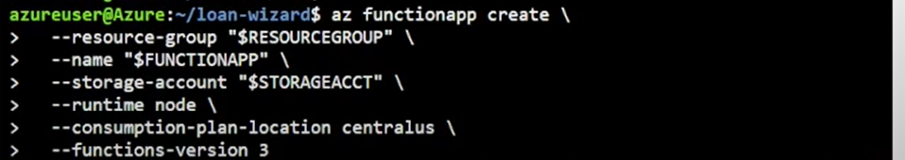

1. Publish to Azure

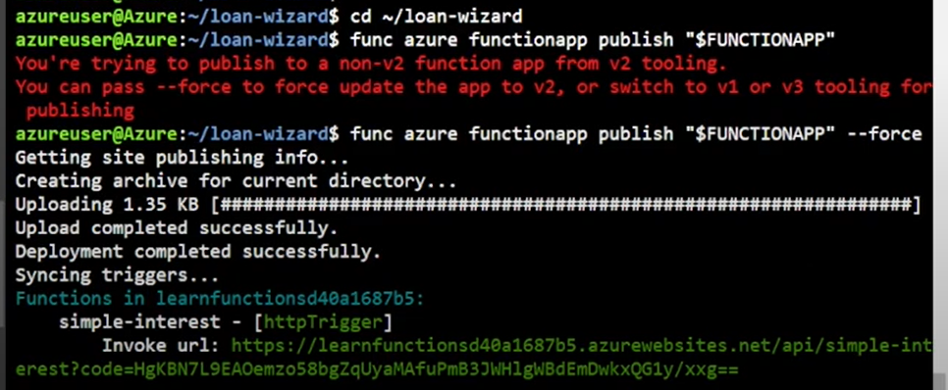

1. Run the function

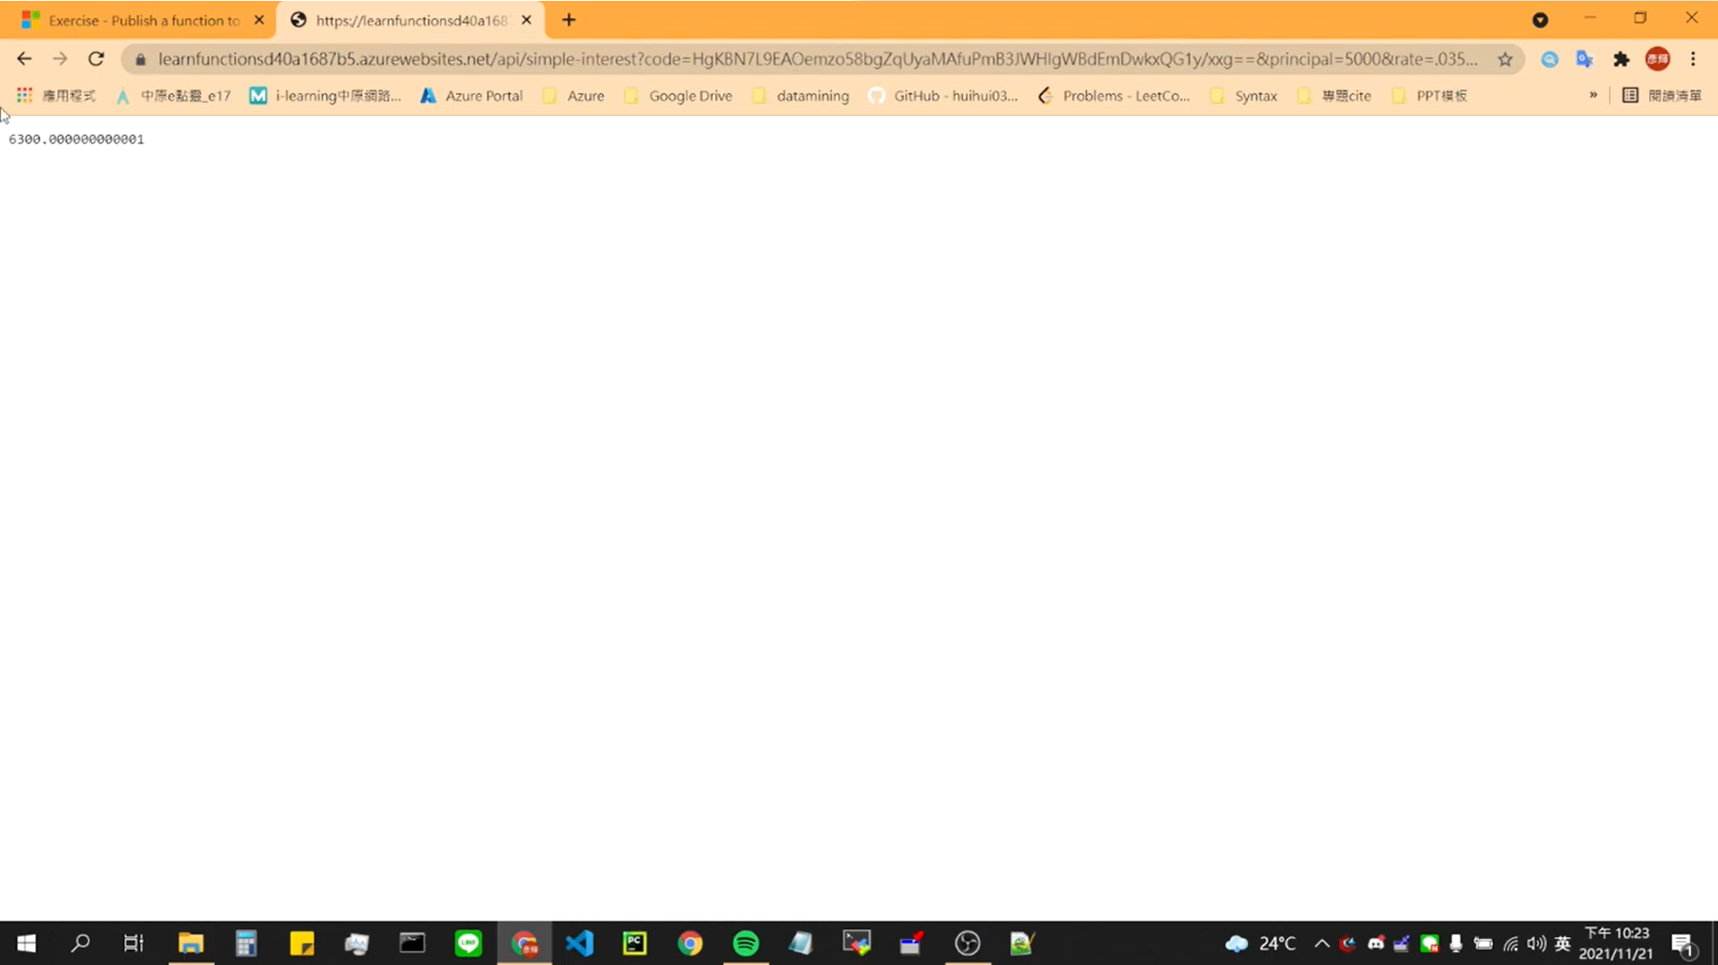

## (Model 7: Develop, test, and deploy an Azure Function with Visual Studio

1. Create an Azure Function app

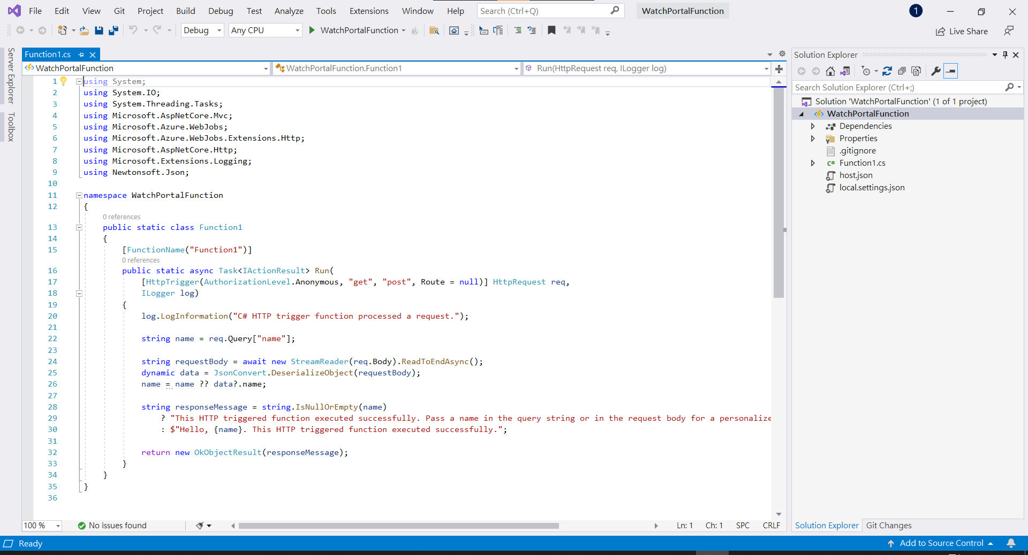

1. Create WatchInfo Function

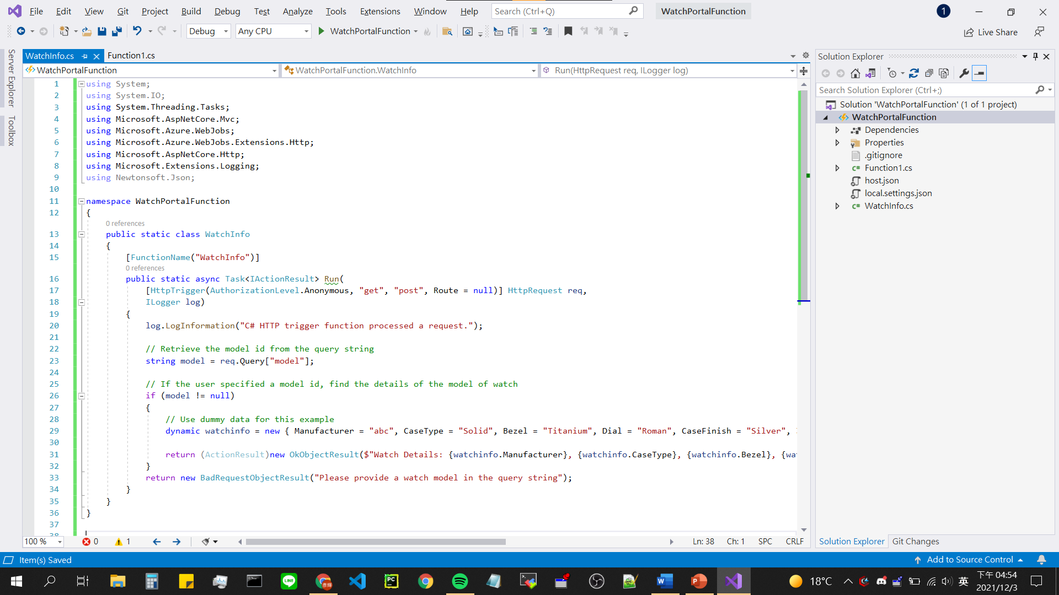

1. Test the Azure Function locally

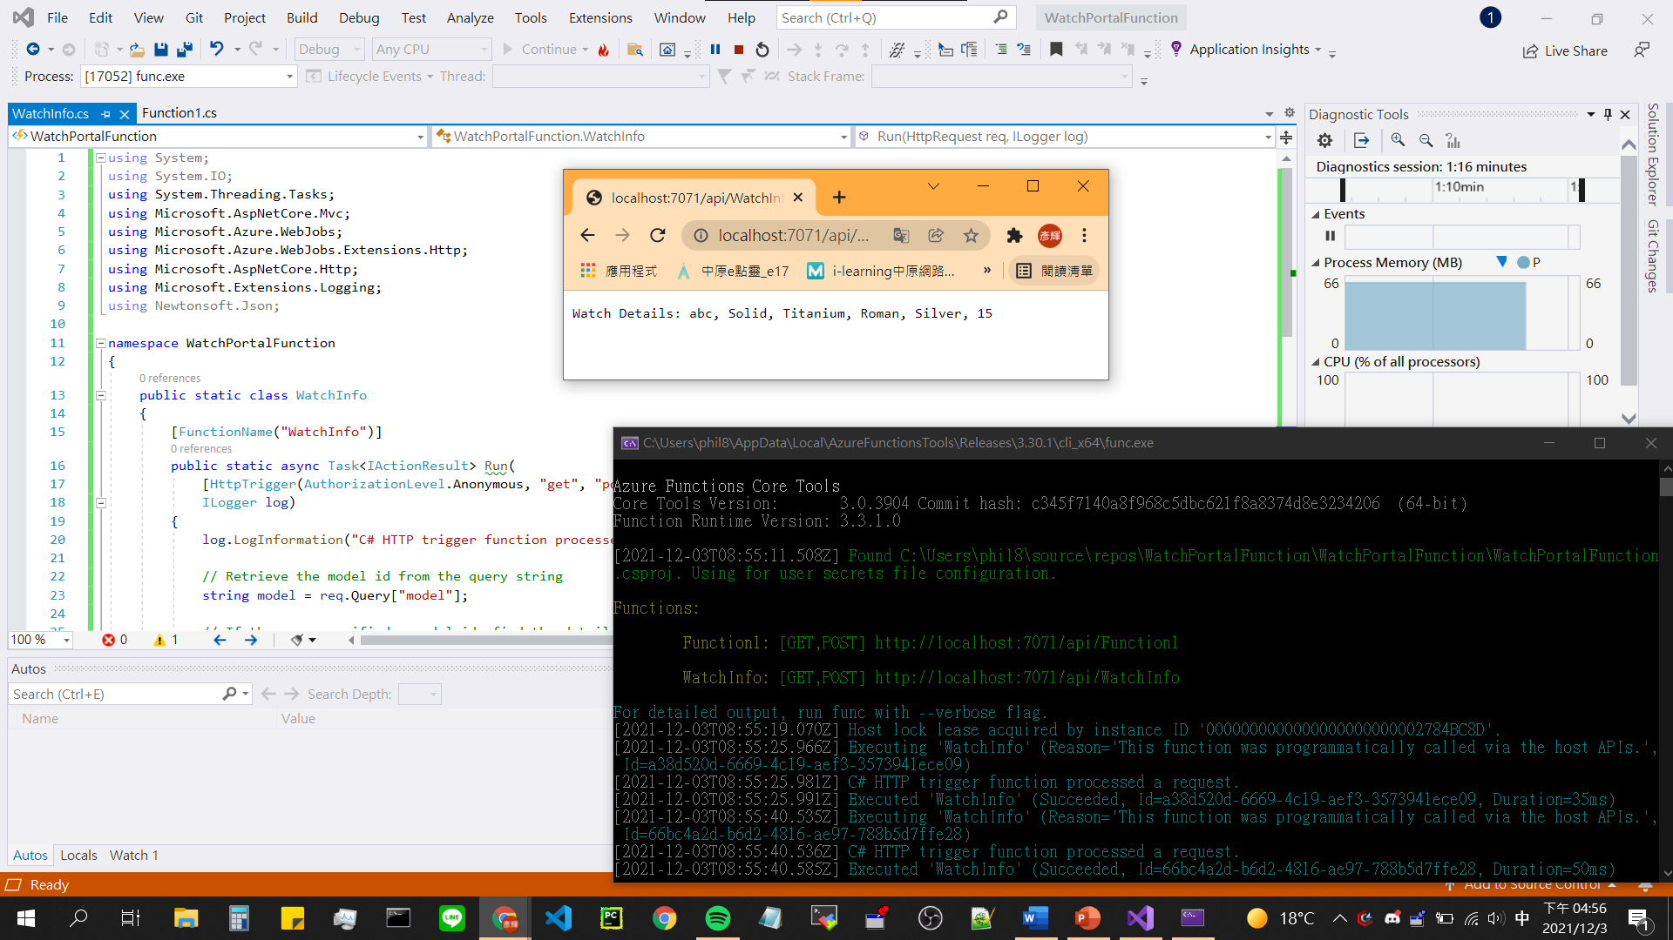

1. Add breakpoint & Test Azure Function locally

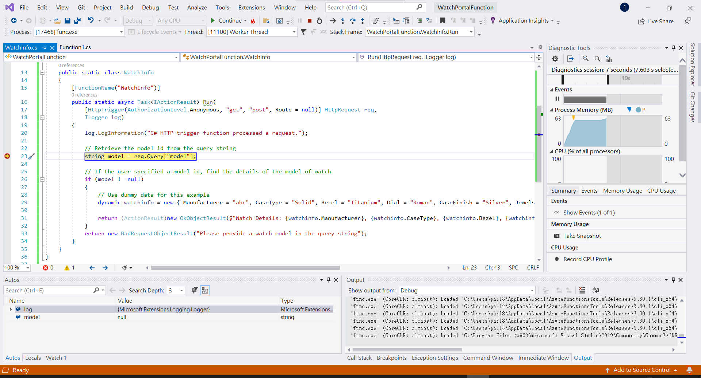

1. Deploy the WatchInfo function to the Azure Function App

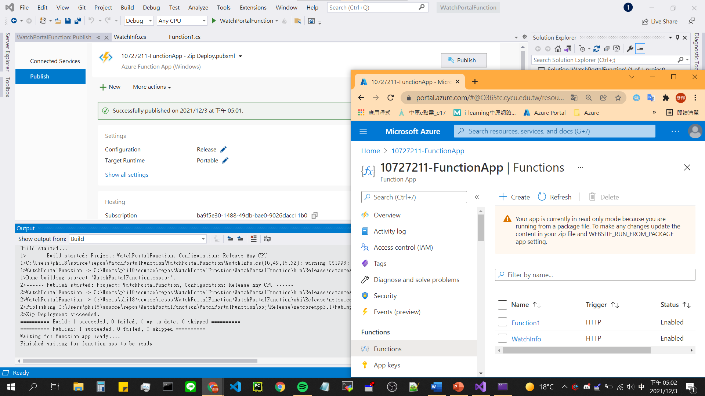

1. Verify the functions have been deployed

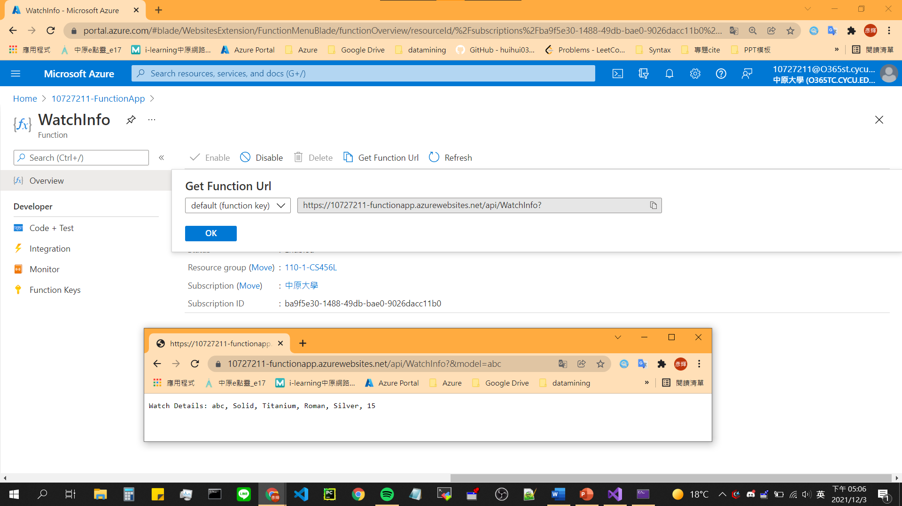

1. Unit test an Azure Function (success version)

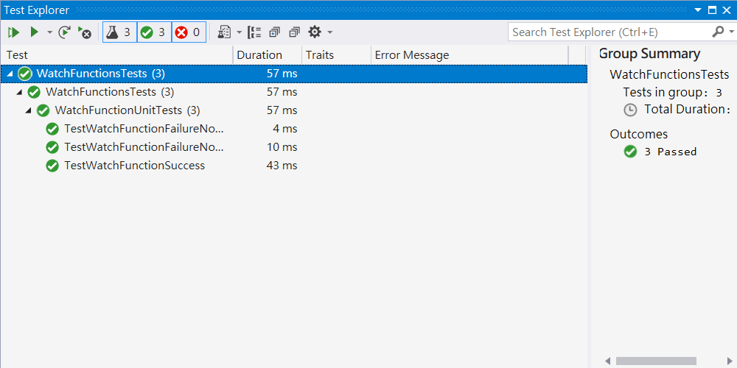

1. Unit test an Azure Function (error version)

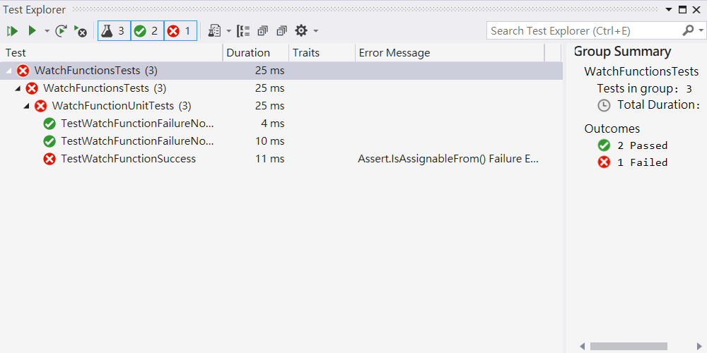

## Model 8: Monitor GitHub events by using a webhook with Azure Functions

1. Create a Webhook Trigger function

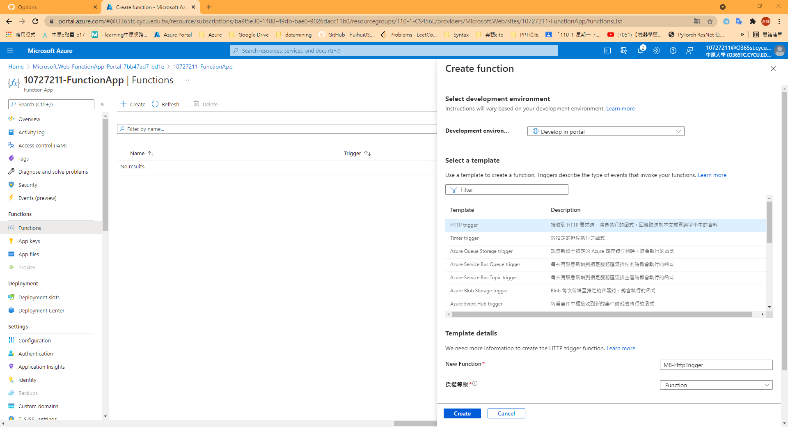

1. Set up a webhook for a GitHub repository

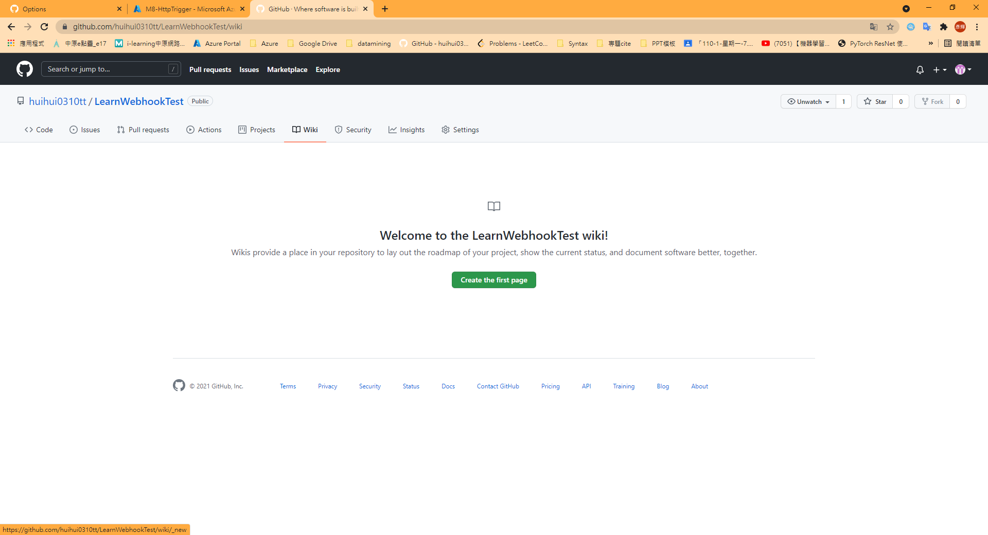

1. Add a webhook and Test

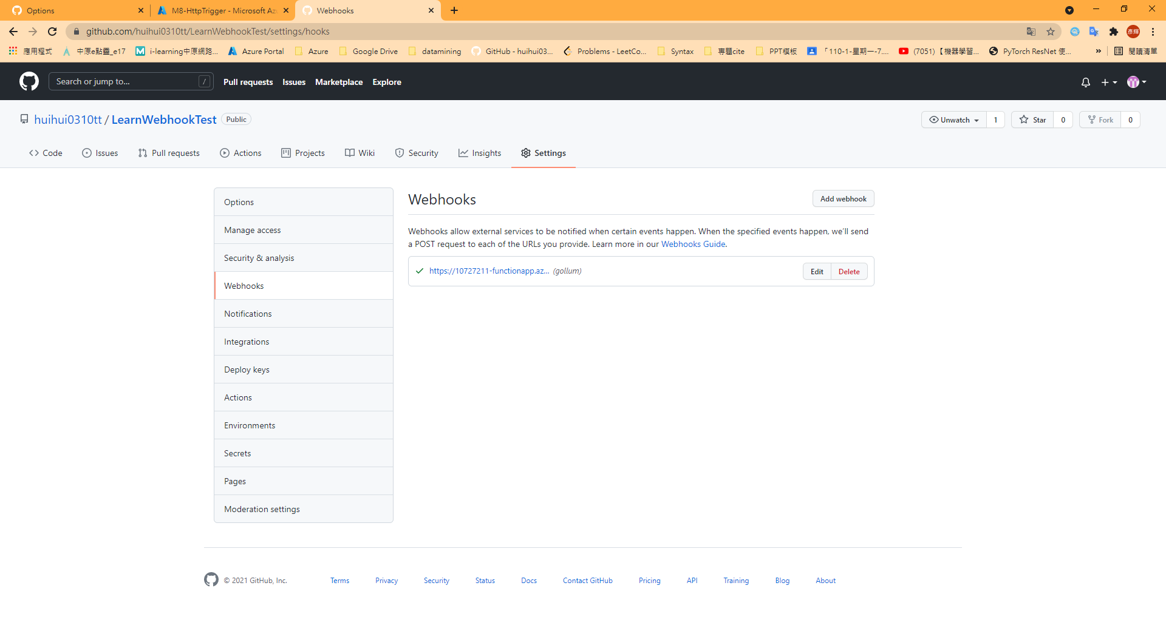

1. Replace index.js in Azure Function

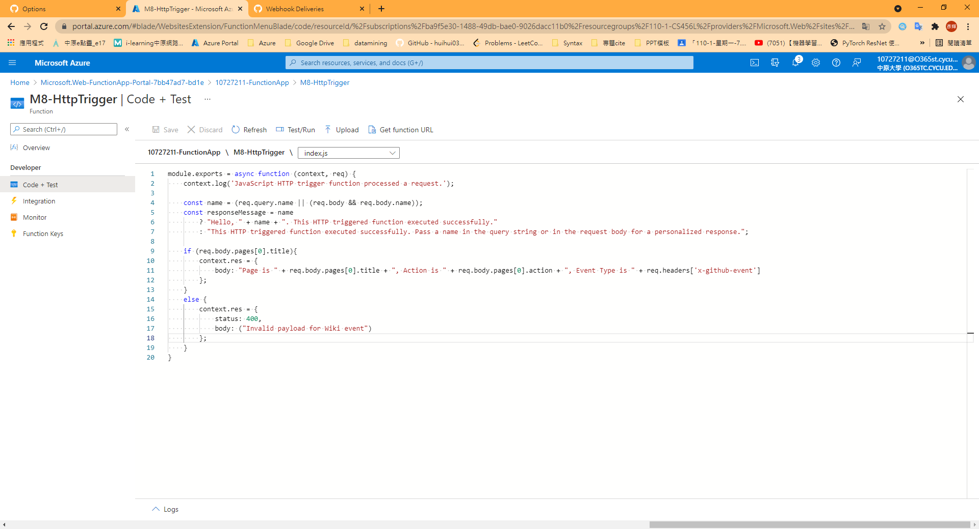

1. 2nd Trigger Webhook

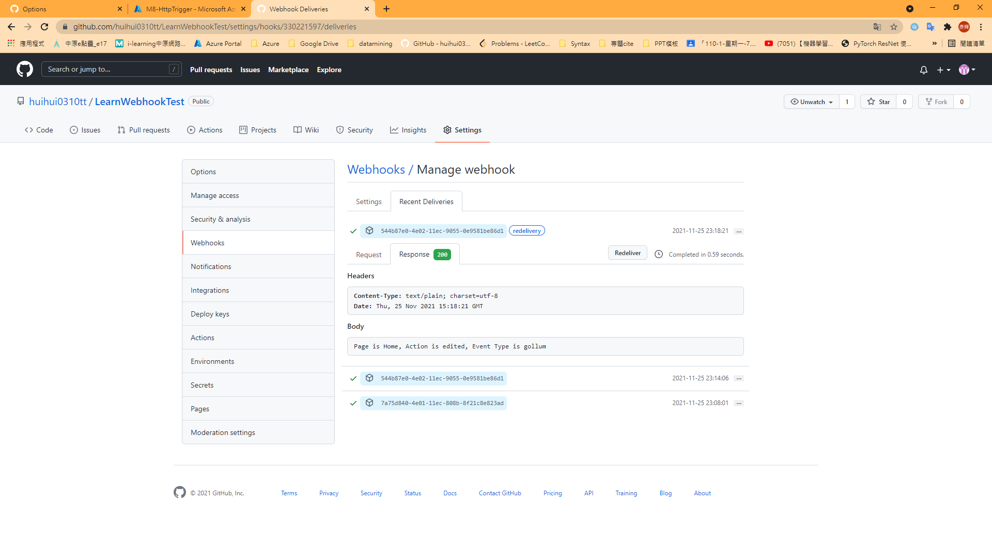

1. Webhook cryption

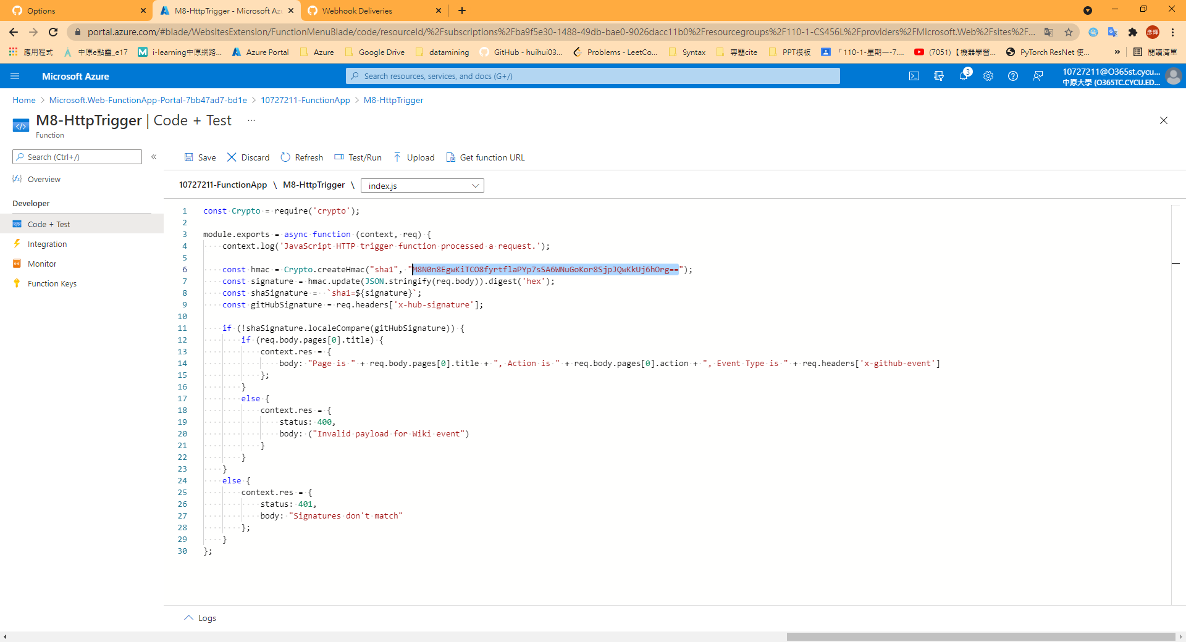

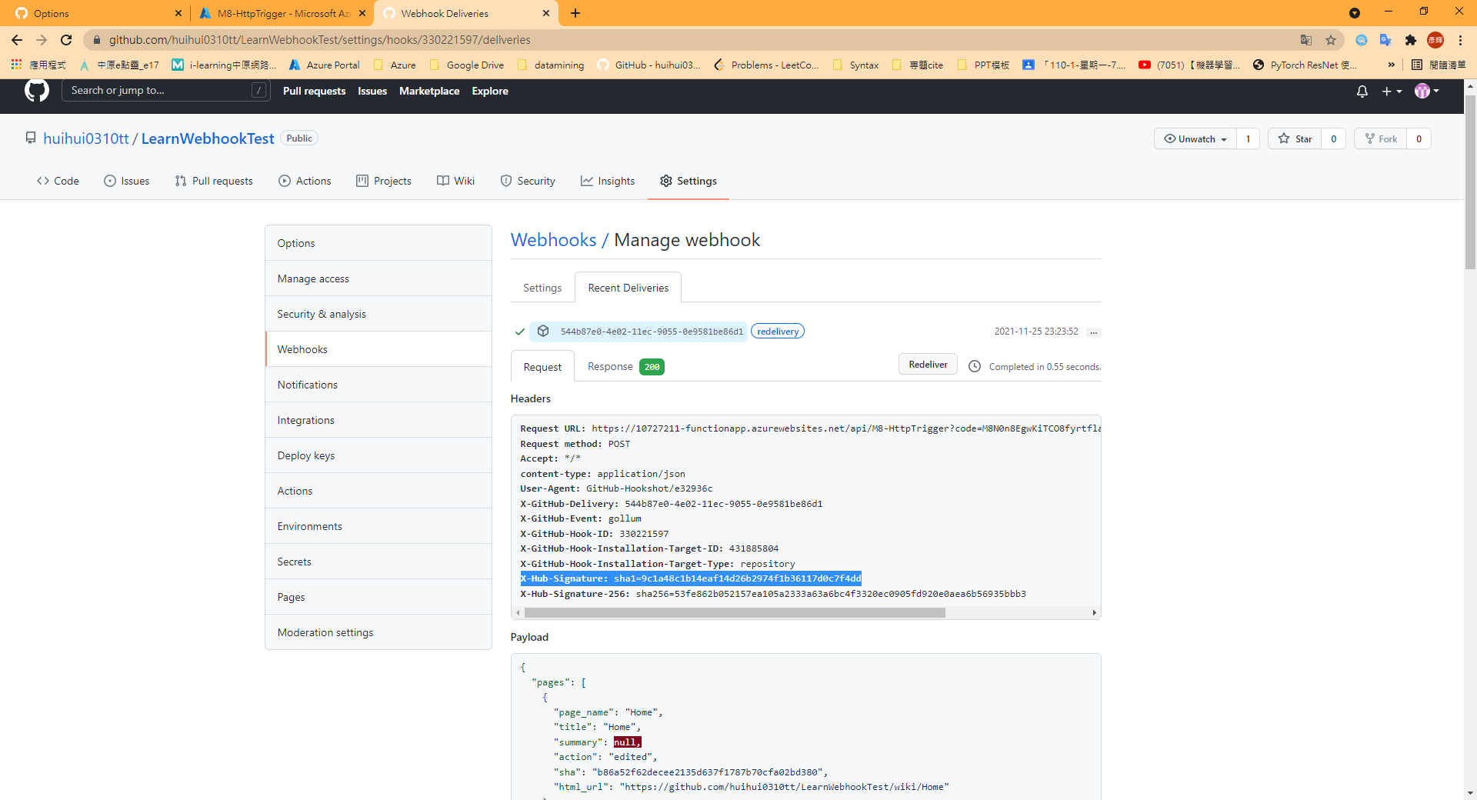

## Model 9: Enable automatic updates in a web application using Azure Functions and SignalR Service

1. Create Resource in Azure

export STORAGE_ACCOUNT_NAME=10727211model9storage

echo "Storage Account Name: $STORAGE_ACCOUNT_NAME"

az storage account create \

--name $STORAGE_ACCOUNT_NAME \

--resource-group 110-1-CS456L \

--kind StorageV2 \

--sku Standard_LRS

az cosmosdb create \

--name 10727211cosmosdb \

--resource-group 110-1-CS456L

1. Download sample app code & switch directory

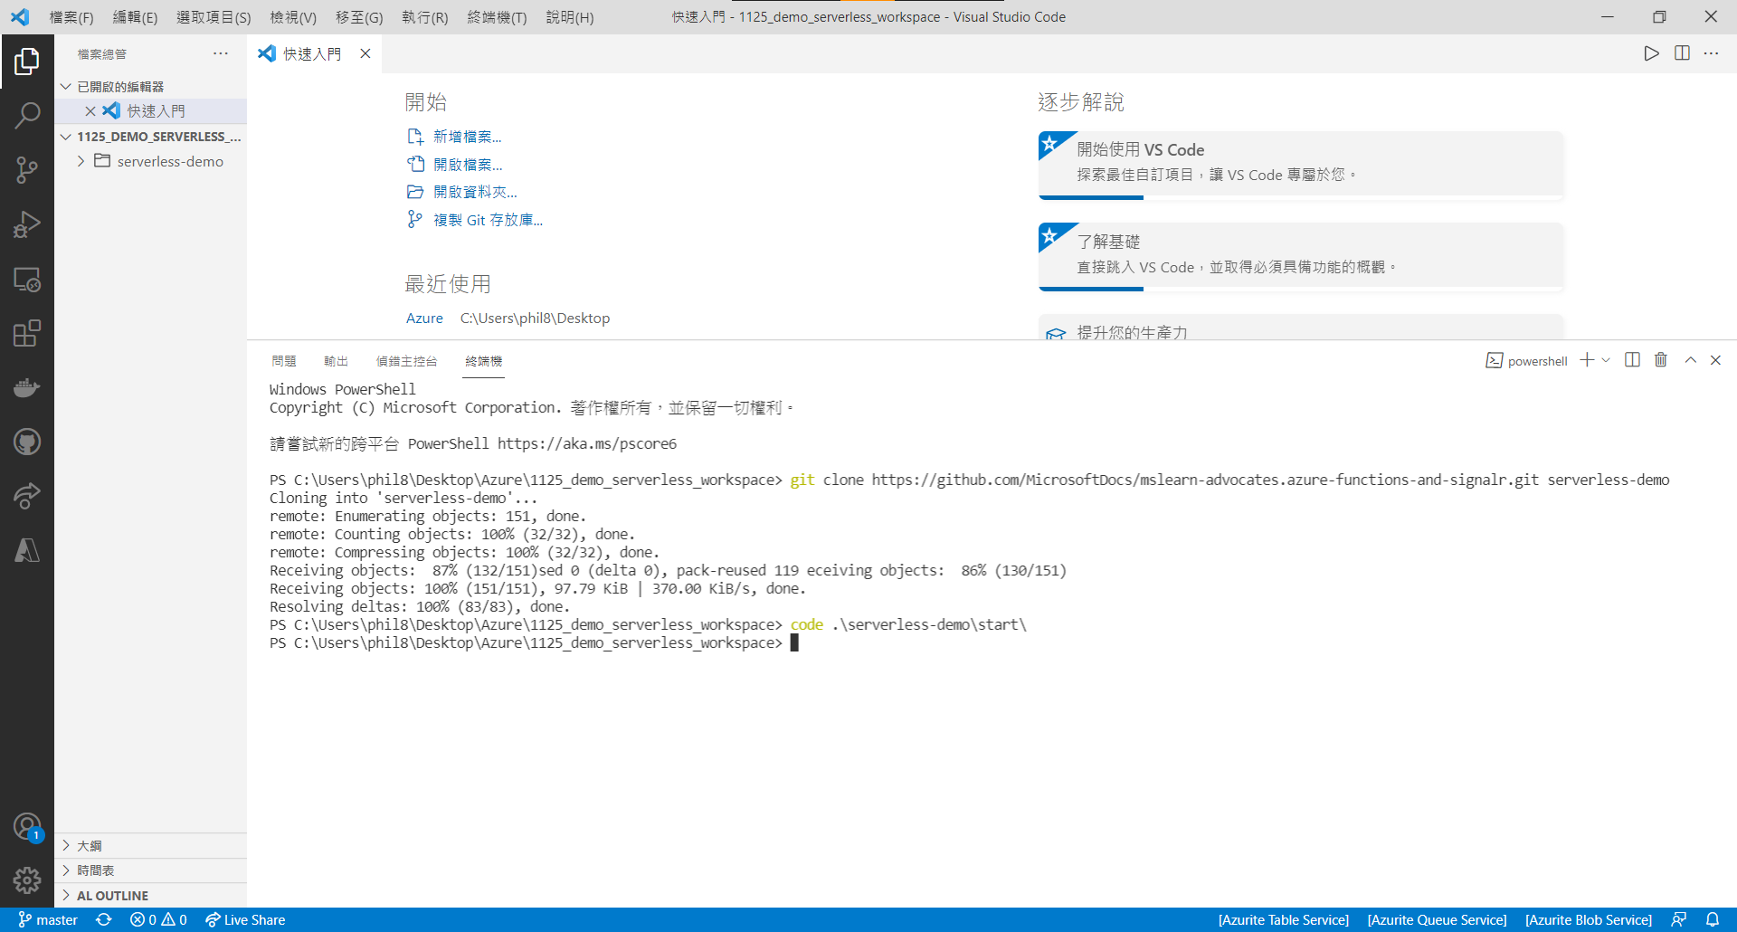

1. Update local settings

STORAGE_CONNECTION_STRING=$(az storage account show-connection-string \

--name $(az storage account list \

--resource-group 110-1-CS456L \

--query [0].name -o tsv) \

--resource-group 110-1-CS456L \

--query "connectionString" -o tsv)

COSMOSDB_ACCOUNT_NAME=$(az cosmosdb list \

--resource-group 110-1-CS456L \

--query [0].name -o tsv)

COSMOSDB_CONNECTION_STRING=$(az cosmosdb list-connection-strings \

--name $COSMOSDB_ACCOUNT_NAME \

--resource-group 110-1-CS456L \

--query "connectionStrings[?description=='Primary SQL Connection String'].connectionString" -o tsv)

COSMOSDB_MASTER_KEY=$(az cosmosdb list-keys \

--name $COSMOSDB_ACCOUNT_NAME \

--resource-group 110-1-CS456L \

--query primaryMasterKey -o tsv)

printf "\n\nReplace <STORAGE_CONNECTION_STRING> with:\n$STORAGE_CONNECTION_STRING\n\nReplace <COSMOSDB_CONNECTION_STRING> with:\n$COSMOSDB_CONNECTION_STRING\n\nReplace <COSMOSDB_MASTER_KEY> with:\n$COSMOSDB_MASTER_KEY\n\n"

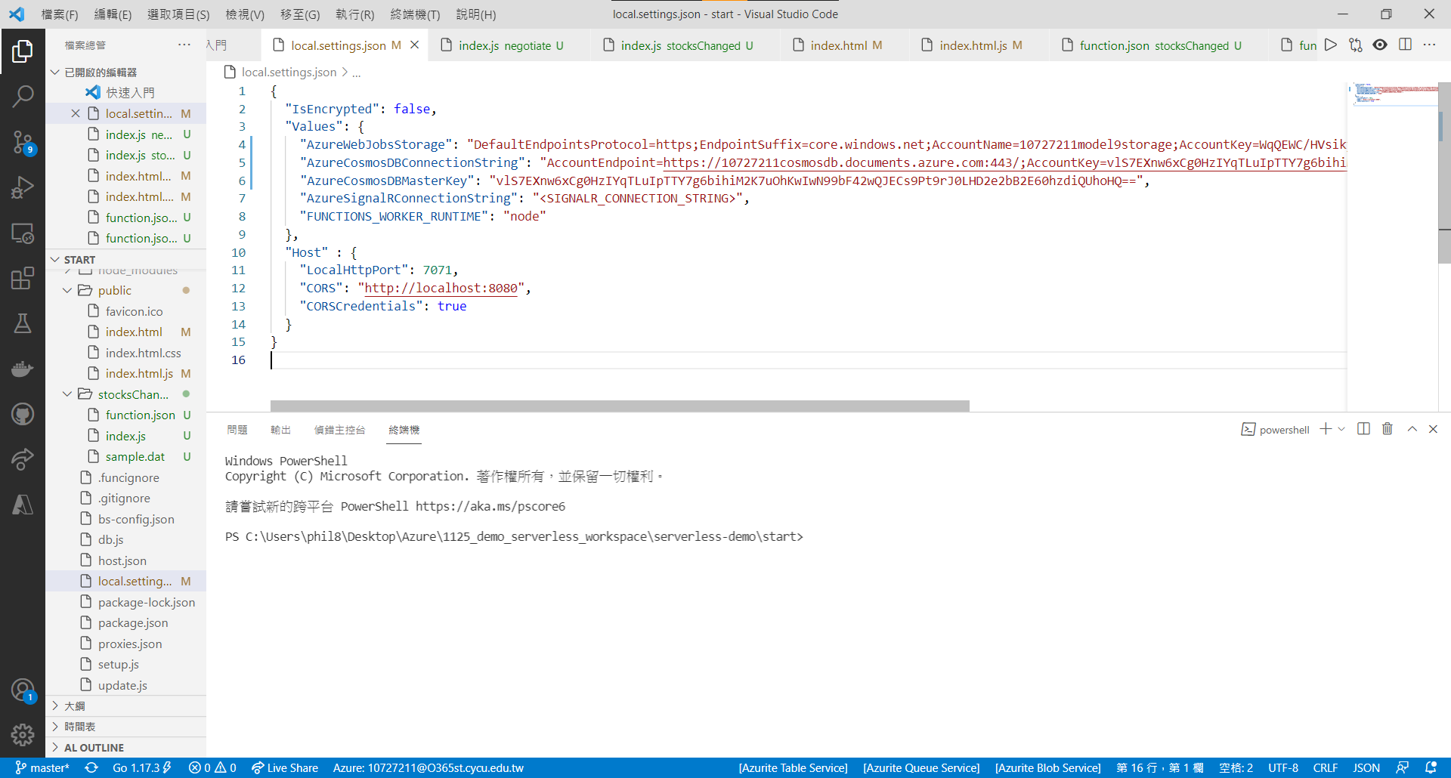

1. Run the application

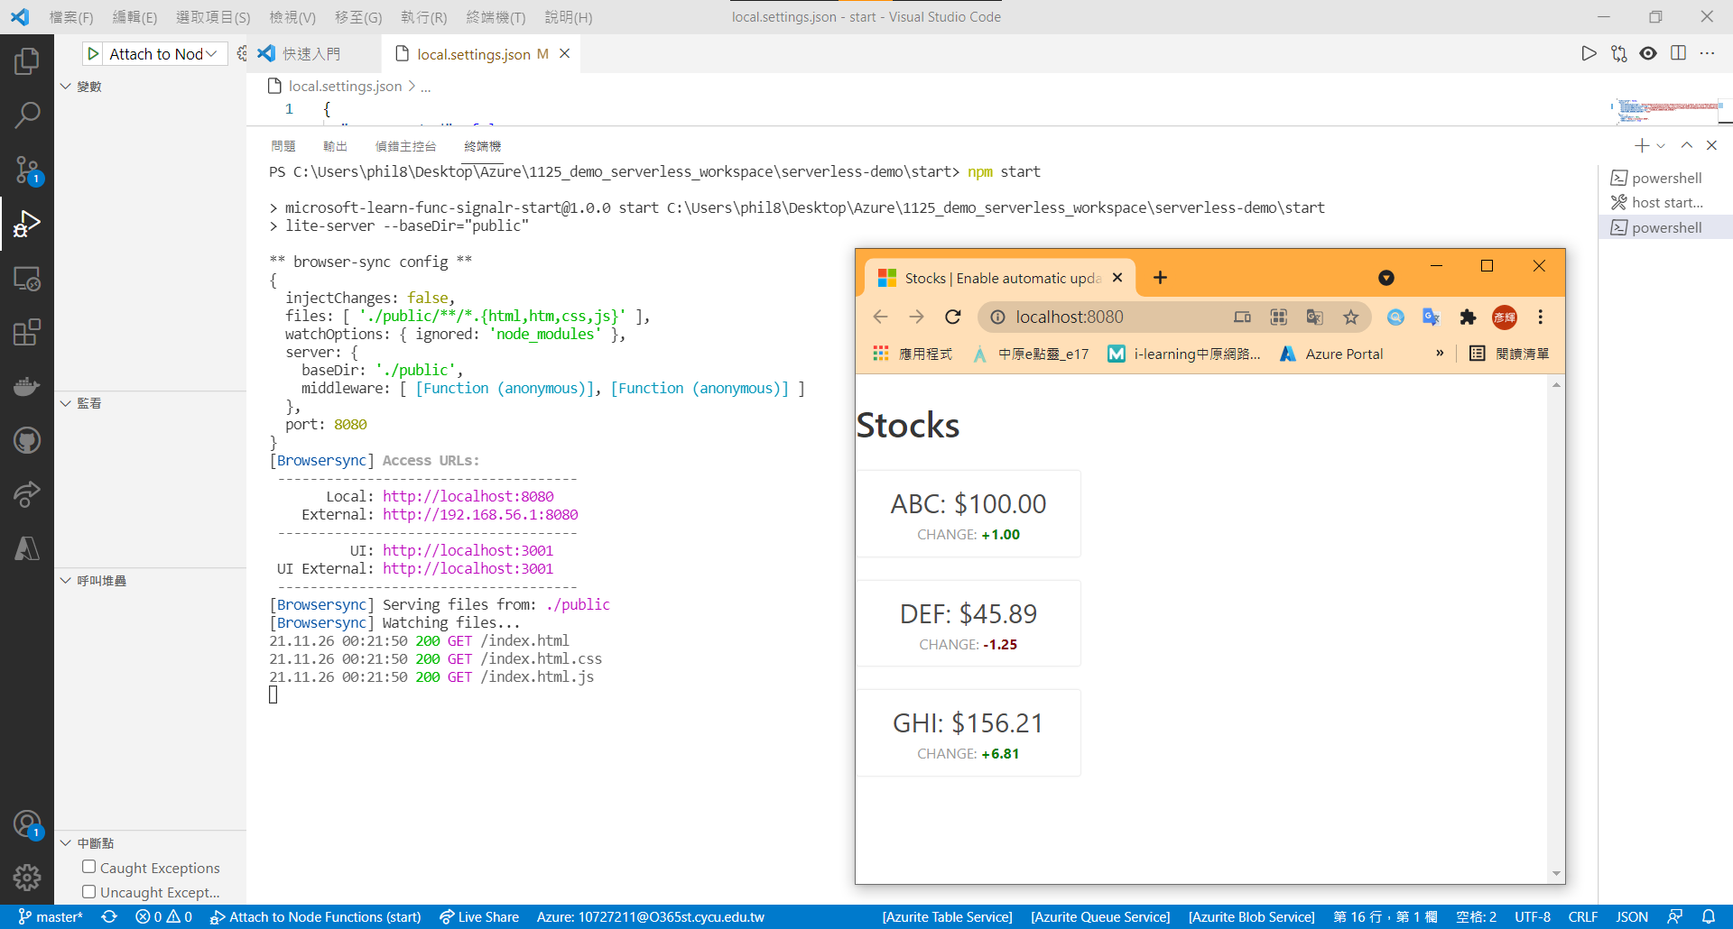

1. Create a SignalR account

SIGNALR_SERVICE_NAME=s10727211signalr

az signalr create \

--name $SIGNALR_SERVICE_NAME \

--resource-group 110-1-CS456L \

--sku Free_DS2 \

--unit-count 1

az resource update \

--resource-type Microsoft.SignalRService/SignalR \

--name $SIGNALR_SERVICE_NAME \

--resource-group 110-1-CS456L \

--set properties.features[flag=ServiceMode].value=Serverless

SIGNALR_CONNECTION_STRING=$(az signalr key list \

--name $(az signalr list \

--resource-group 110-1-CS456L \

--query [0].name -o tsv) \

--resource-group 110-1-CS456L \

--query primaryConnectionString -o tsv)

printf "\n\nReplace <SIGNALR_CONNECTION_STRING> with:\n$SIGNALR_CONNECTION_STRING\n\n"

1. Update local settings

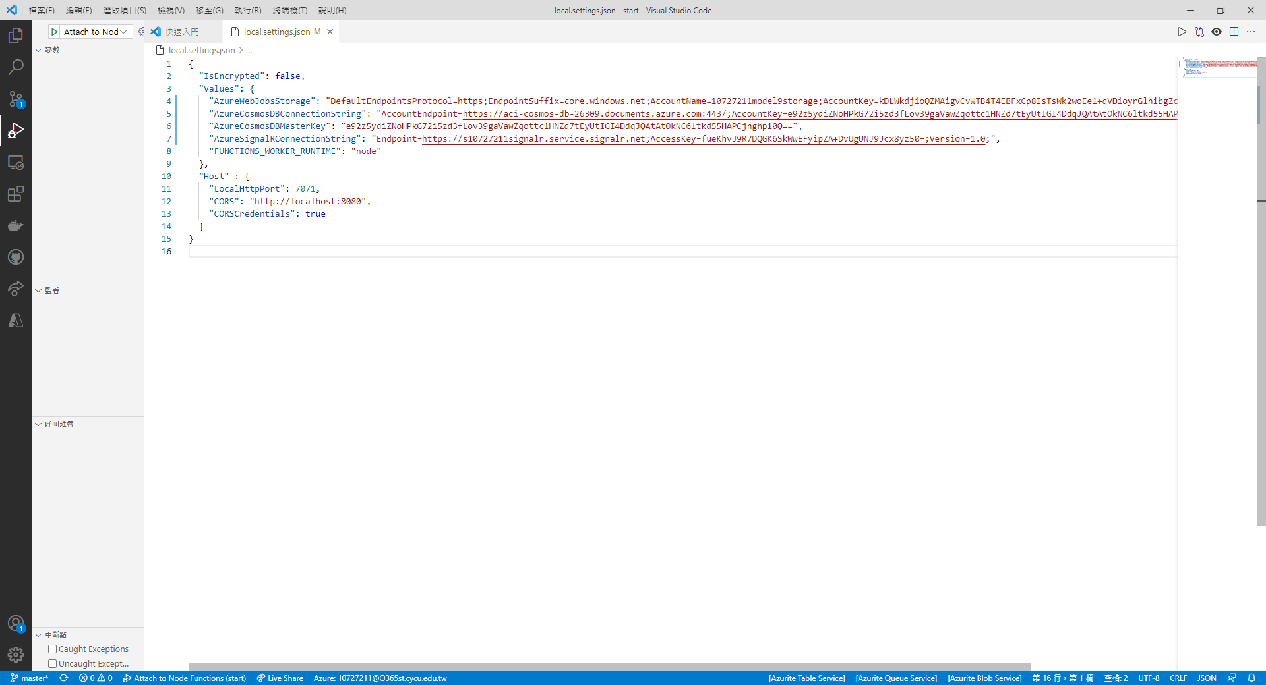

1. Create Azure Functions

|  |  |
| --- | --- |
|  | **Azure Functions: Create Function** |
| Template | HTTP Trigger |
| Name | negotiate |
| Authorization level | Anonymous |

1. Update client connections : negotiate > function.json

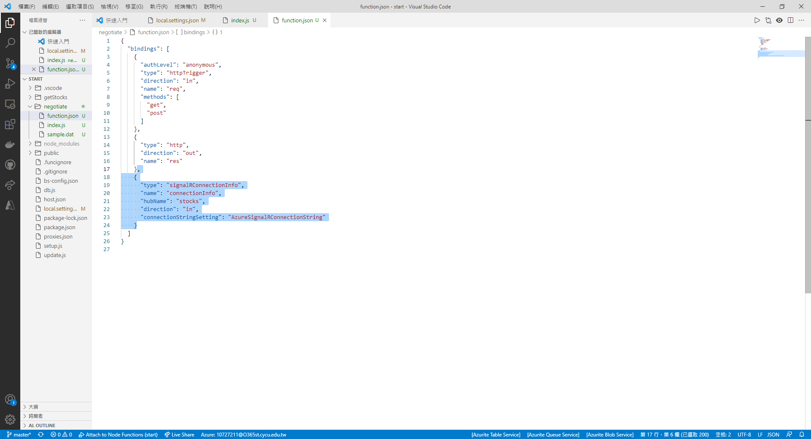

1. Update client connections : negotiate > index.js

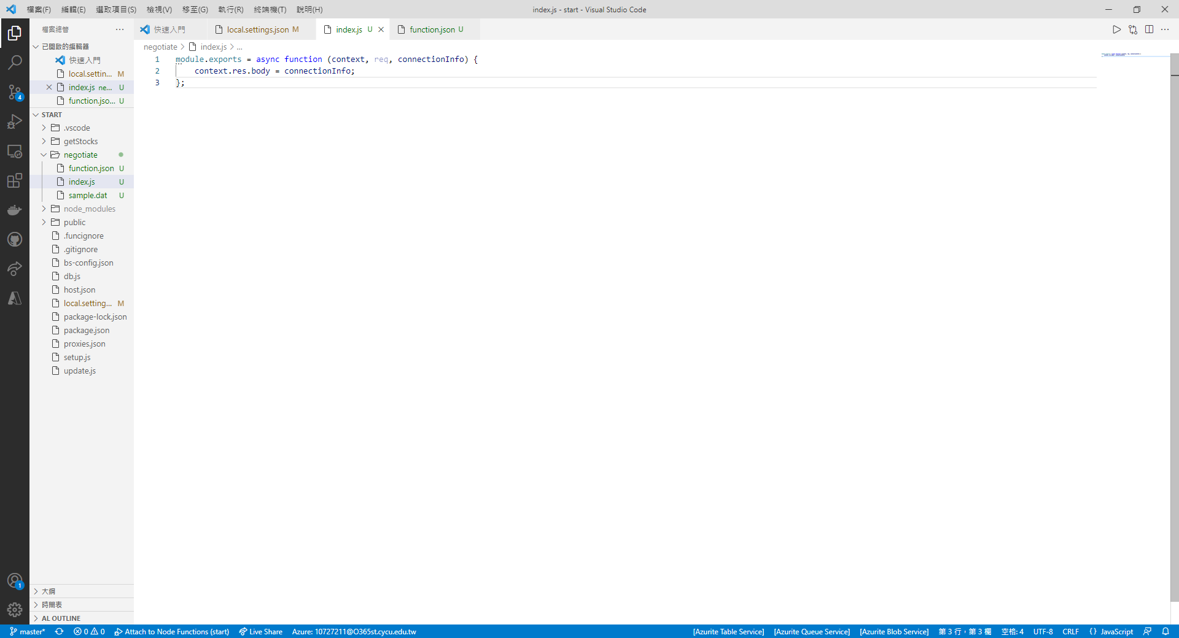

1. Create Azure Functions

|  |  |
| --- | --- |
|  | **Azure Functions: Create Function** |
| Template | Azure Cosmos DB Trigger |
| Name | stocksChanged |
| App setting for your Azure Cosmos DB account | AzureCosmosDBConnectionString |
| Database name | stocksdb |
| Collection name | stocks |
| Collection name for leases | leases |
| Create lease collection if not exists | true |

1. Update Detect and broadcast database changes : stocksChanged > function.json

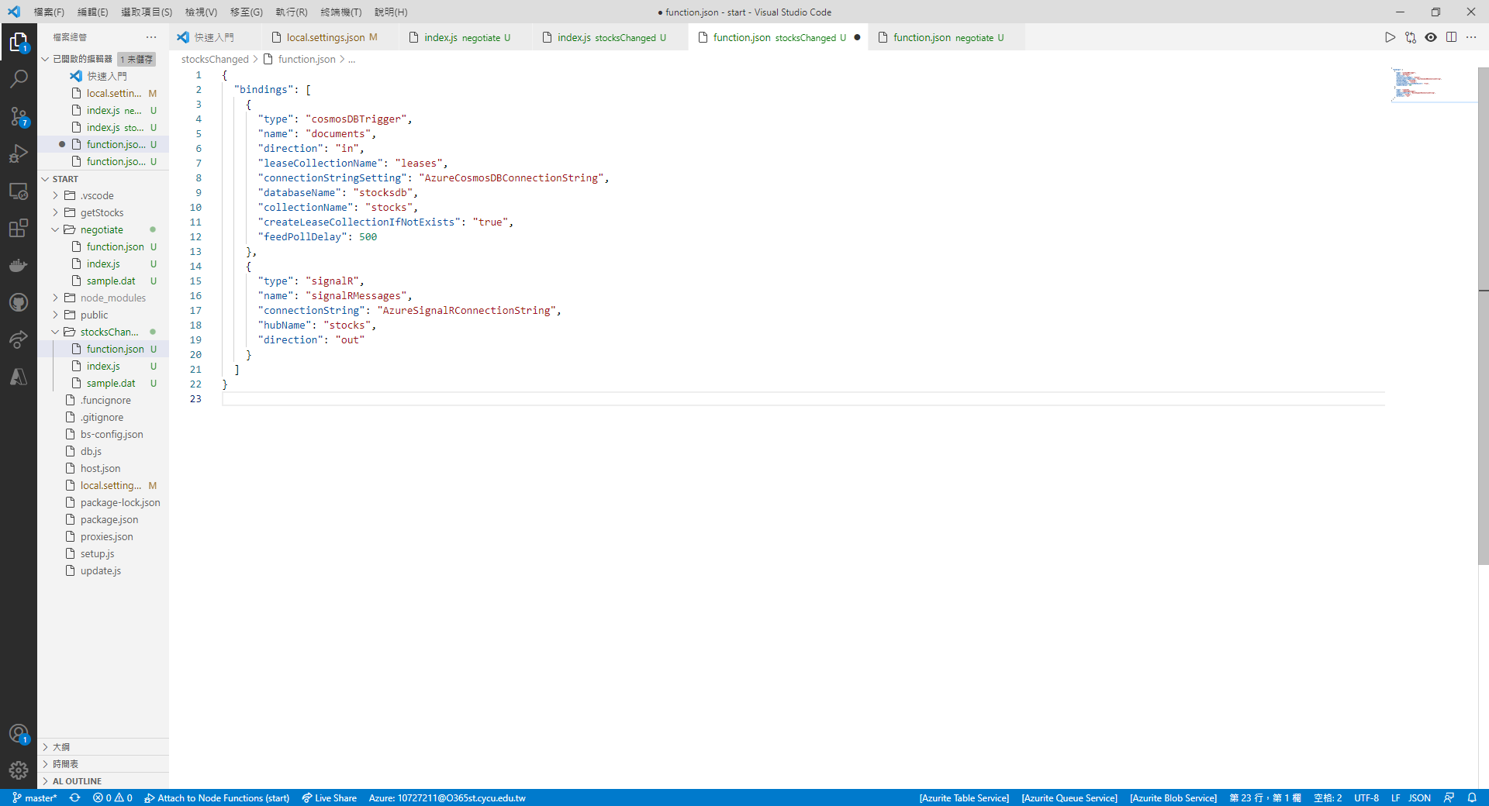

1. Update Detect and broadcast database changes : stocksChanged > index.js

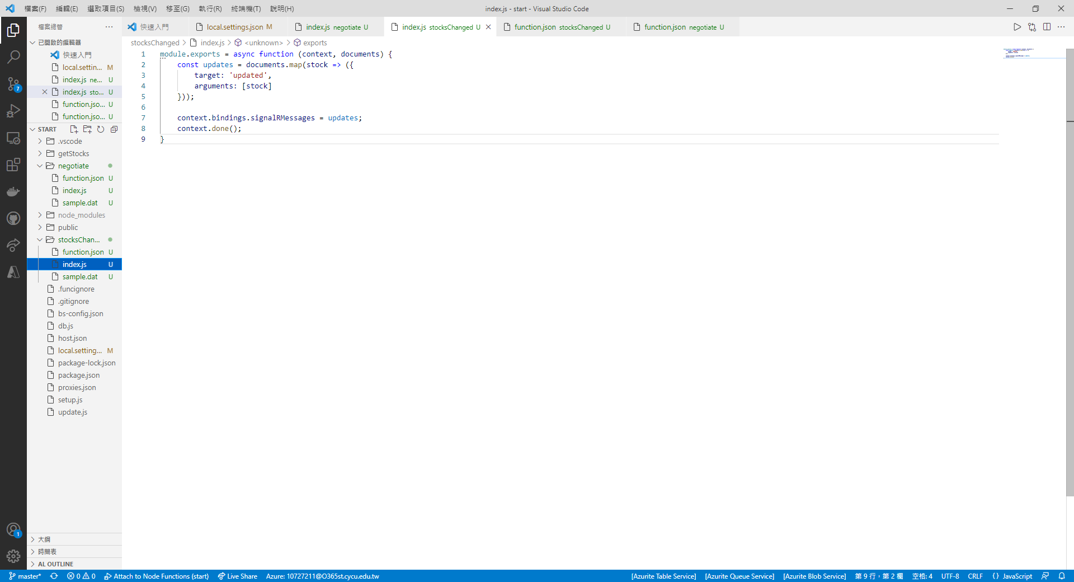

1. Update the web application : public > index.html

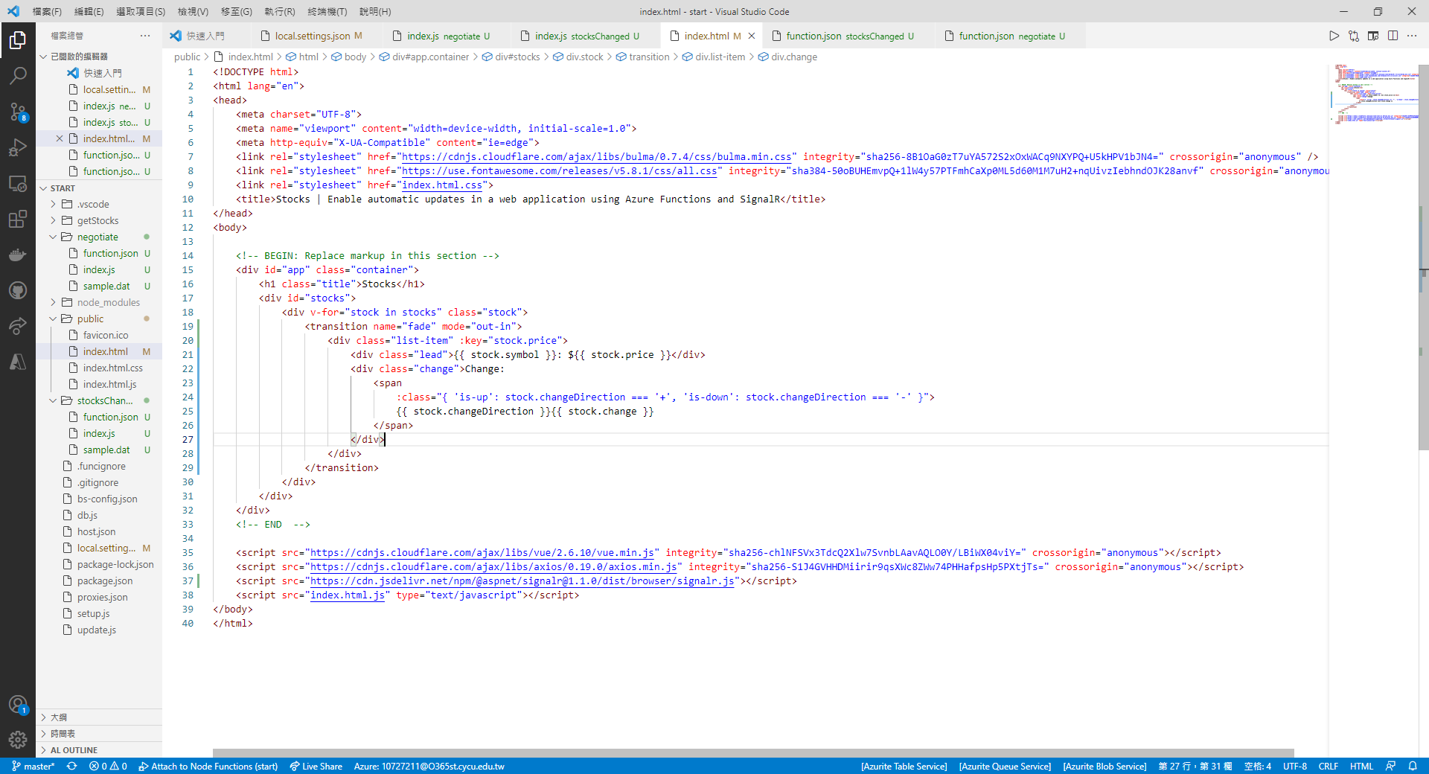

1. Update the web application : public > index.html.js

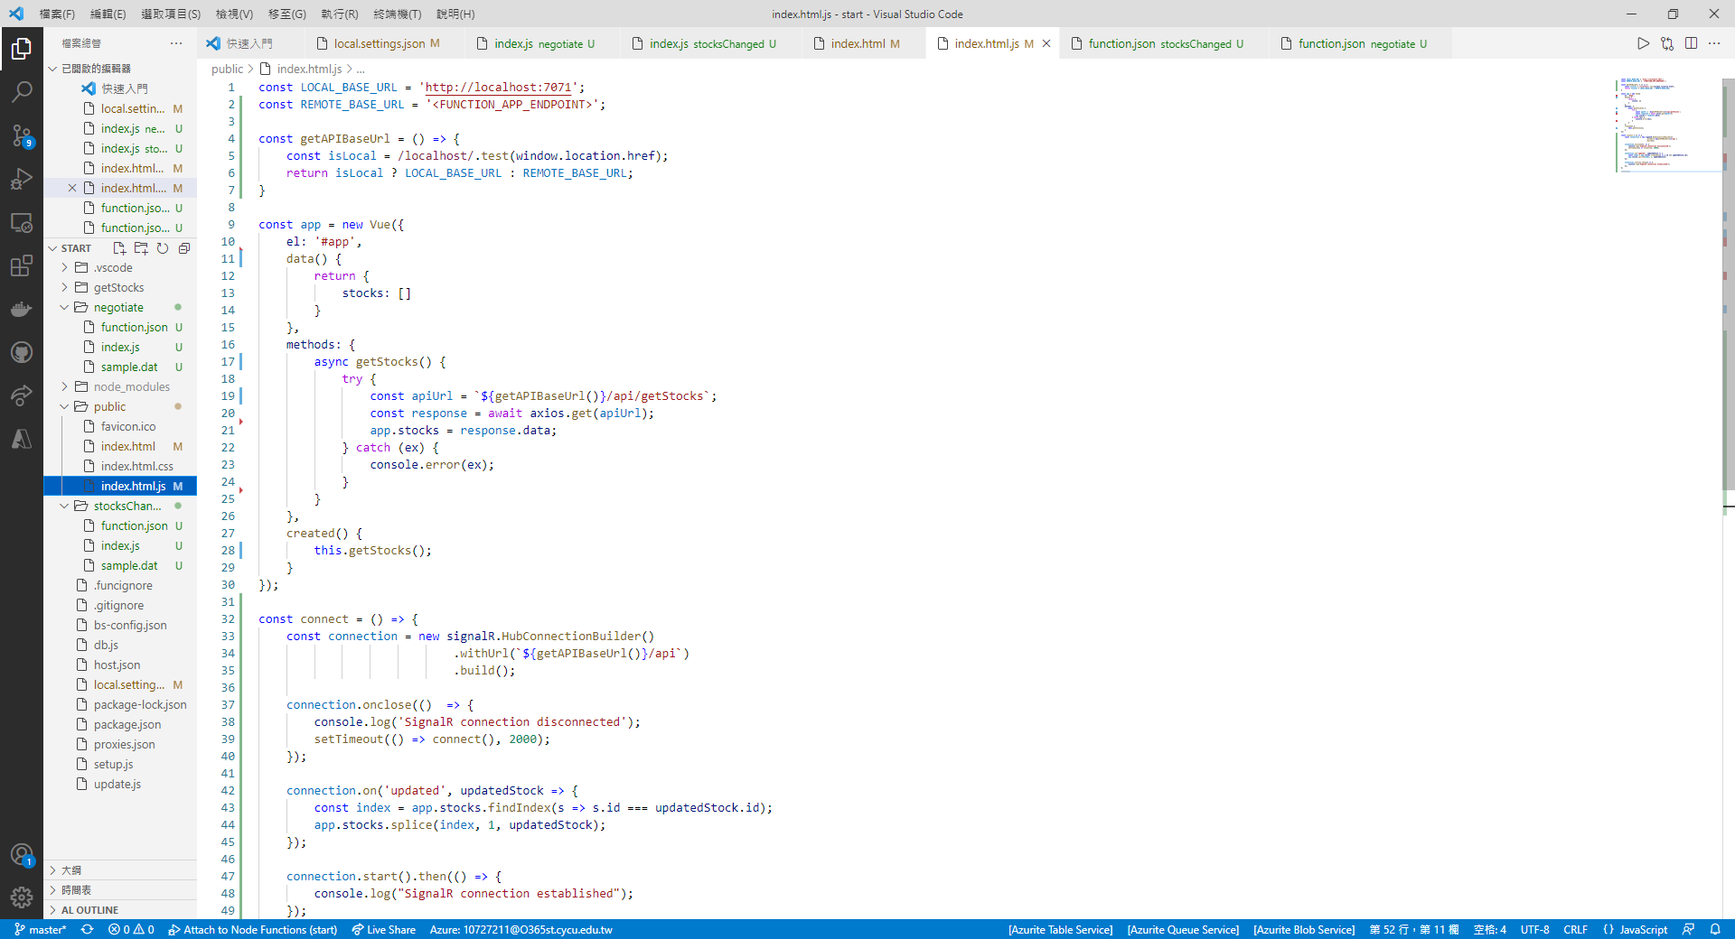

1. Run the application

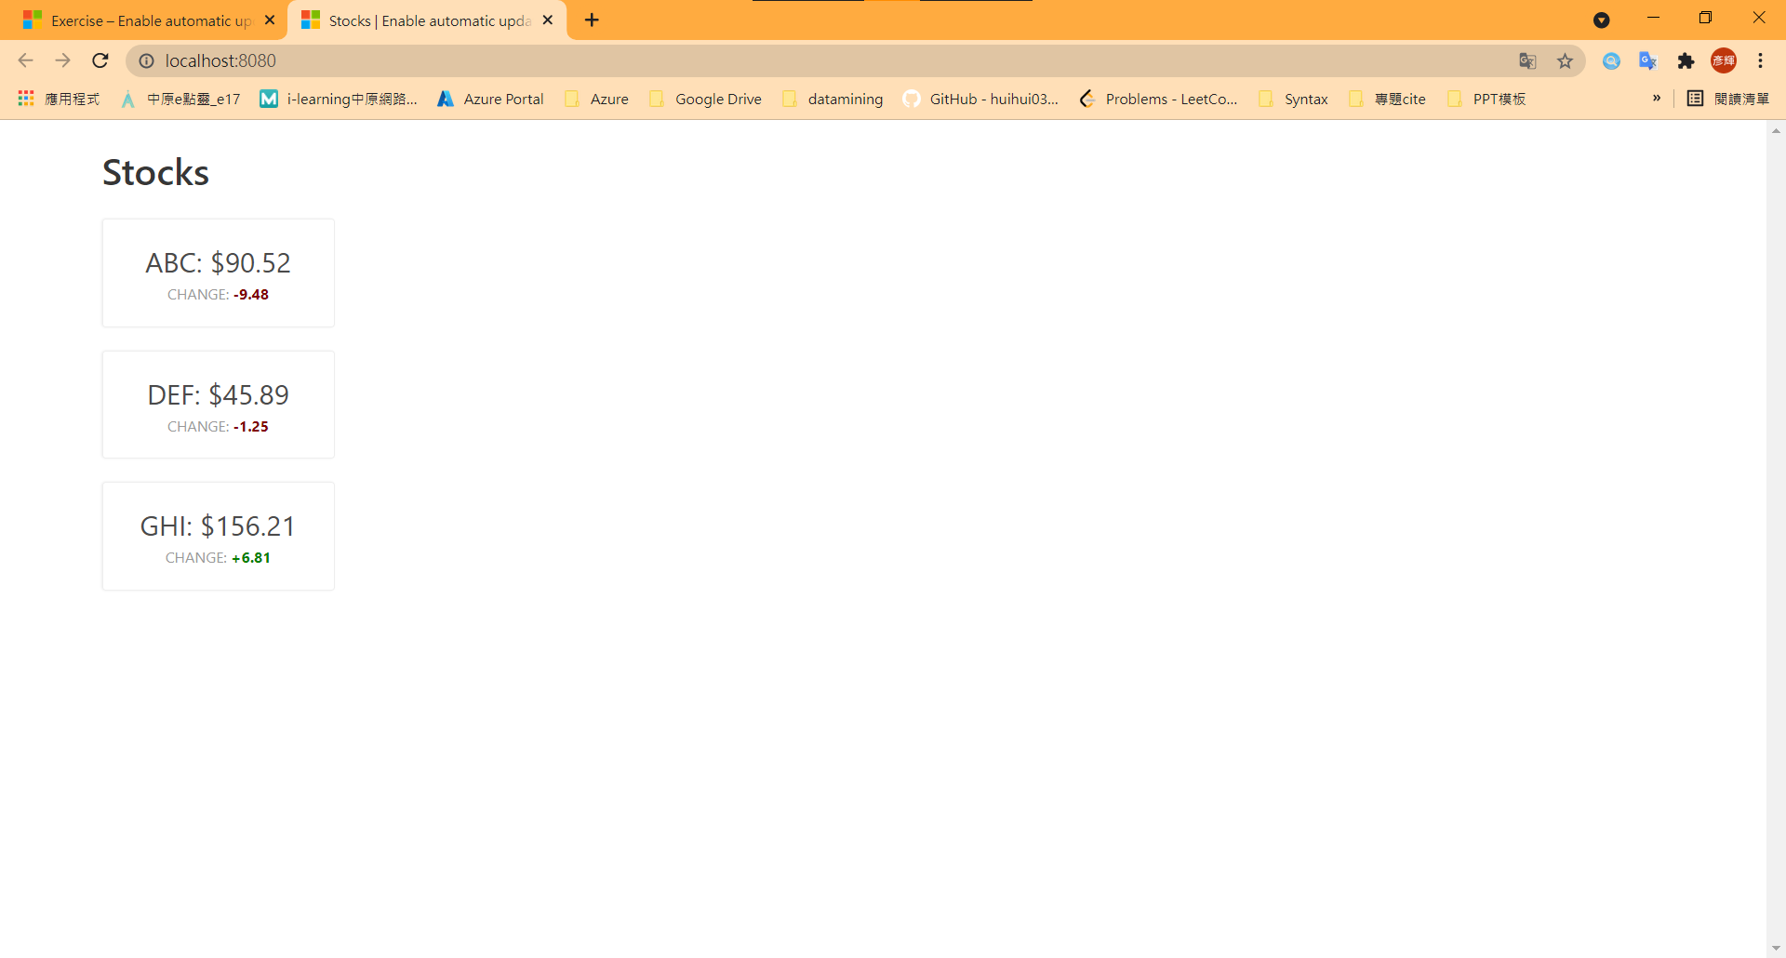 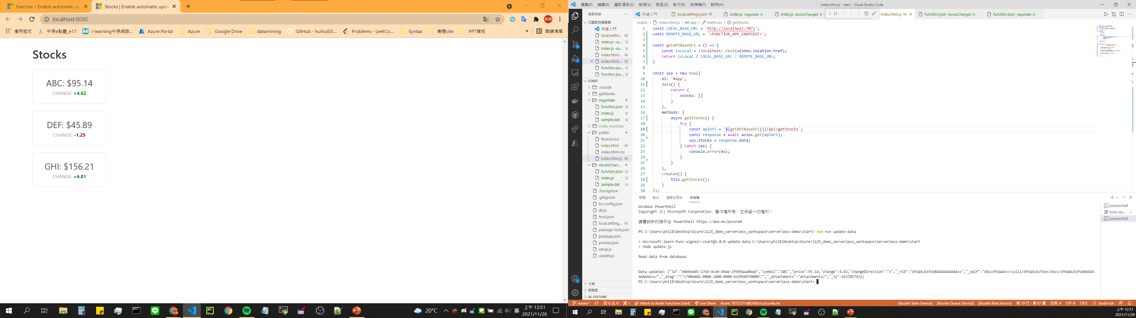

npm run update-data

1. Create Azure Functions

|  |  |
| --- | --- |
|  | **Azure Functions: Deploy to Function App** |
| Template | Create new Function App in Azure... Advanced |
| Name | 10727211-deployfunctionapp |
| Running Stack | Node.js 8 LTS |
| Resource Group | 110-1-CS456L |
| Location for new resource | 東南亞 (for CS456L) |
| Hosting Plan | Consumption |
| storage | 10727211model9storage |
| Application Insights resource | Skip for now |

1. Update the function URL

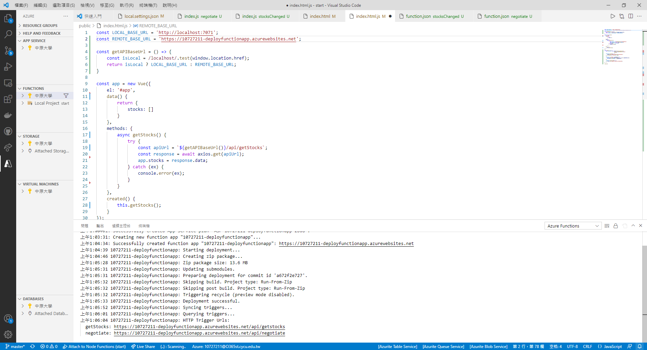

1. Upload Function Settings

|  |  |
| --- | --- |
|  | **Azure Functions: Upload local settings** |
| Function App in Azure | 10727211-deployfunctionapp |

1. Configure static websites in Azure Storage

|  |  |
| --- | --- |
|  | **Azure Storage: Configure Static Website** |
| Storage account | 10727211model9storage |
| Default file | Index.html |
| Error document | Index.html |

1. Deploy the web application to Azure Storage

|  |  |
| --- | --- |
|  | **Azure Storage: Deploy to static website via Azure Storage** |
| Storage account | 10727211model9storage |
| Select the folder to deploy | Select **browse** and choose the *public* subfolder containing the web app. |

1. Set up CORS in the function app

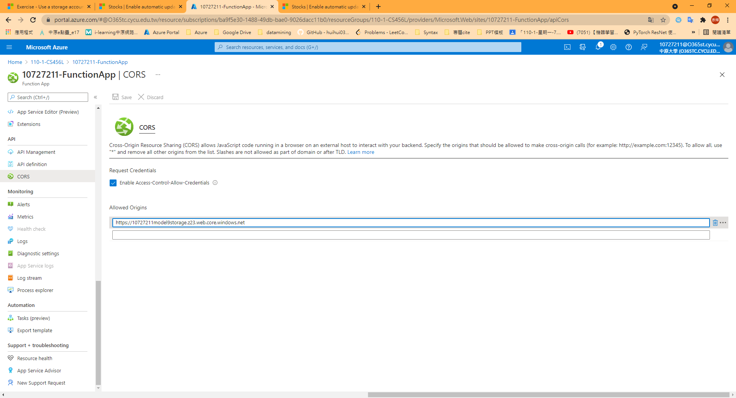

7. Run the deployed application

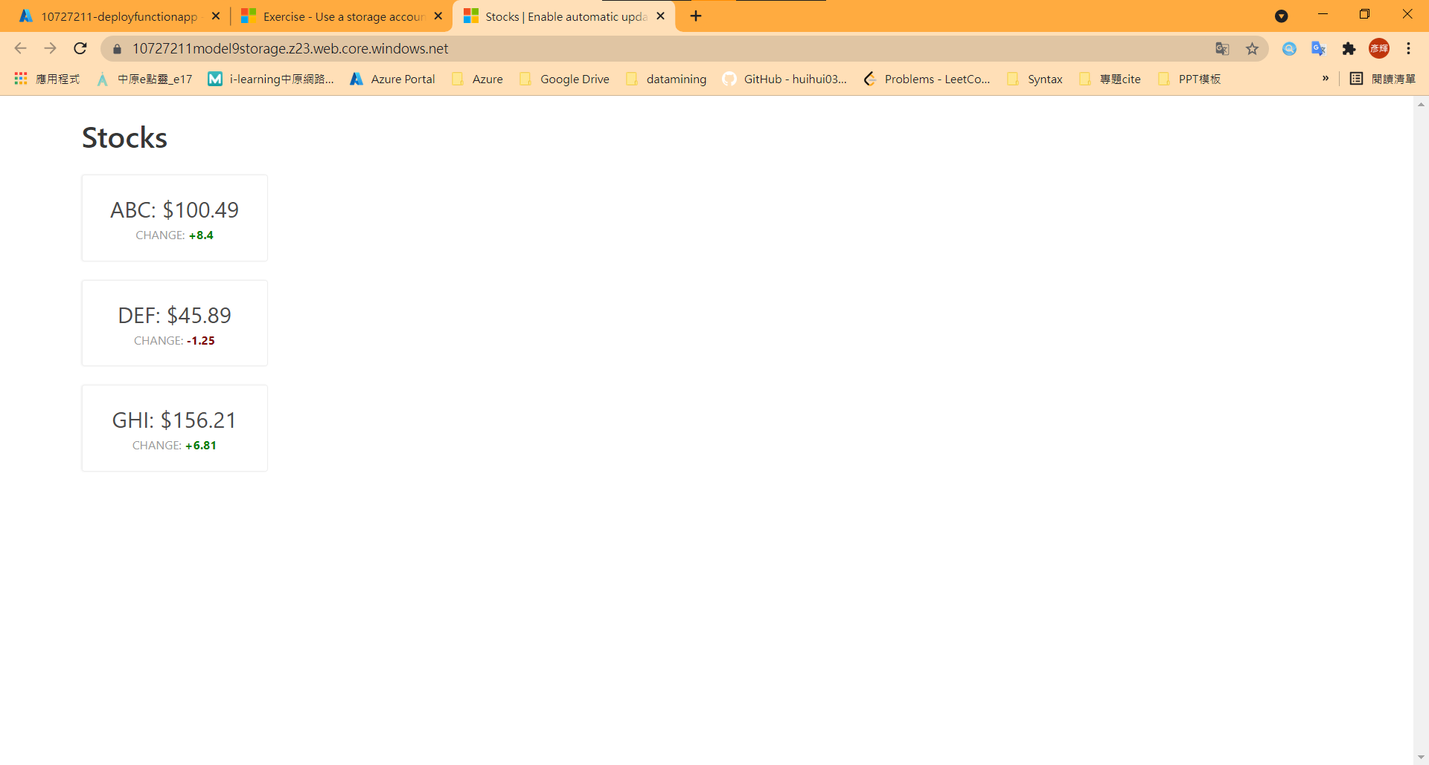

## Model 10: Expose multiple Azure Function apps as a consistent API by using Azure API Management

1. Create functions

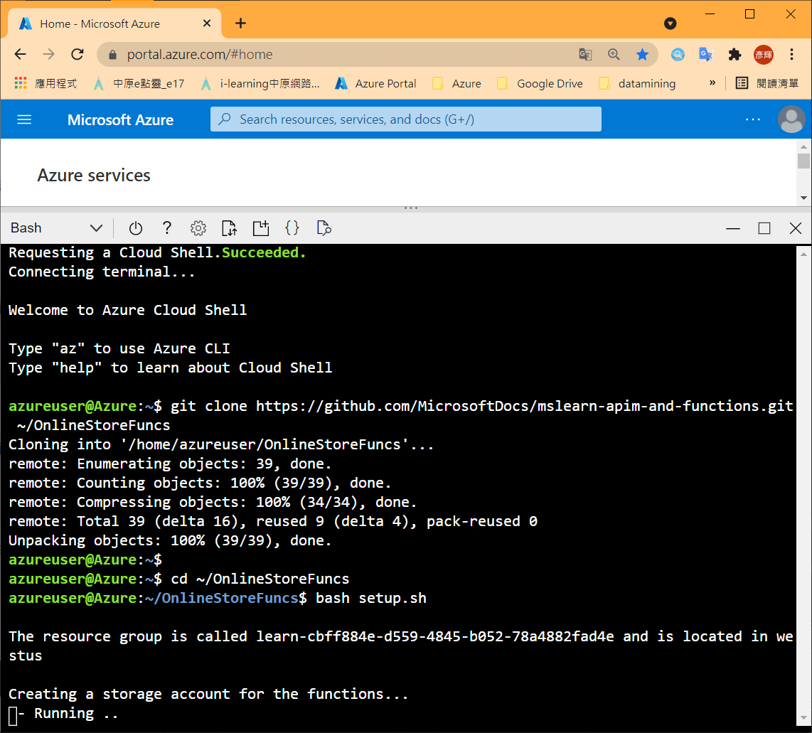

1. Test ProductDetails function

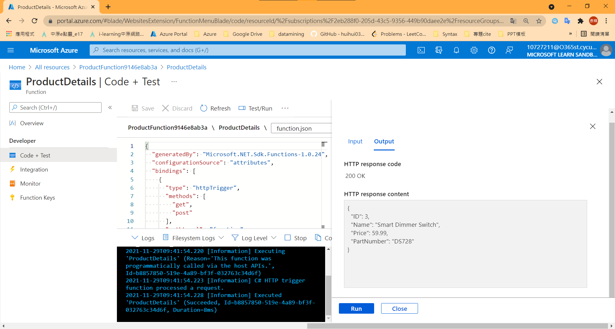

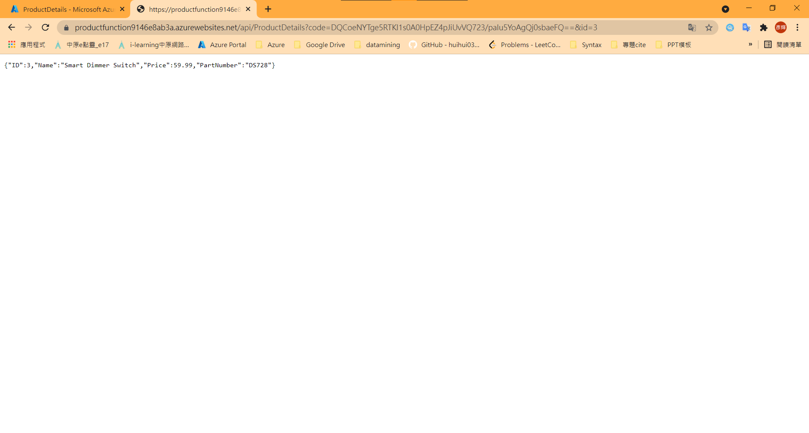

1. Expose function app as an API using Azure API Management

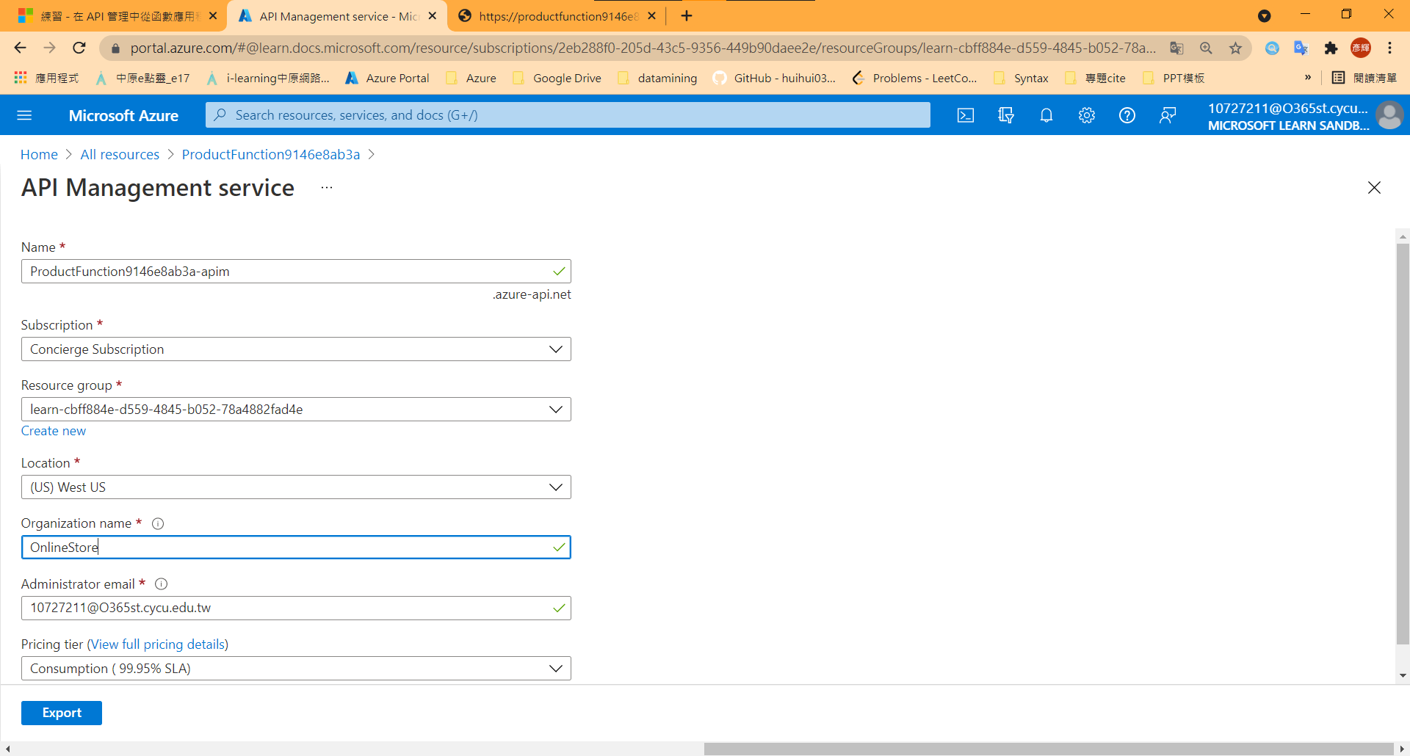 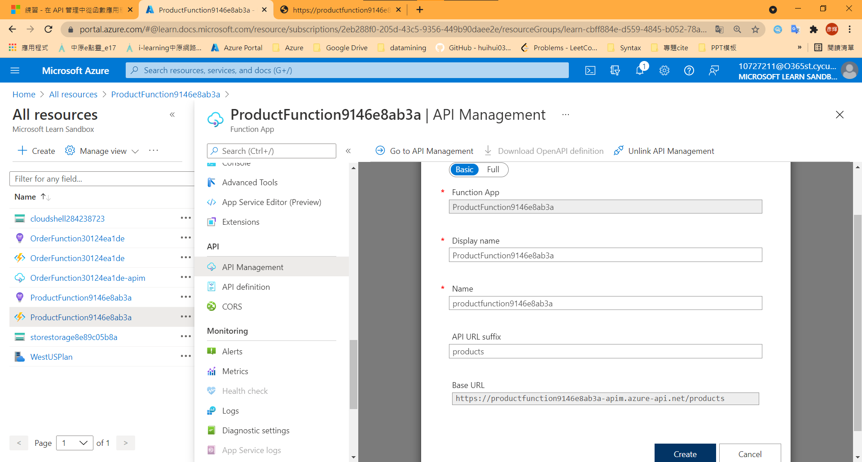

1. Test the OnlineStore products endpoint

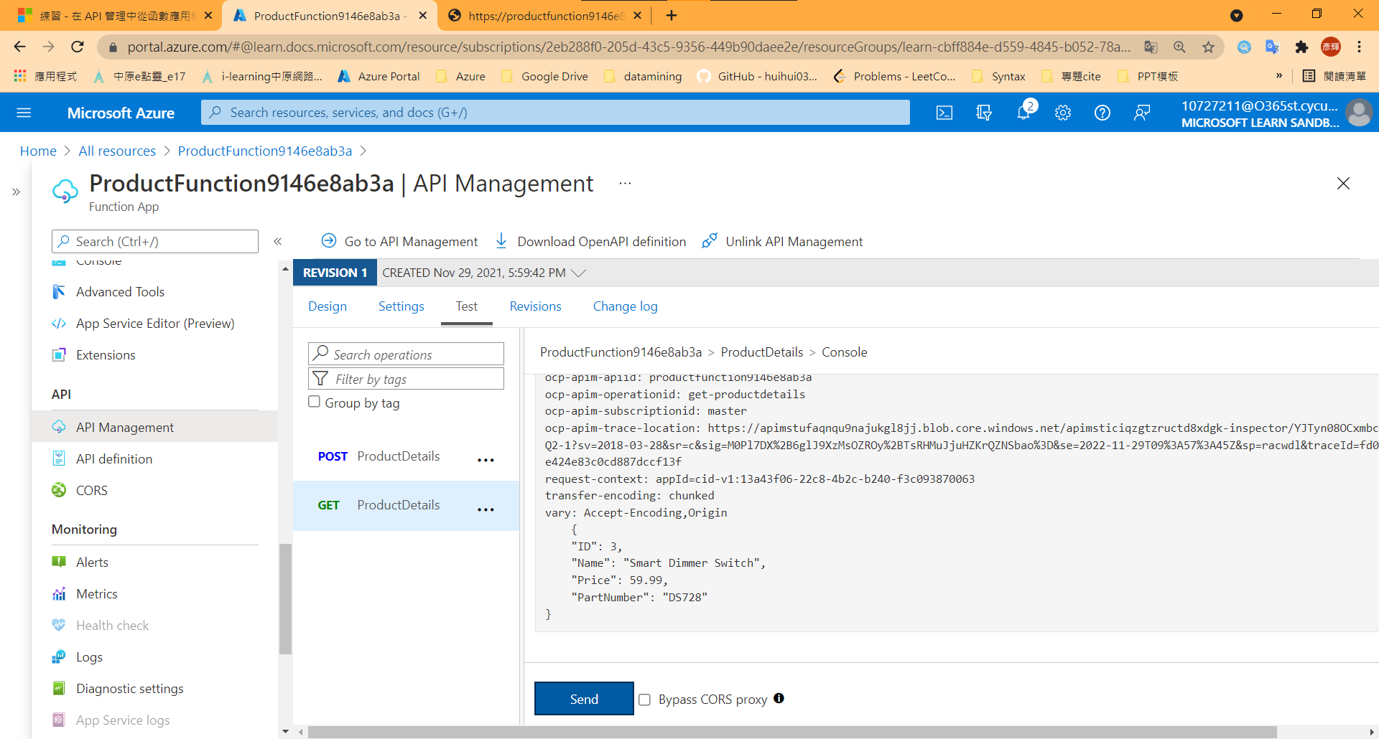

1. Test the OrderDetails function

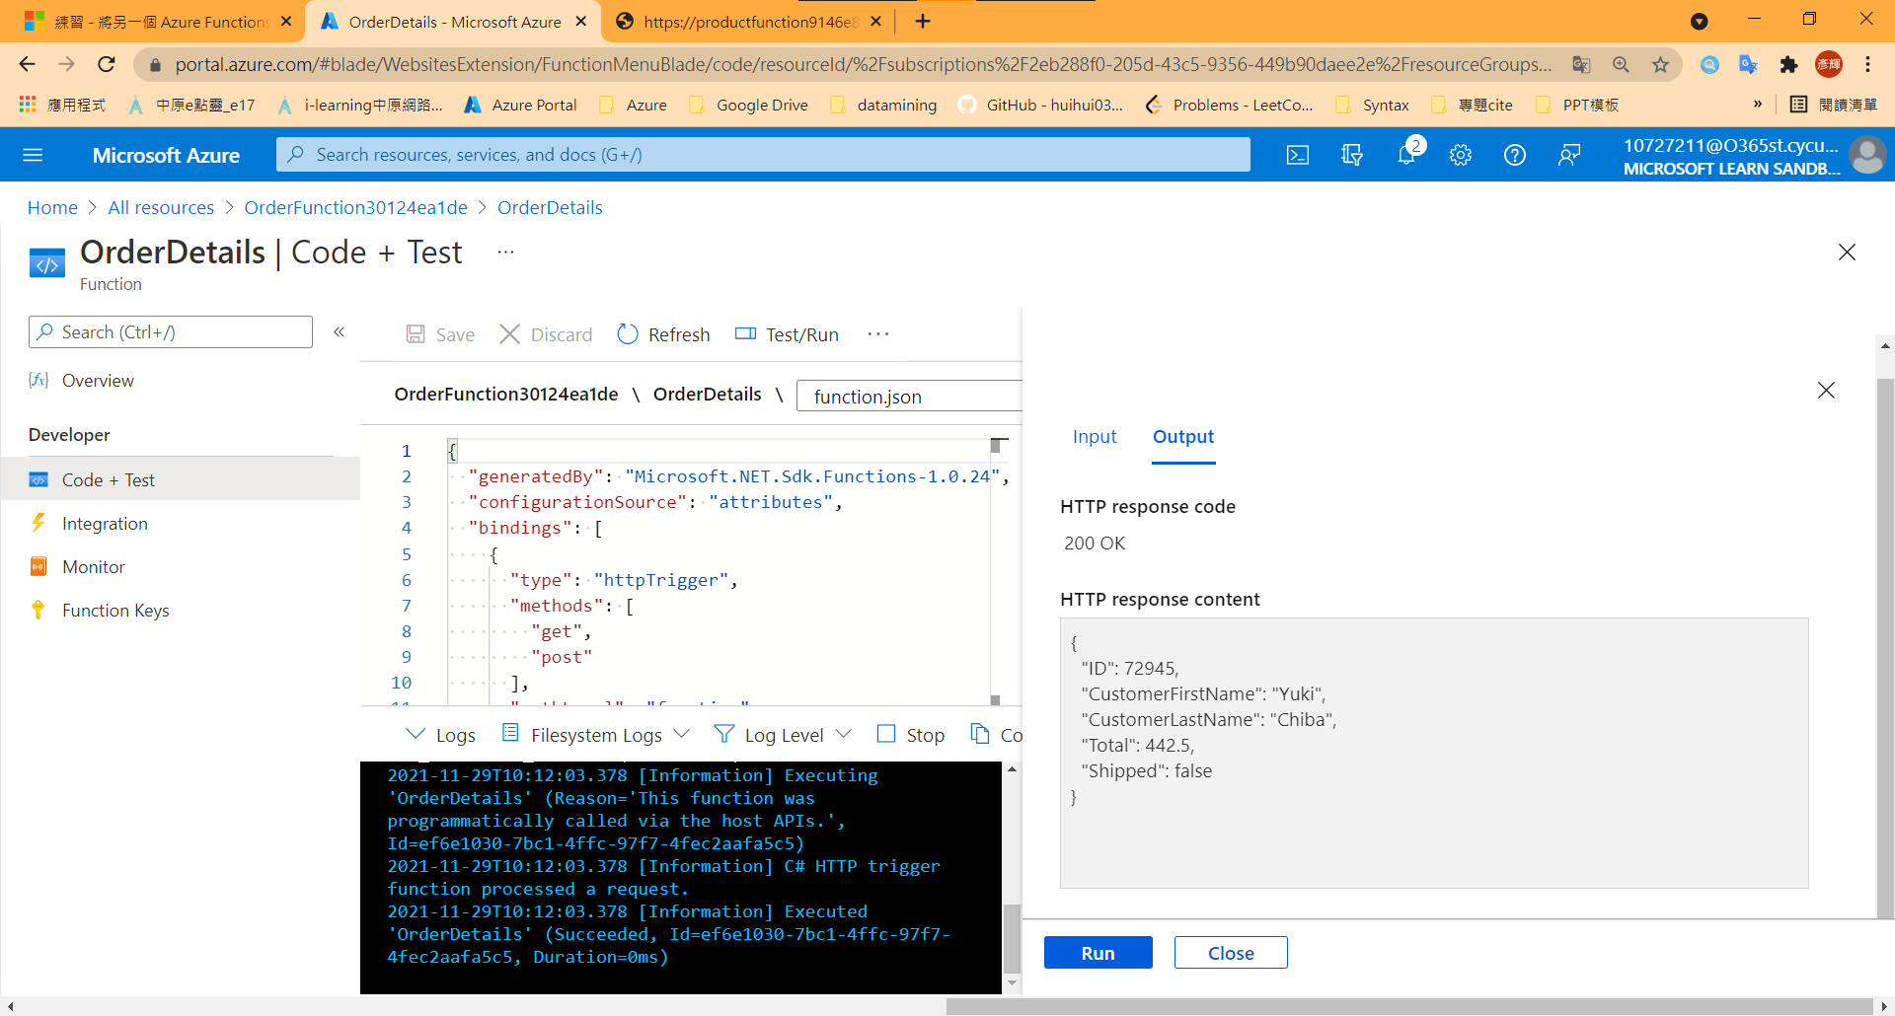

1. Add a function to an existing API

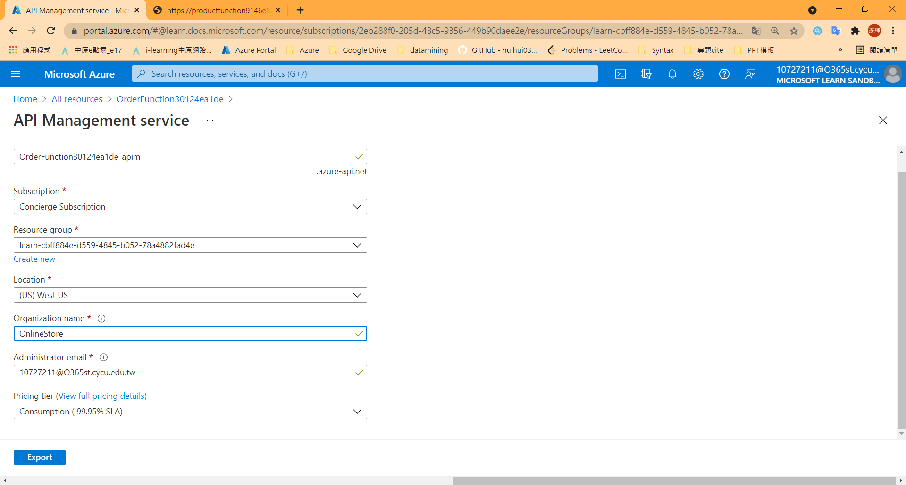

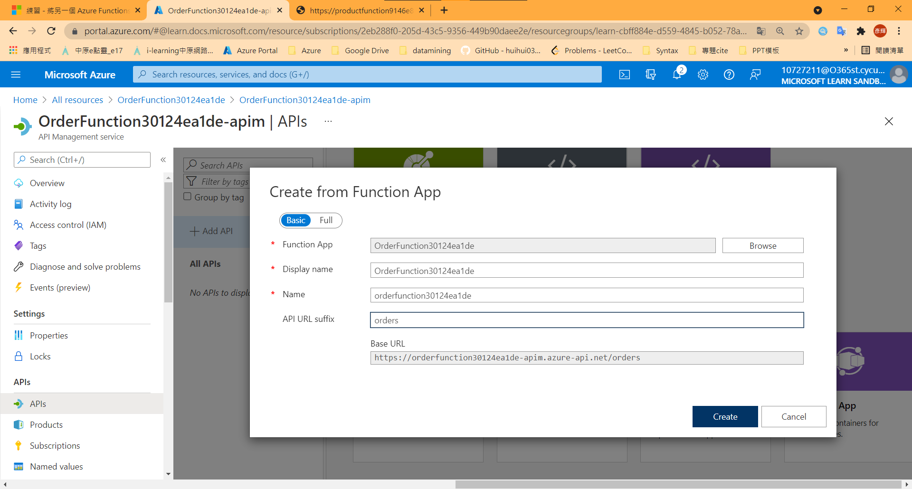

1. Test the OnlineStore orders endpoint in the portal

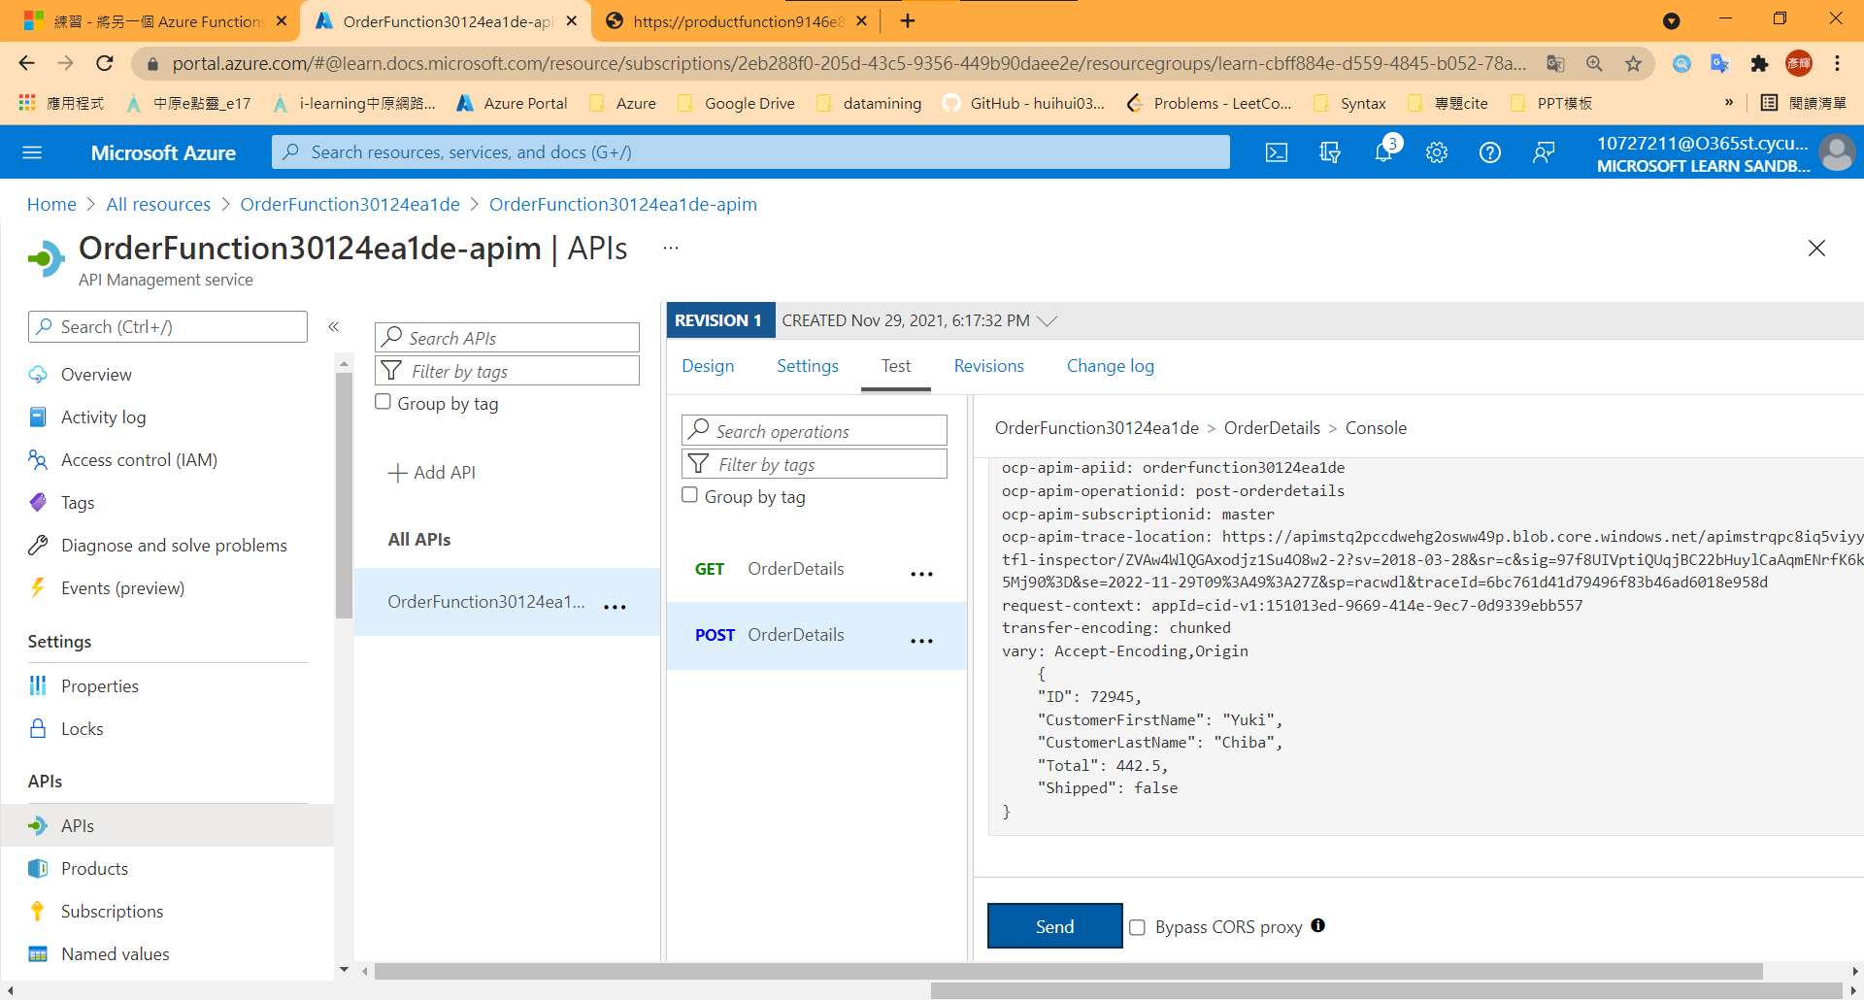

1. Test the combined API

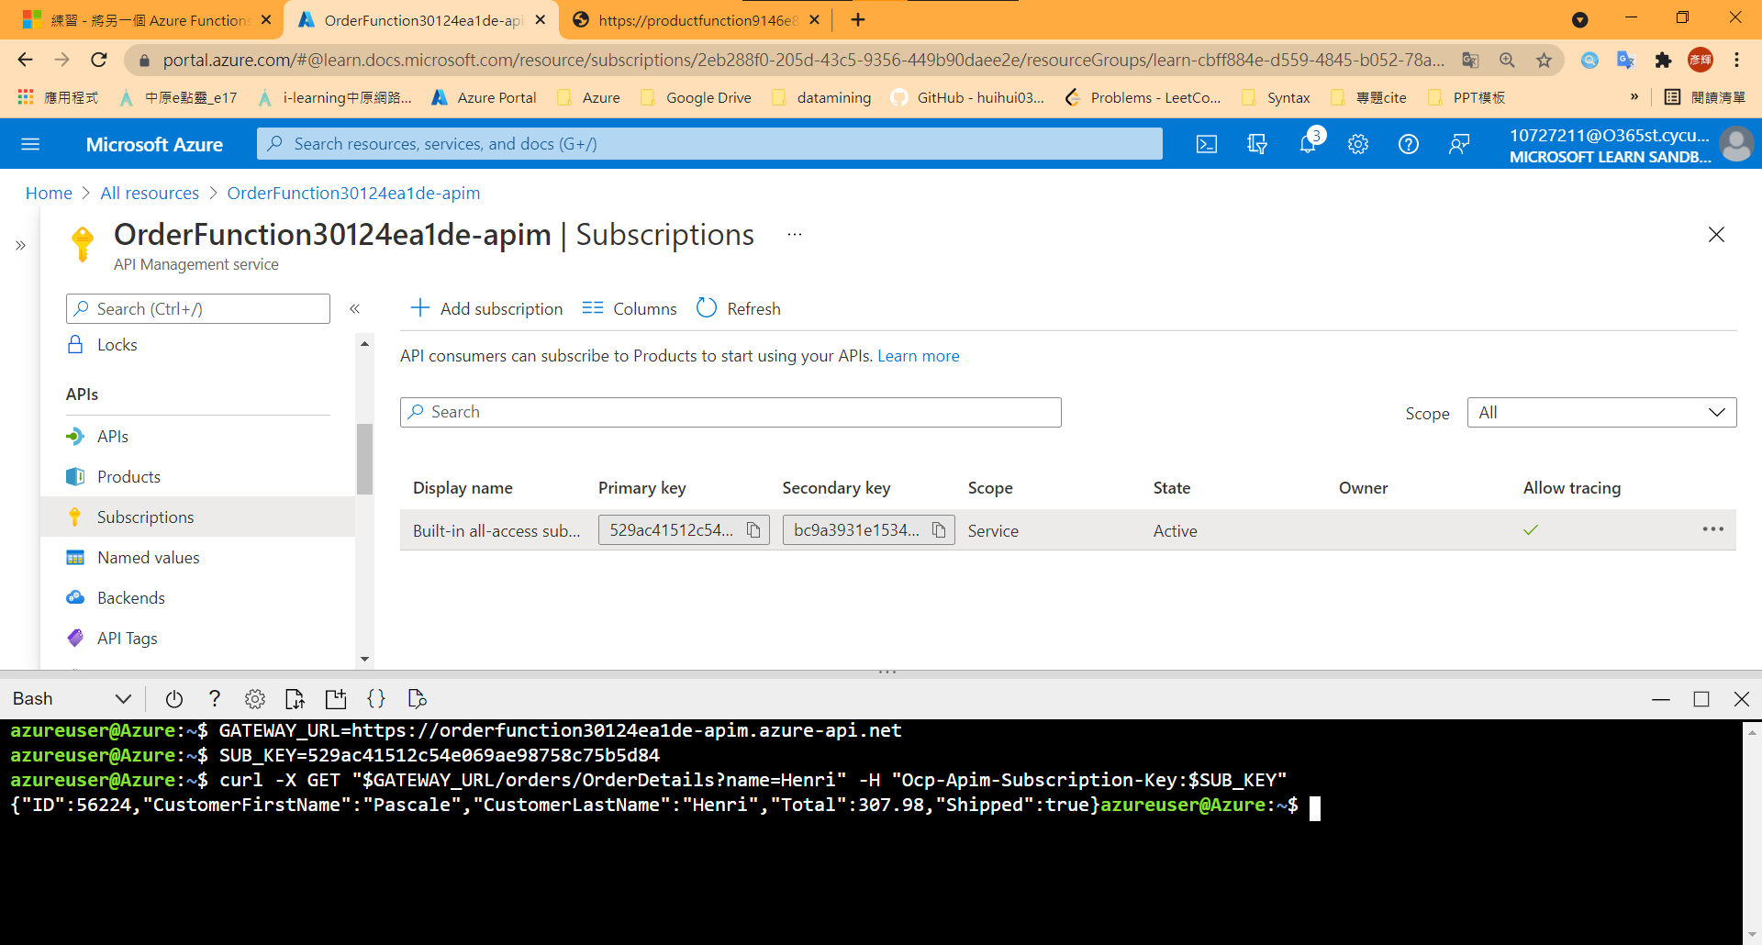

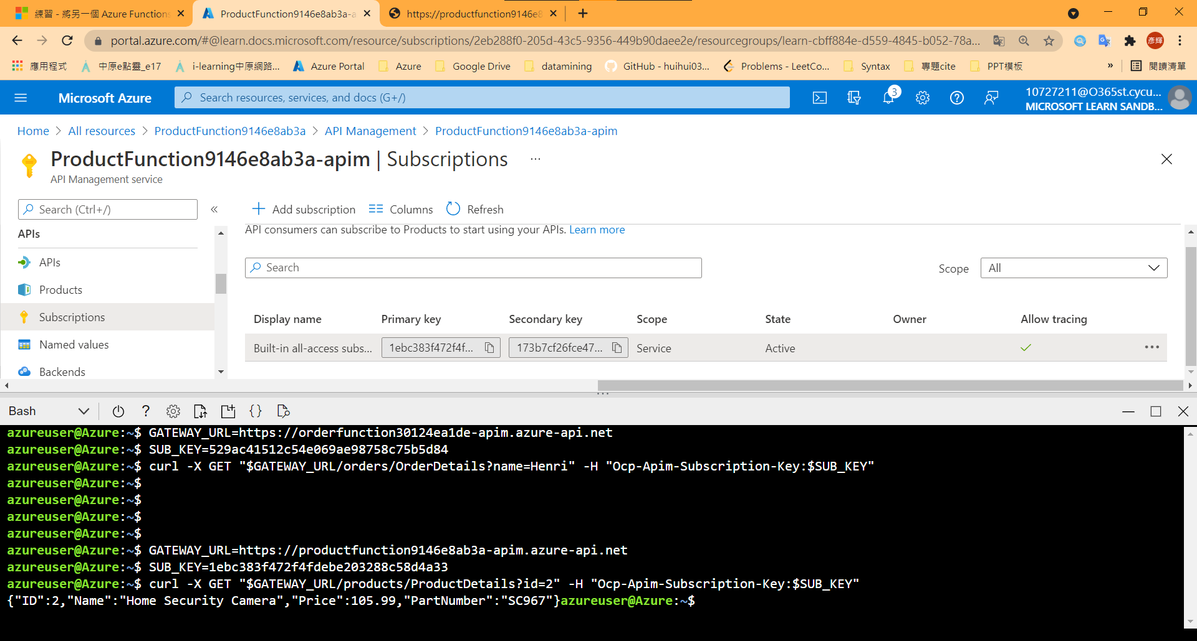

## Model 11: Build serverless apps with Go

1. Create a function app

|  |  |
| --- | --- |
|  | **Azure Functions: Create New Project** |
| function project workspace | {Part1} |
| Select a language | Custom Handler |
| Select a template for your first function | HttpTrigger |
| Provide a function name | hello |
| 授權等級 | Anonymous |

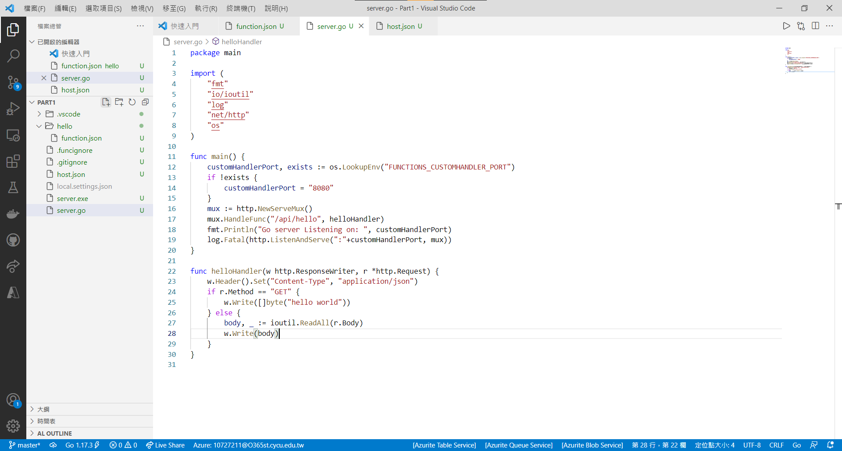

1. config host.json & build execution

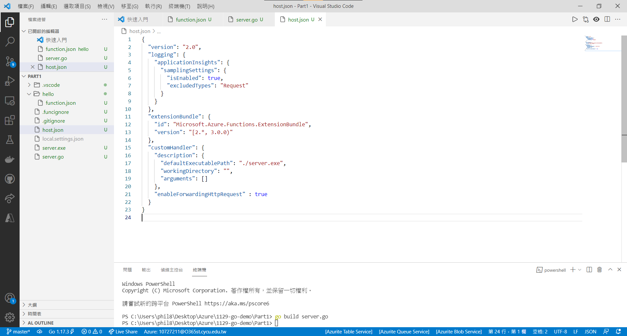

1. Run app

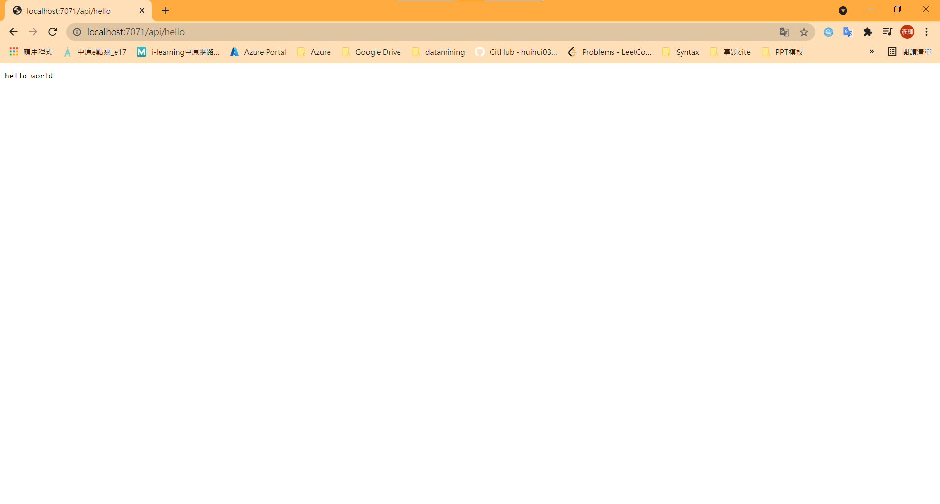

1. Create a function app

|  |  |
| --- | --- |
|  | **Azure Functions: Create New Project** |
| Select the folder that will contain your function project | {Part2} |
| Select a language | Custom Handler |
| Select a template for your first function | HttpTrigger |
| Provide a function name | queueTrigger |
| 授權等級 | Anonymous |

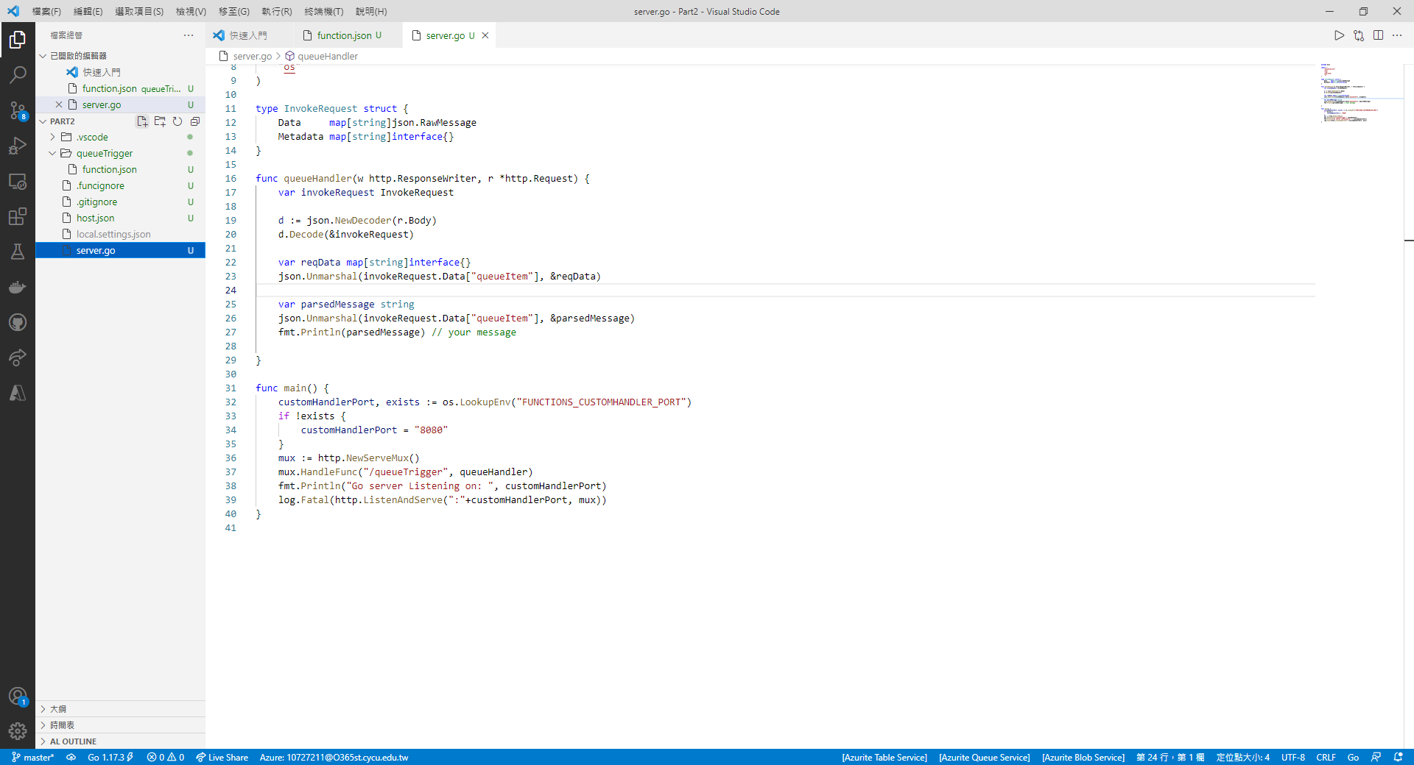

1. config host.json & build execution

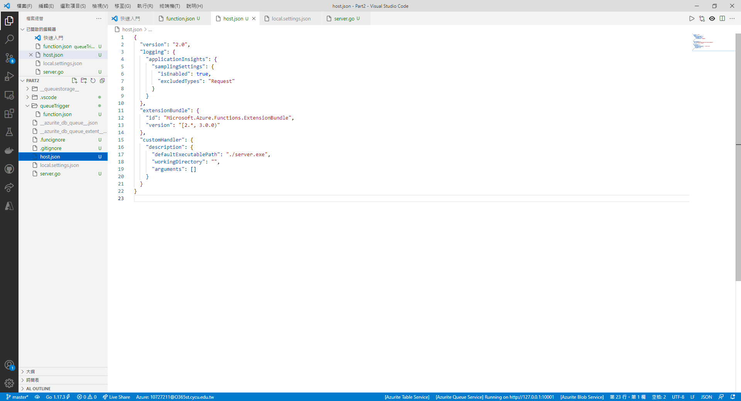

1. config local.settings.json

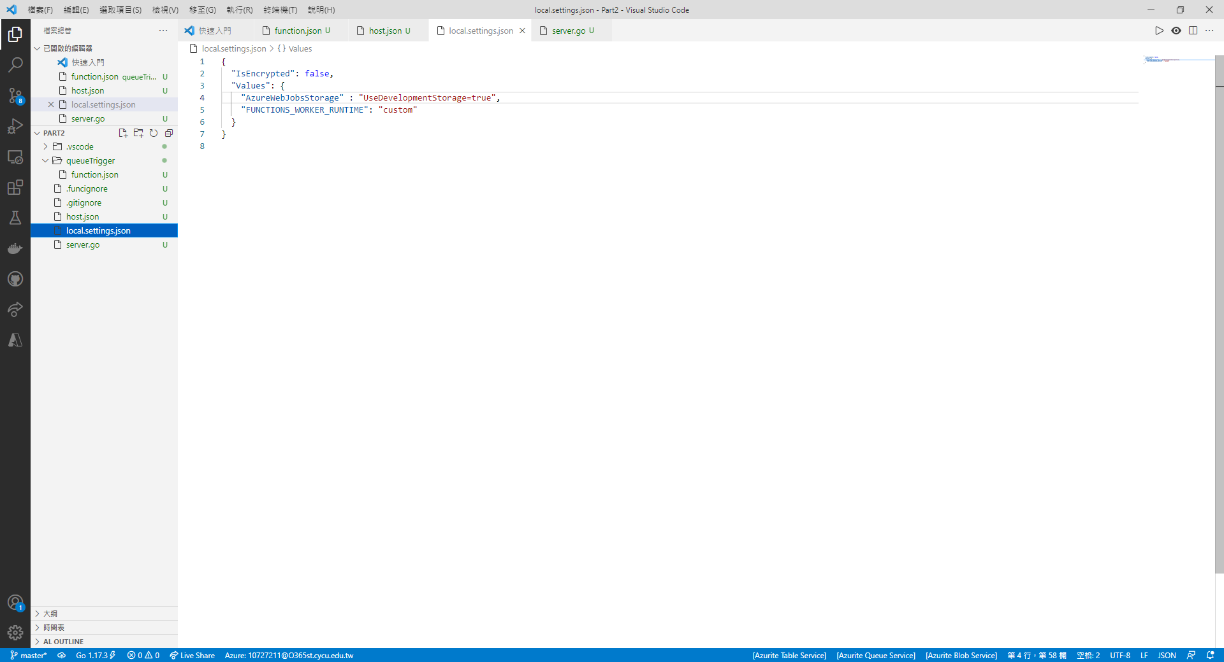

1. Start Queue Service

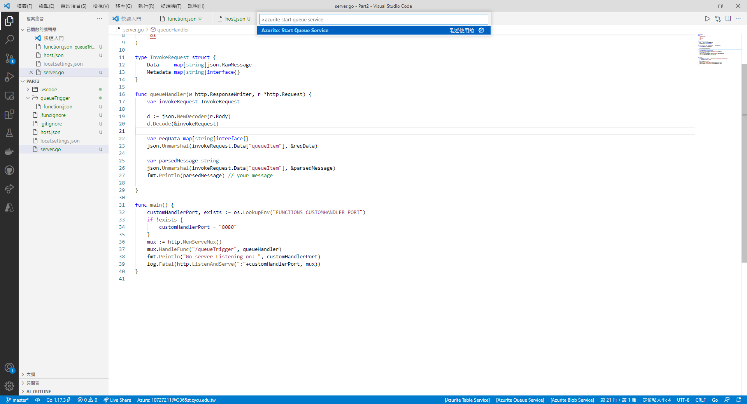

1. config function.json

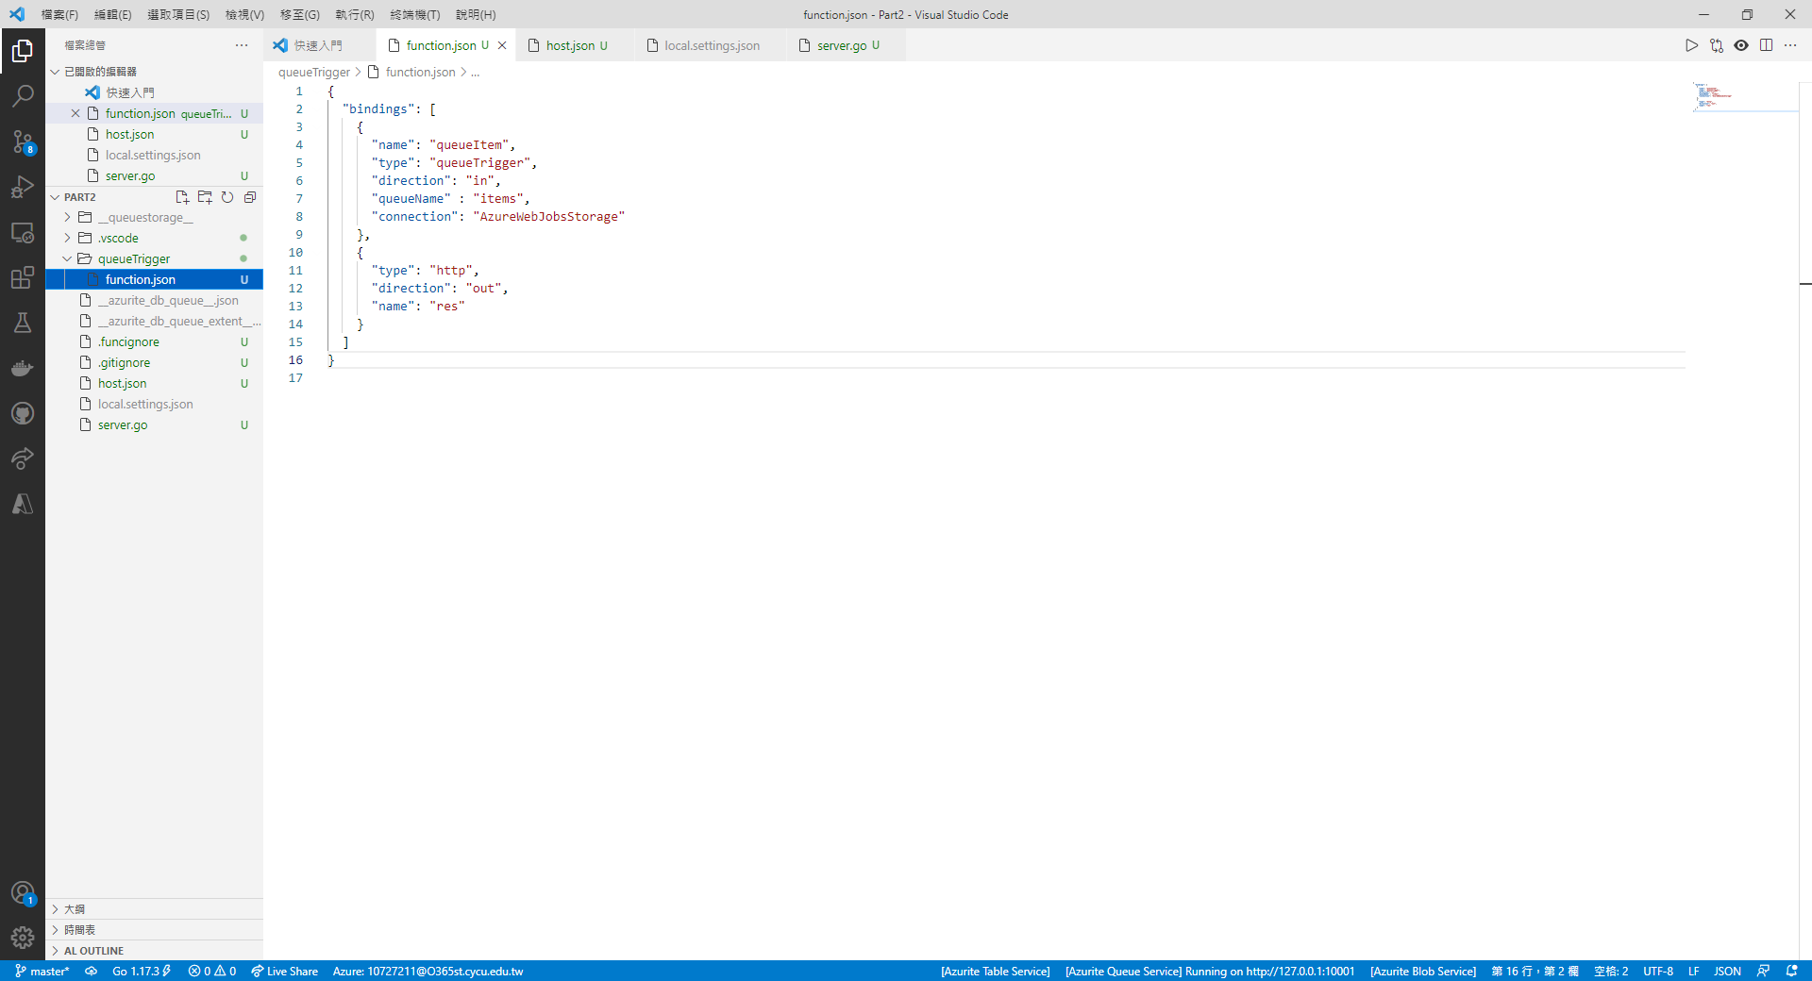

1. Create Queues in Azurite

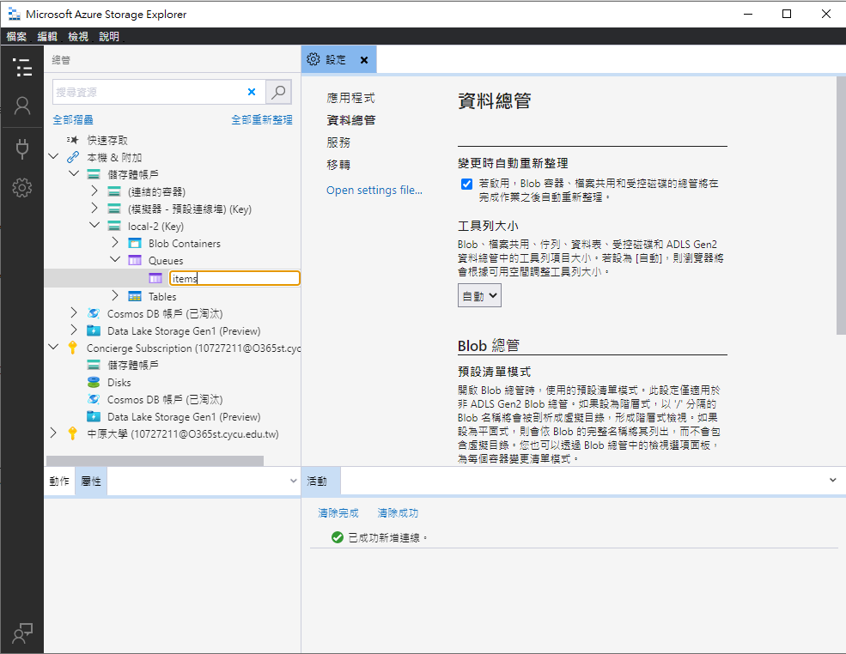

1. Run the app

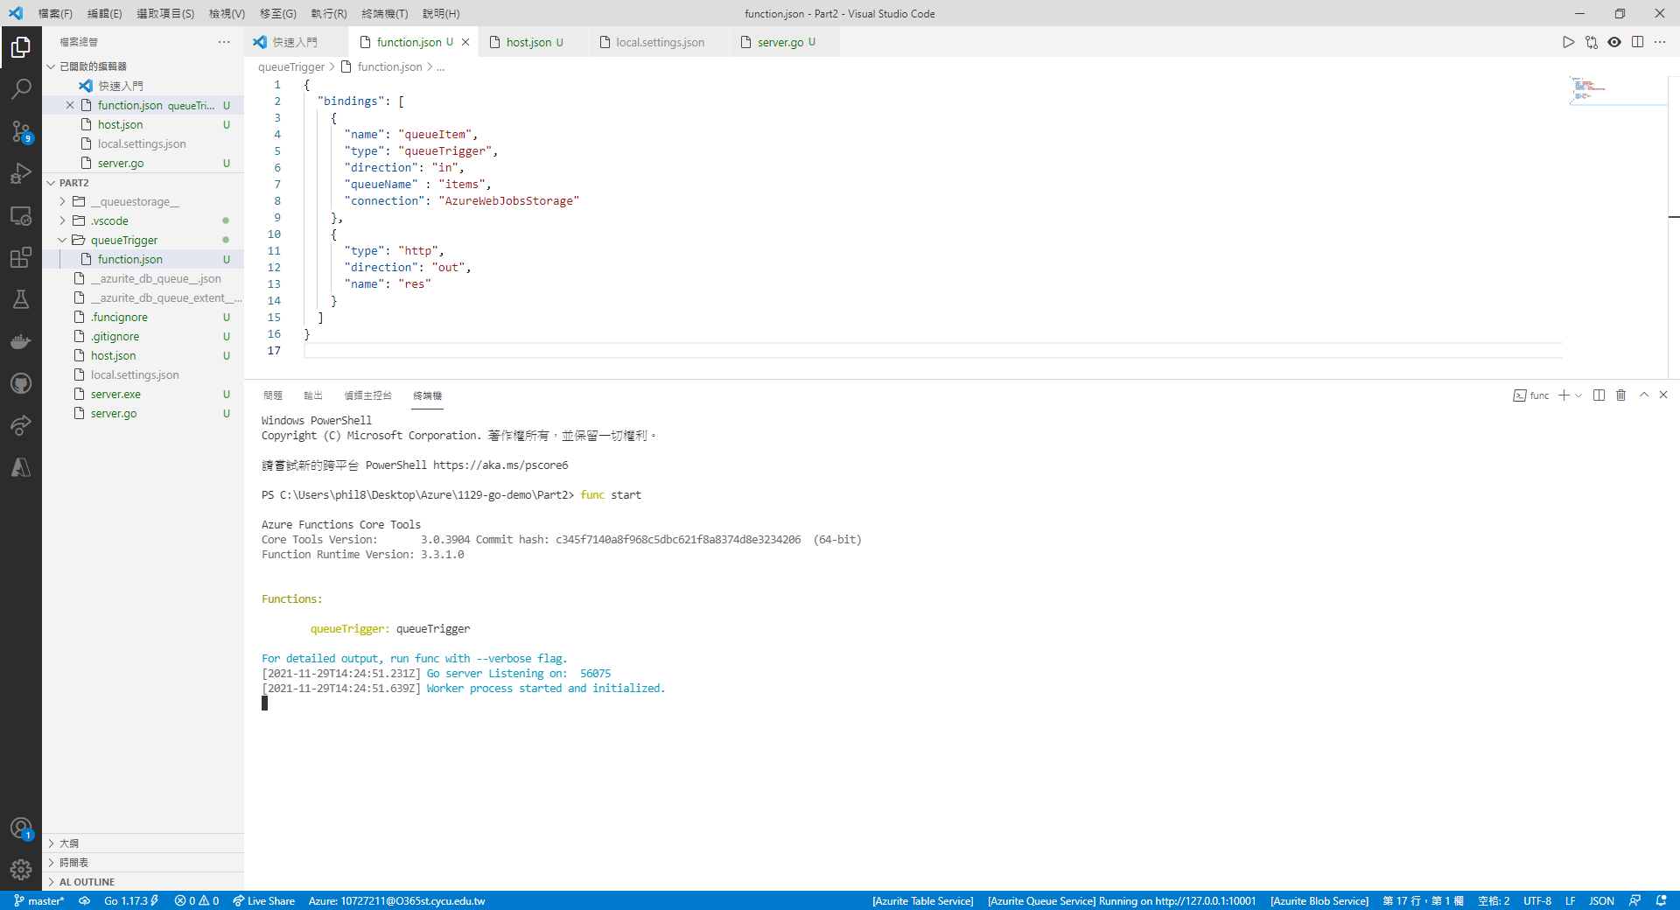

1. Add message in queue

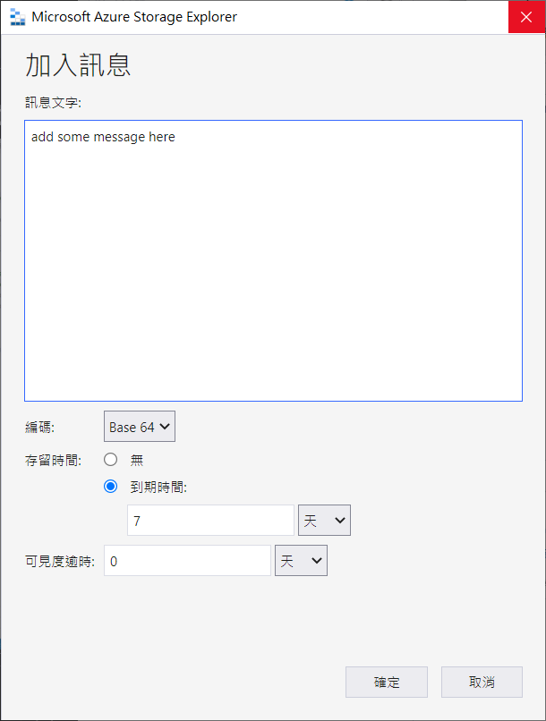

1. Results

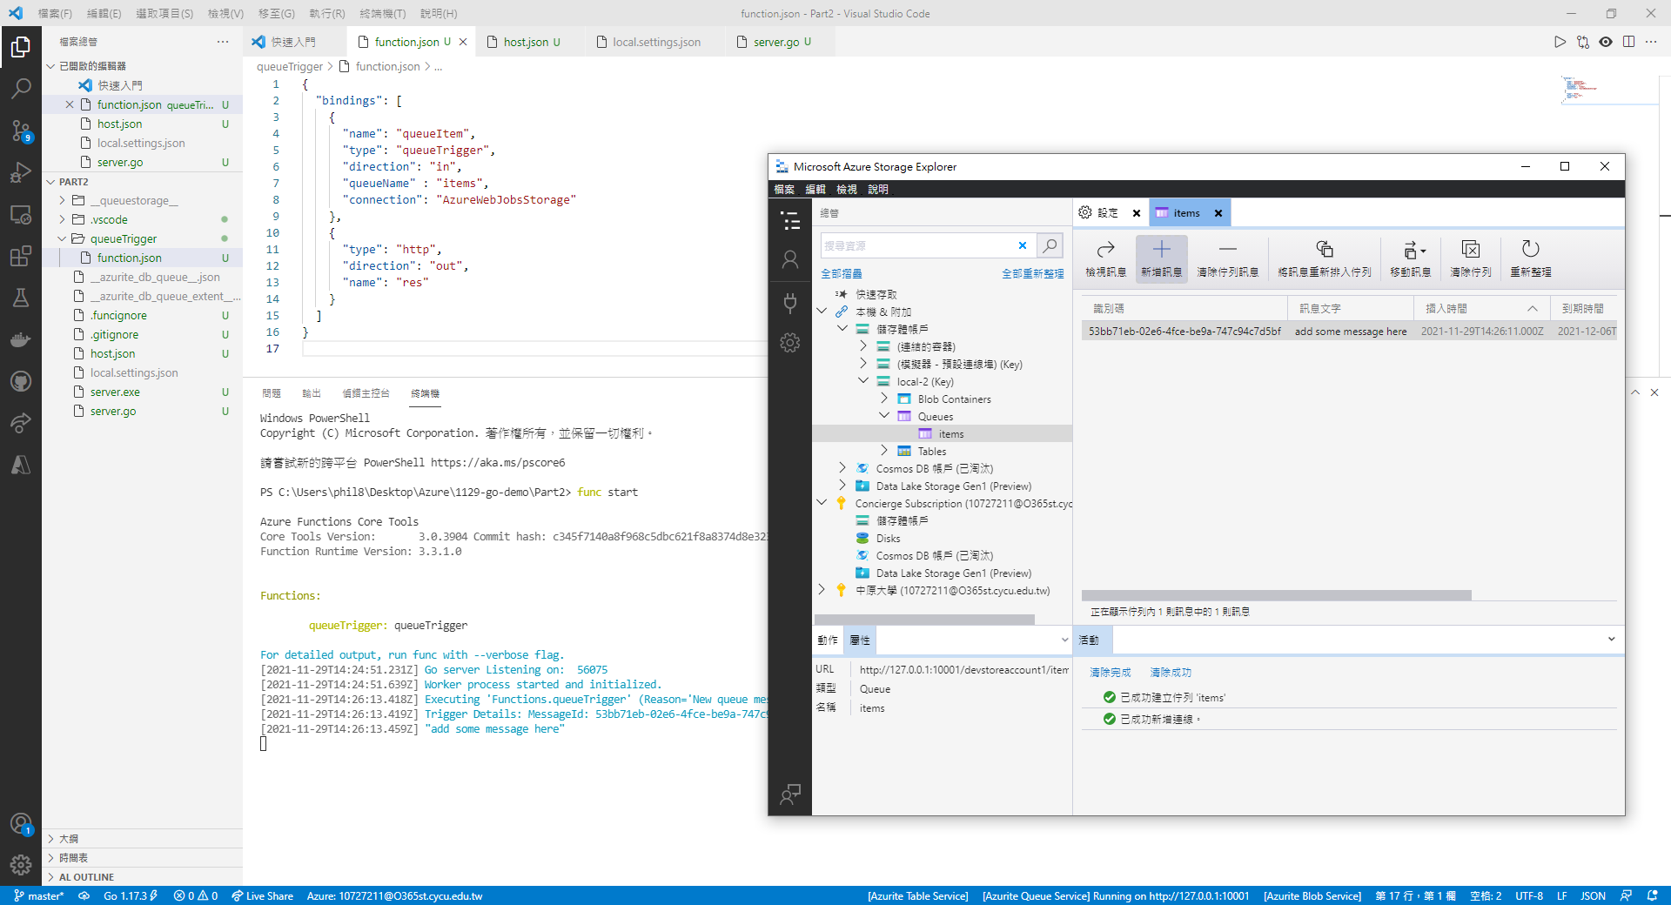

## Take screenshots of Badges and Trophies

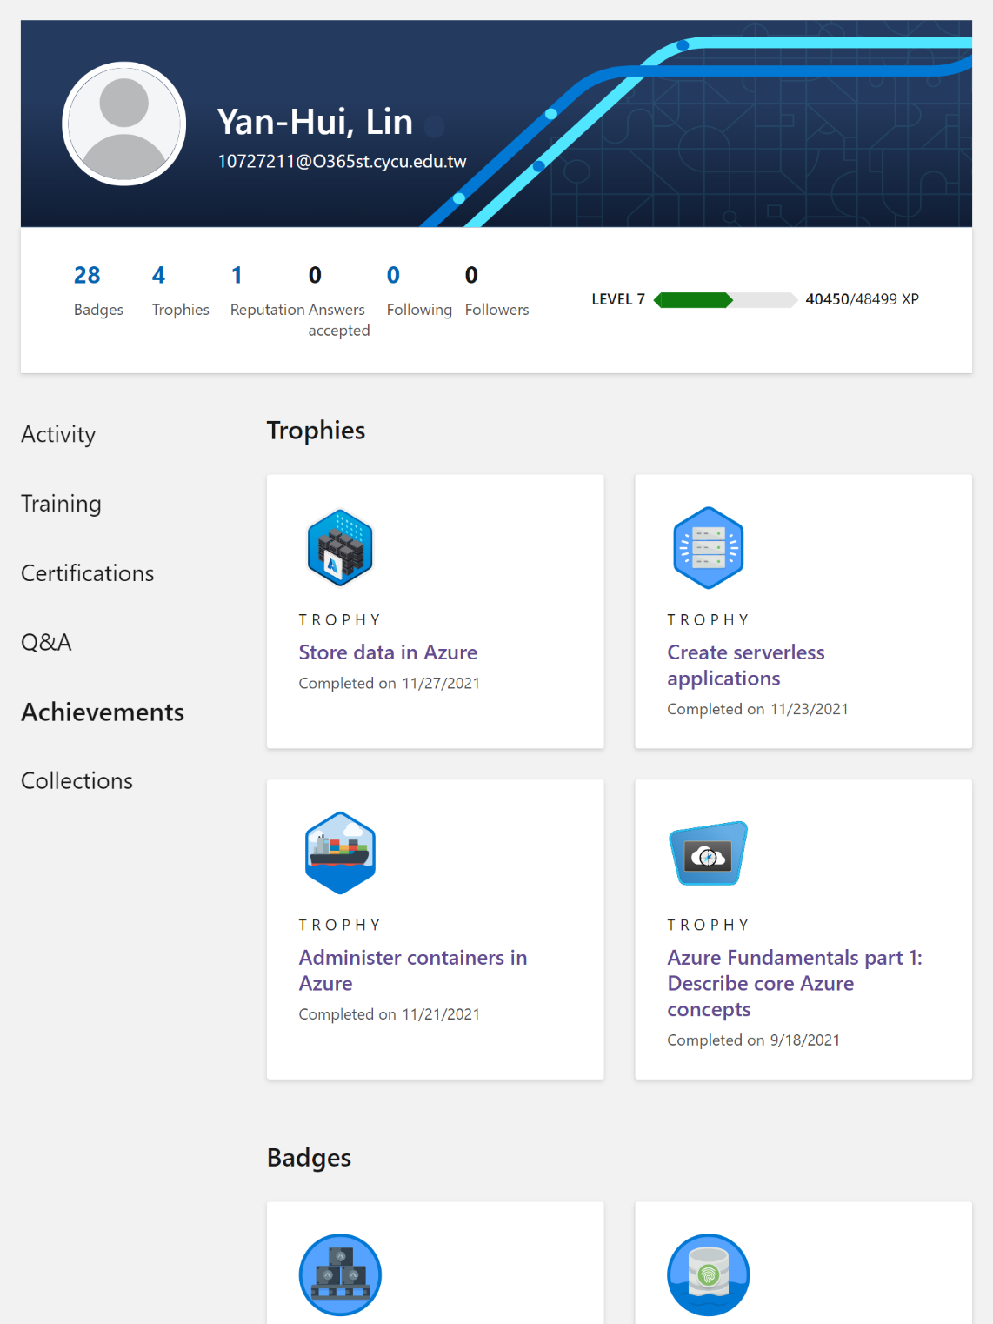

## Learned from the Learning Path

在此Learning Path中充分實作了Azure Function的各種功能，了解Serverless的概念，也從Azure Function的Trigger中看到Azure中的其他資源，透過不同的Trigger方法搭配不同的Azure Resource，甚至可以搭配IDE做資源的佈署，使得Azure Function能實作的功能越來越多，進而看見Microsoft Azure的強大生態圈。

# Problems

1. Model6

在Model6中，使用Azure Cloud Shell在背景執行Azure Functions時發現錯誤，同樣的方法使用在沙盒中卻能正常運行。

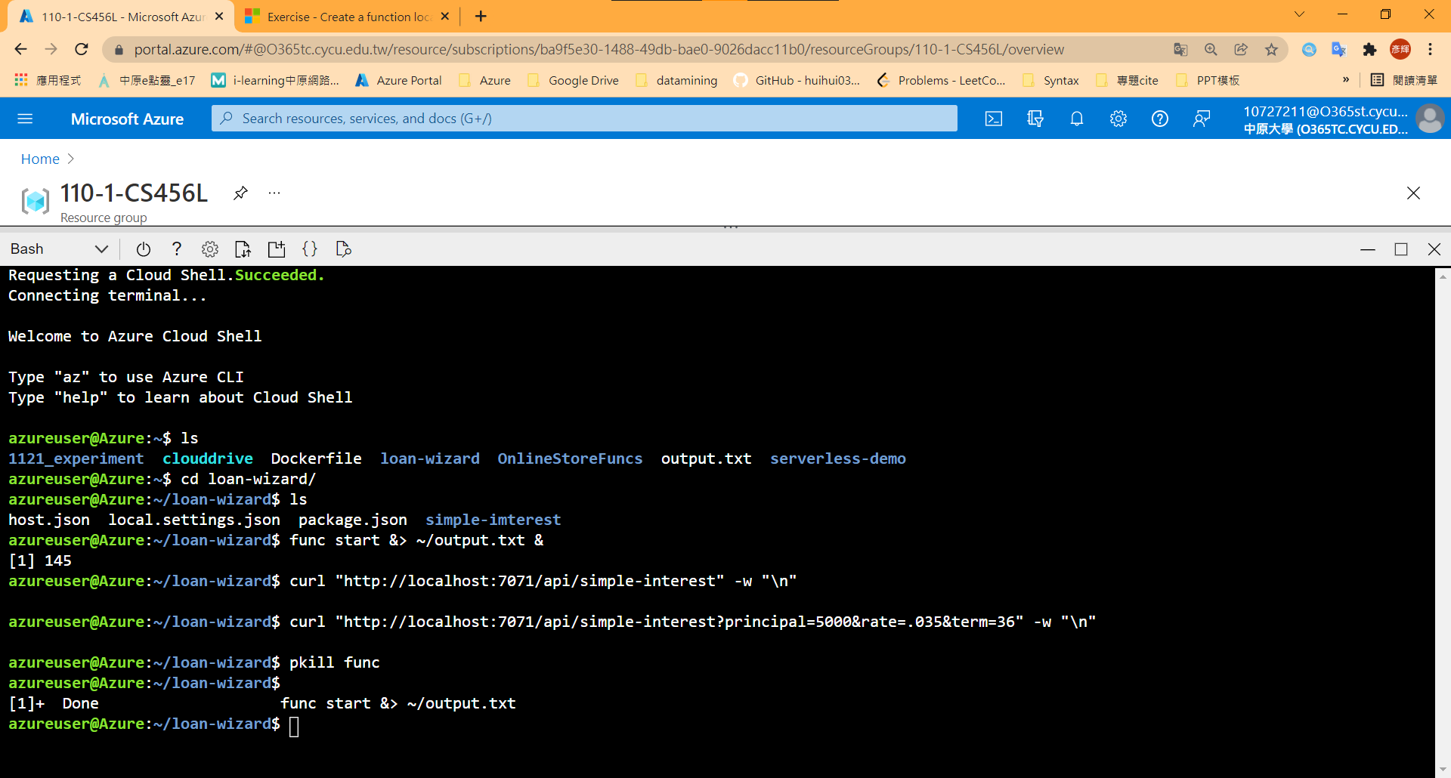

1. Model9

需要下載Node.js以接續教程。但官方給的Node.js載點中https://nodejs.org/en/會安裝到最新版本的Node.js、npm（如下圖為16.13LTS）

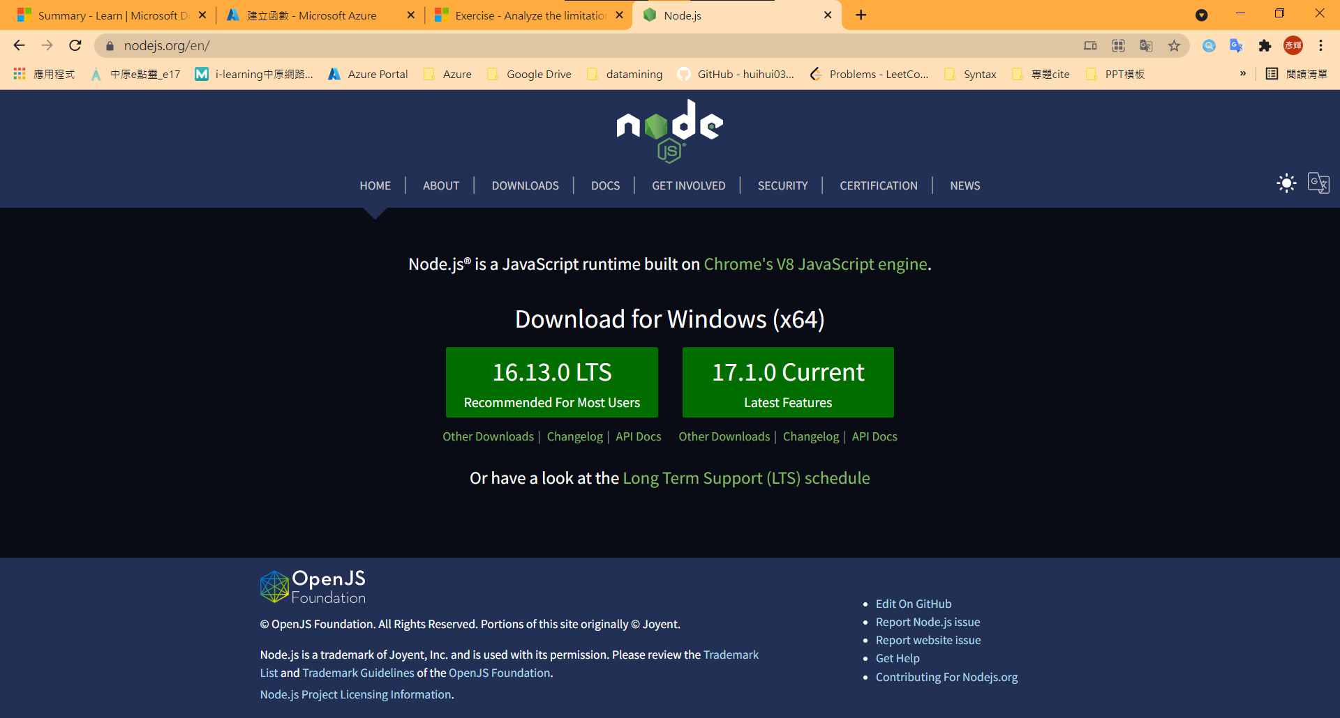

但此版本將無法與Azure Core Functions相容，在Start Local Function將出現Error。

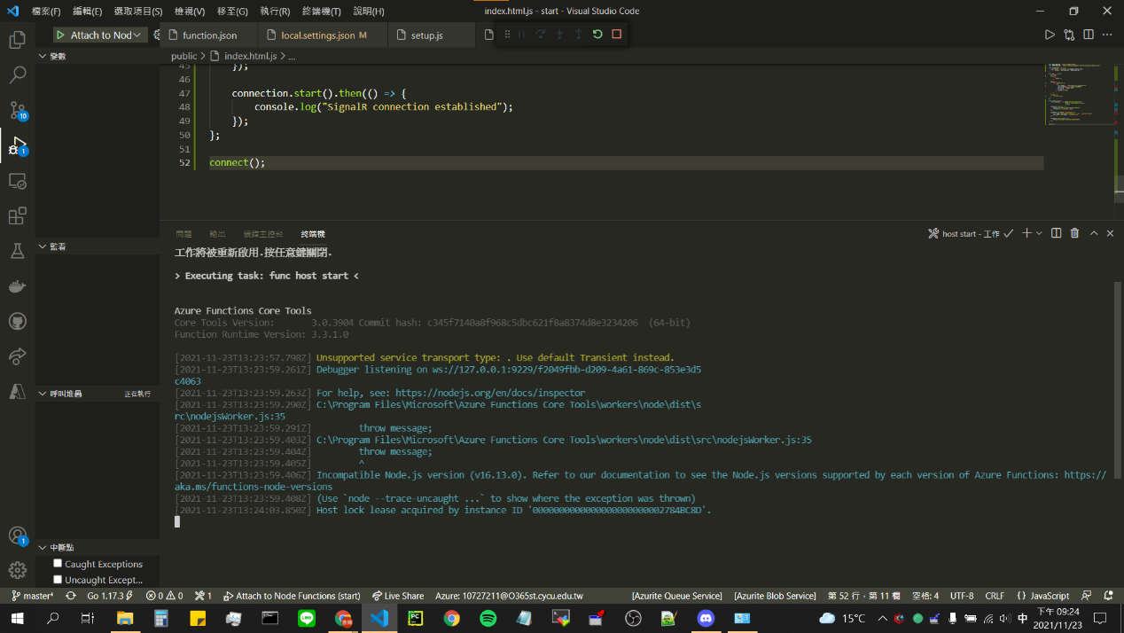

依序網址來到相容性說明網頁

https://docs.microsoft.com/zh-tw/azure/azure-functions/functions-reference-node?tabs=v2#node-version

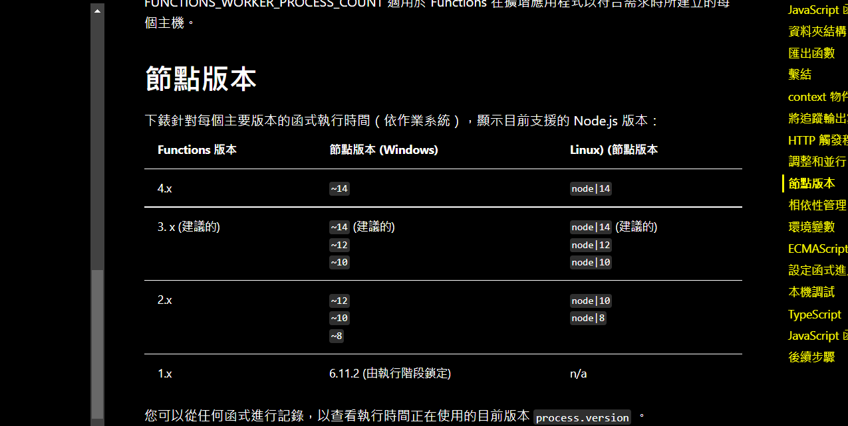

將Node.js降版後即可解決問題(v14) https://nodejs.org/download/release/v14.18.1/

1. Model 9

在拿SingalR key String時，範例程式碼中的query[0]有可能導致Error（將index寫死，將拿到第一個SignalR Resource的key，但「第一個SignalR Resource」並非剛創立的Resource）

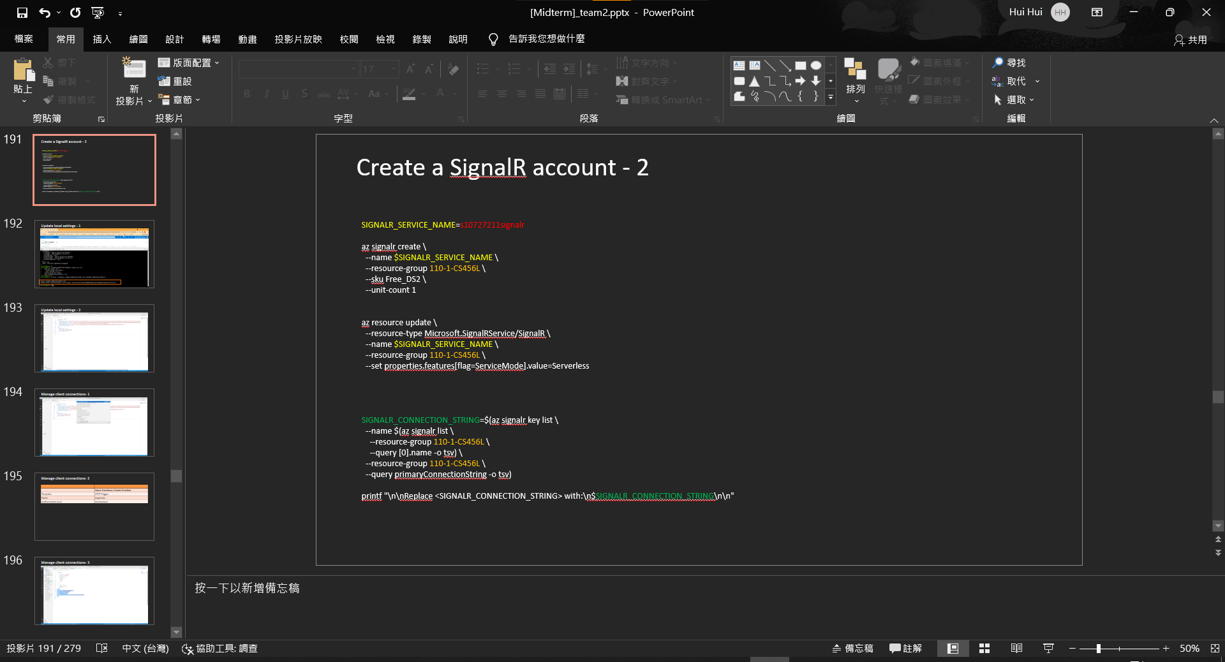

1. Model 10

在110-1-456L使用官方提供之腳本時出現Error，原因不明，環境更換為沙盒時即可恢復運作。

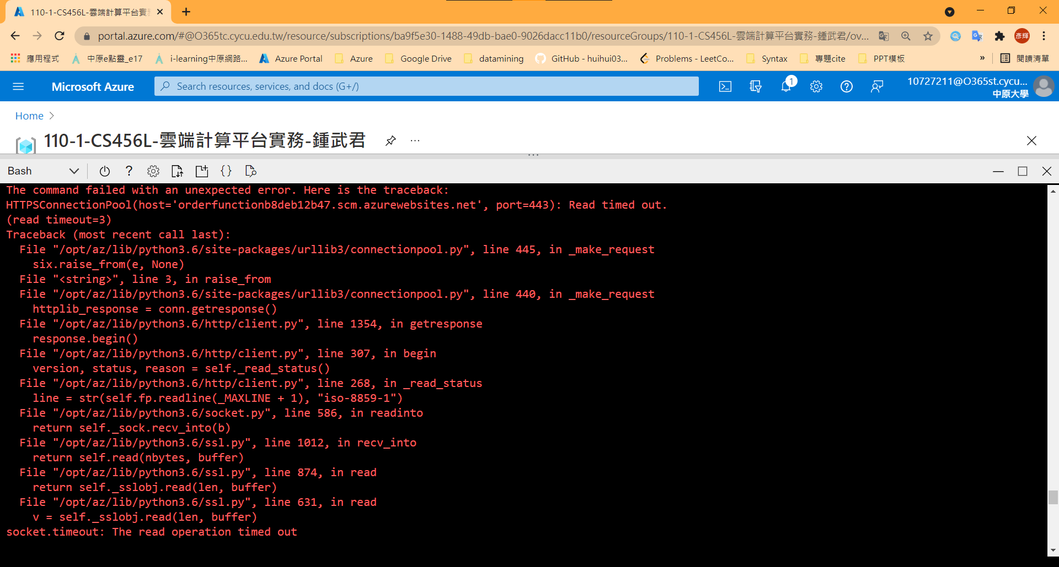

1. Model11 – Unit4

在Windows環境下，路徑使用’\’將Error，應改為’/’。

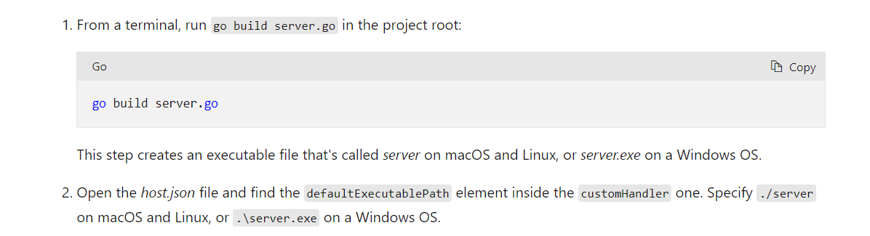

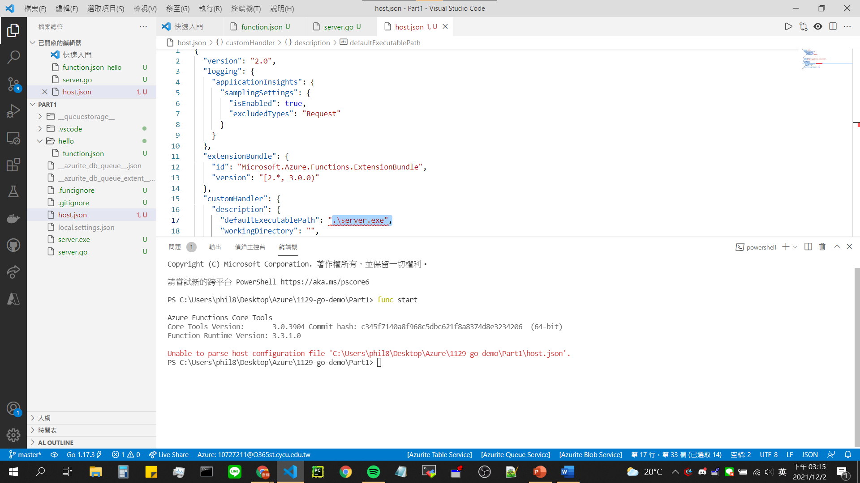

# FeedBack

## 中文翻譯改進

1. Model1 – Unit2

左邊為英文版，右邊為中文版，過程中看到教程會穿插圖片做解說，但解說圖片的文字翻譯程度卻不統一，翻譯過後的可讀性甚至更低。

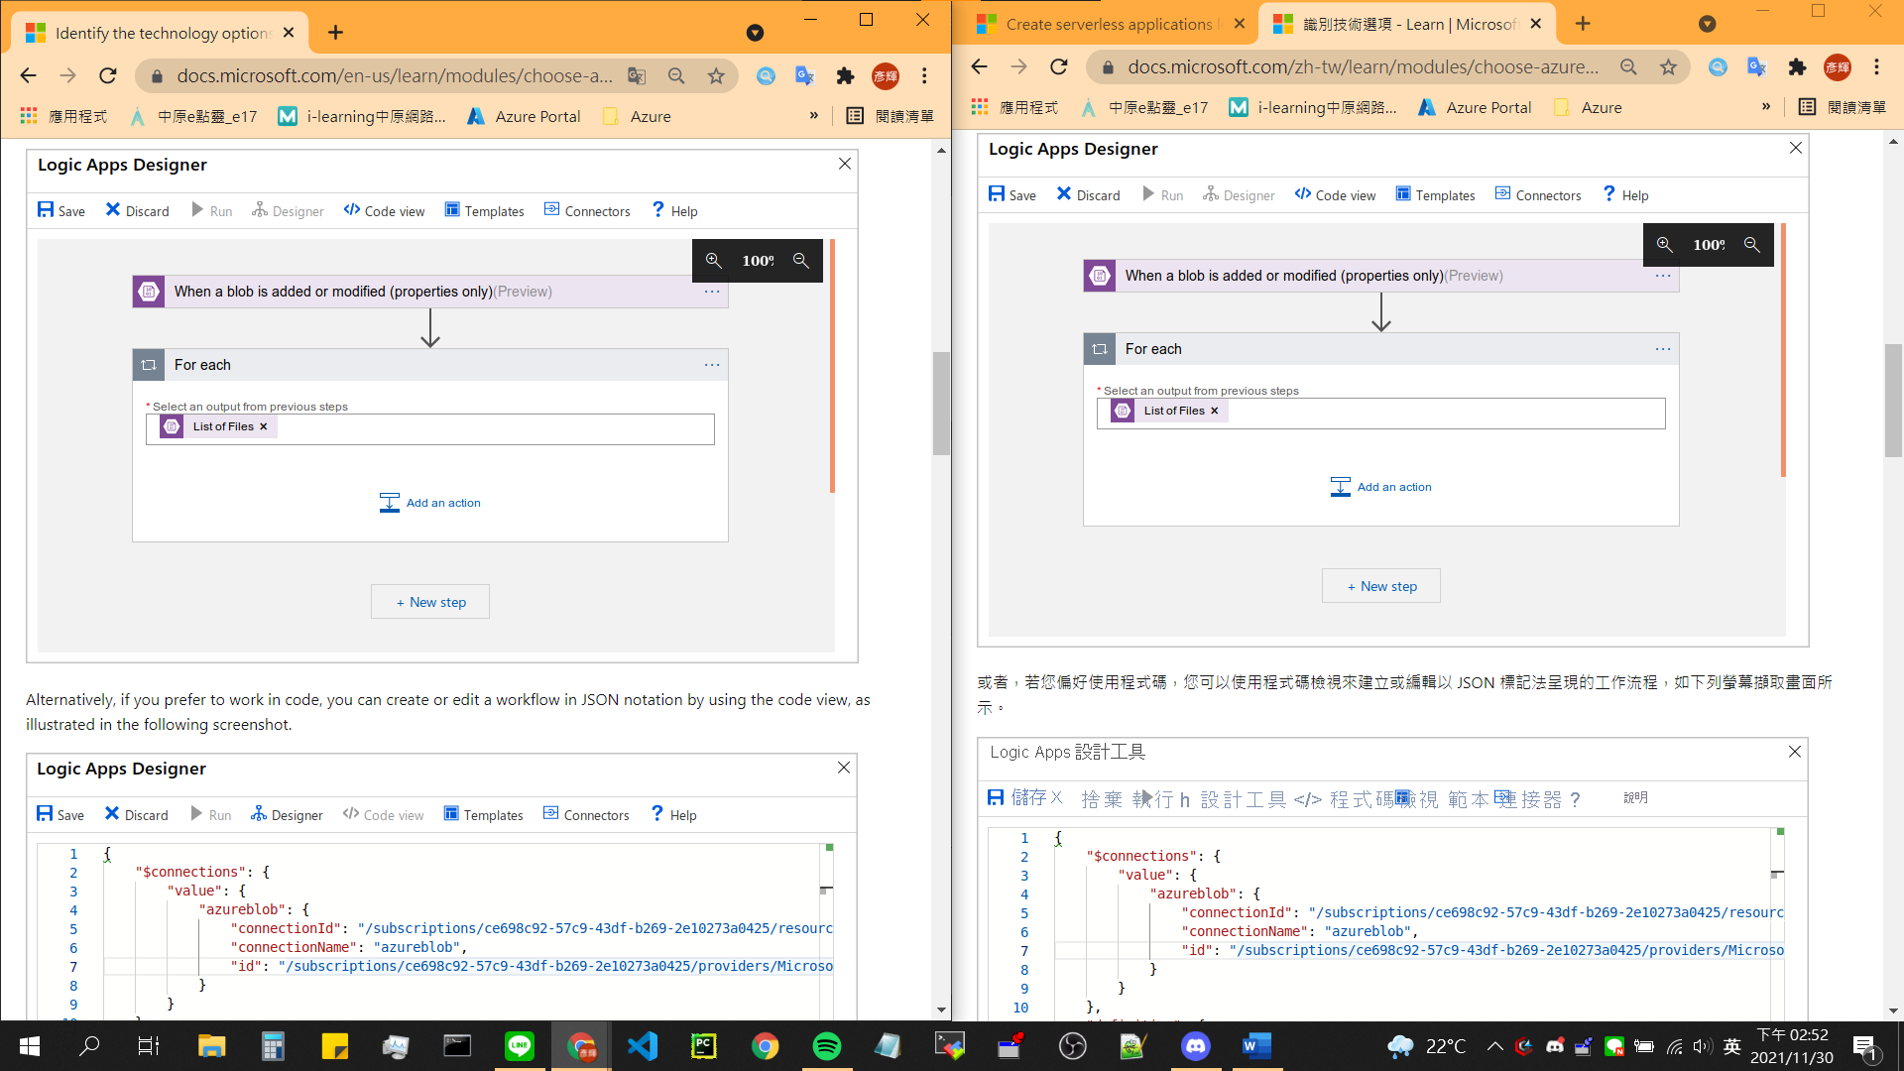

英文版< | >中文版

1. Model1 – Unit3

產品名稱經過翻譯可讀性降低。

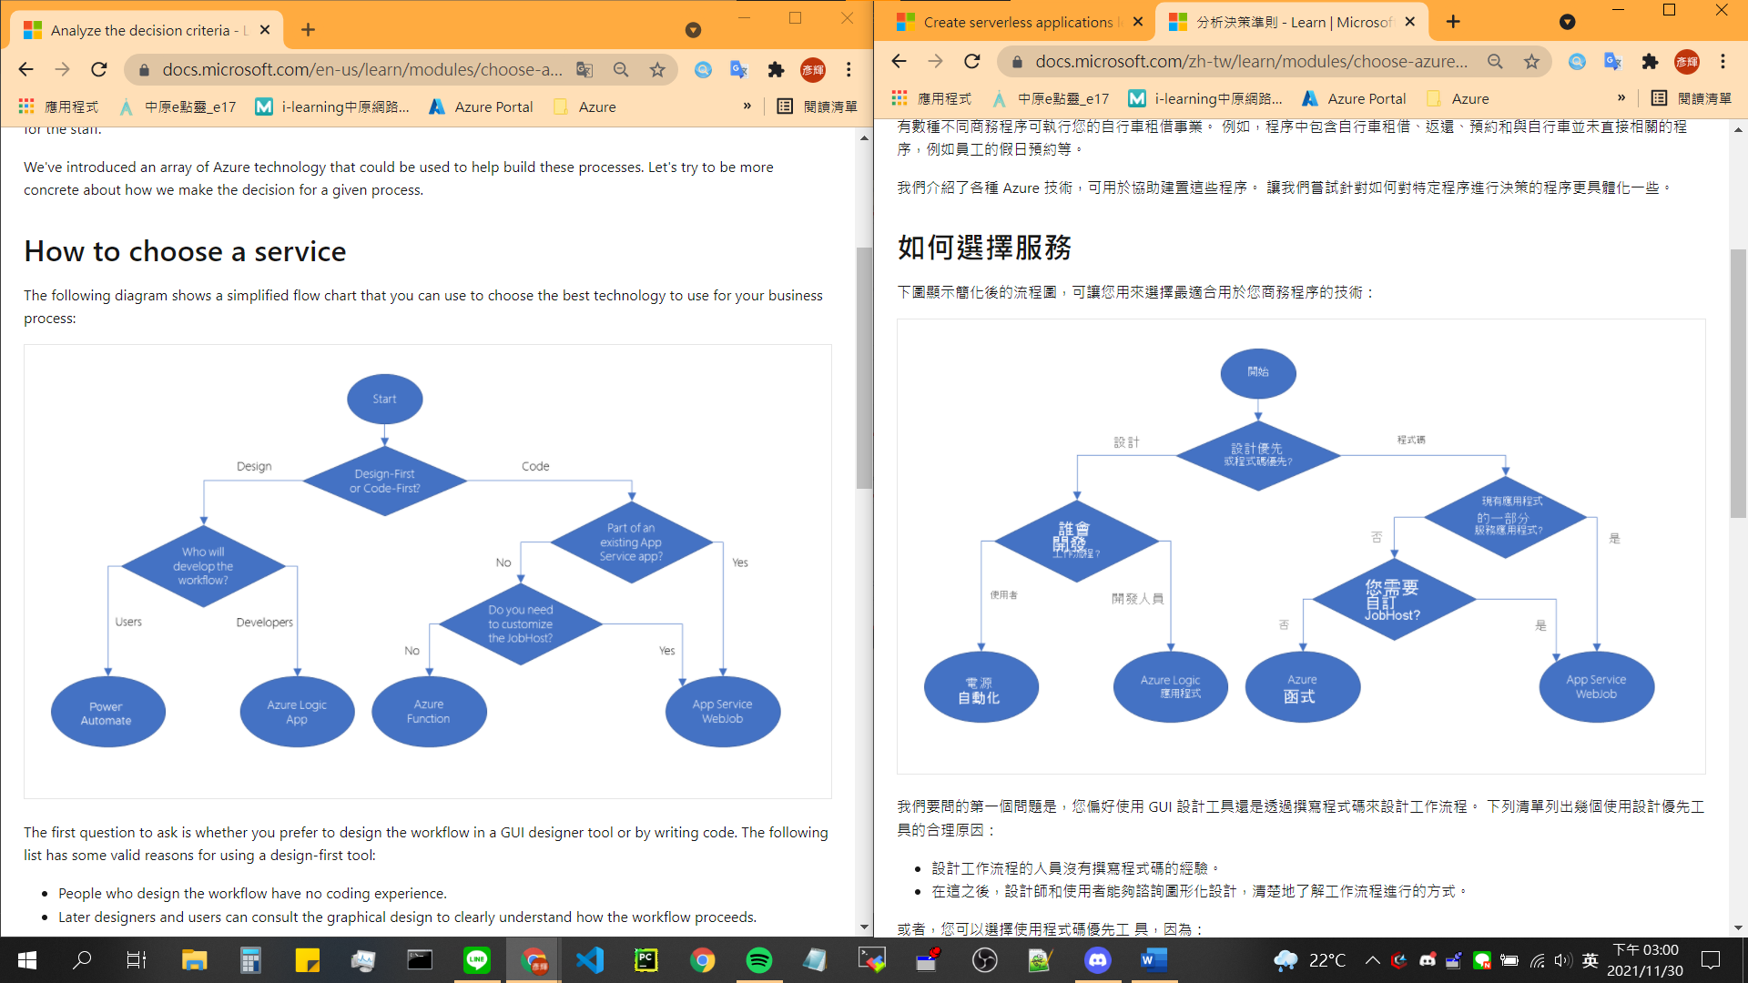

英文版< | >中文版

1. Model1 – Unit4

排版。

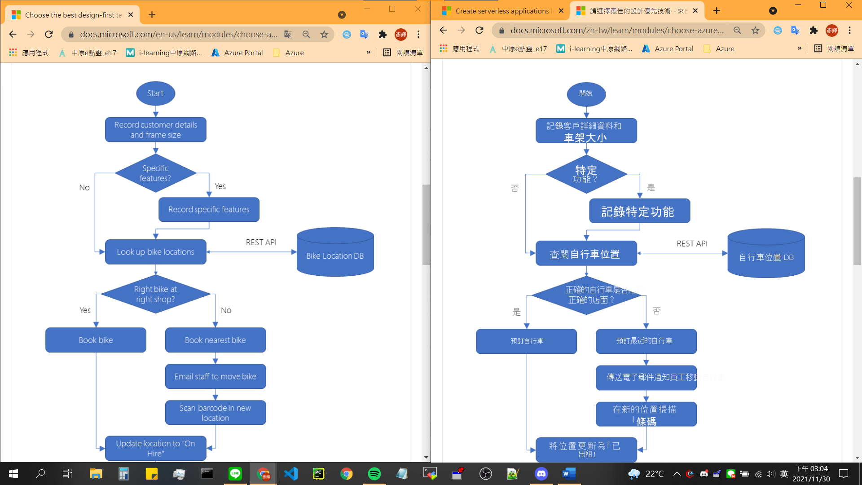

1. Model2 – Unit4

服務名稱要統一英文版本，在Azure Portal上創建名稱時，服務為英文版本。

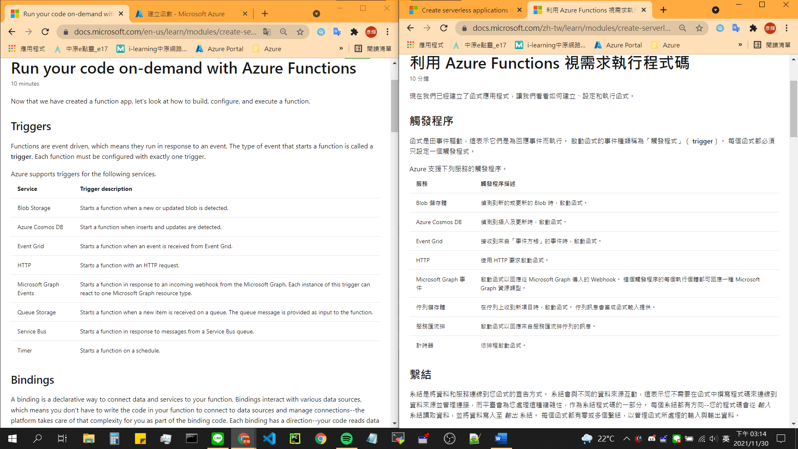

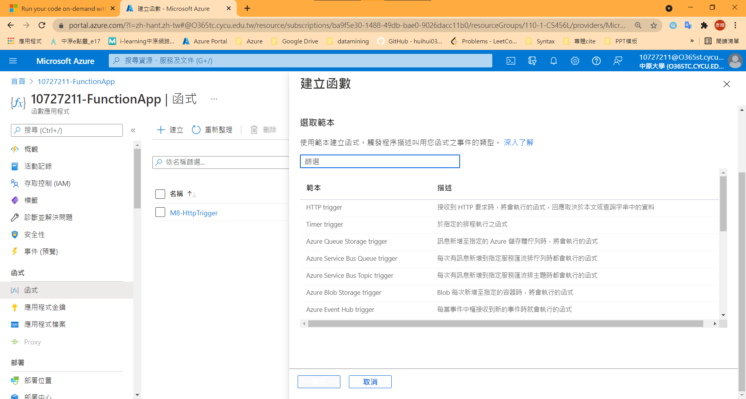

1. Model2 – Unit5

名稱不統一。

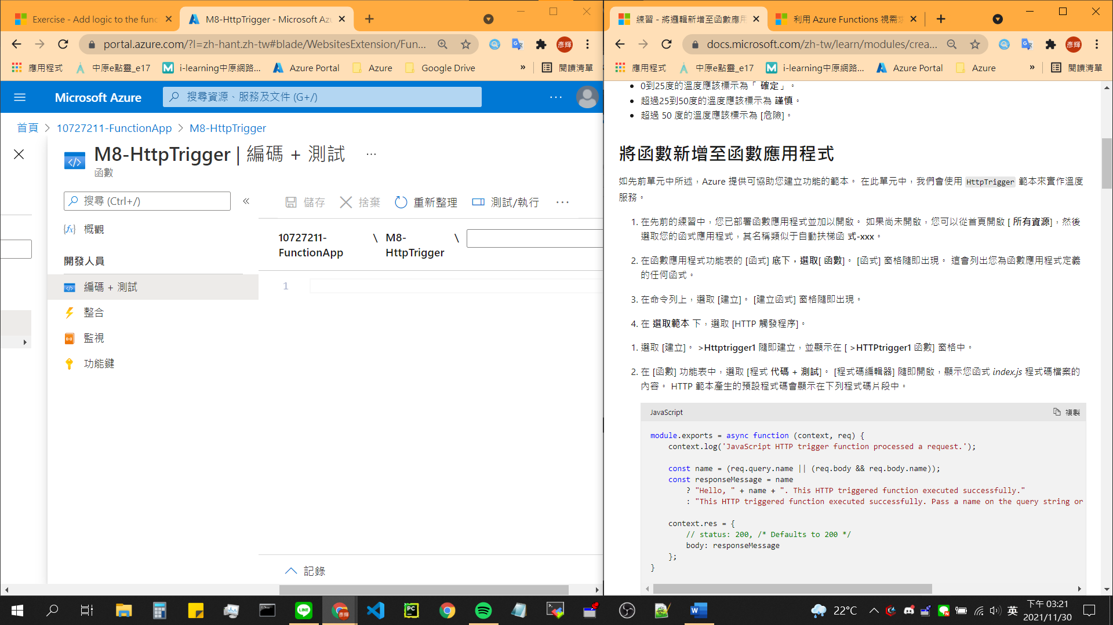

1. Model2 – Unit5

變數名稱被翻譯。

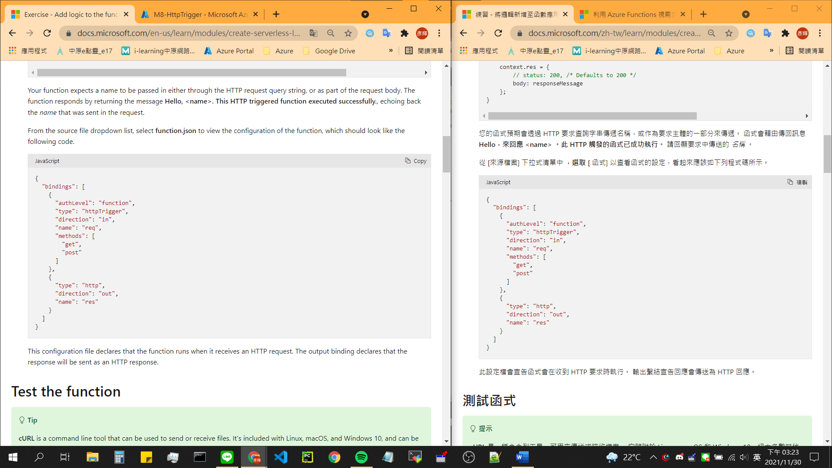

1. Model2 – Unit5

名稱不統一。

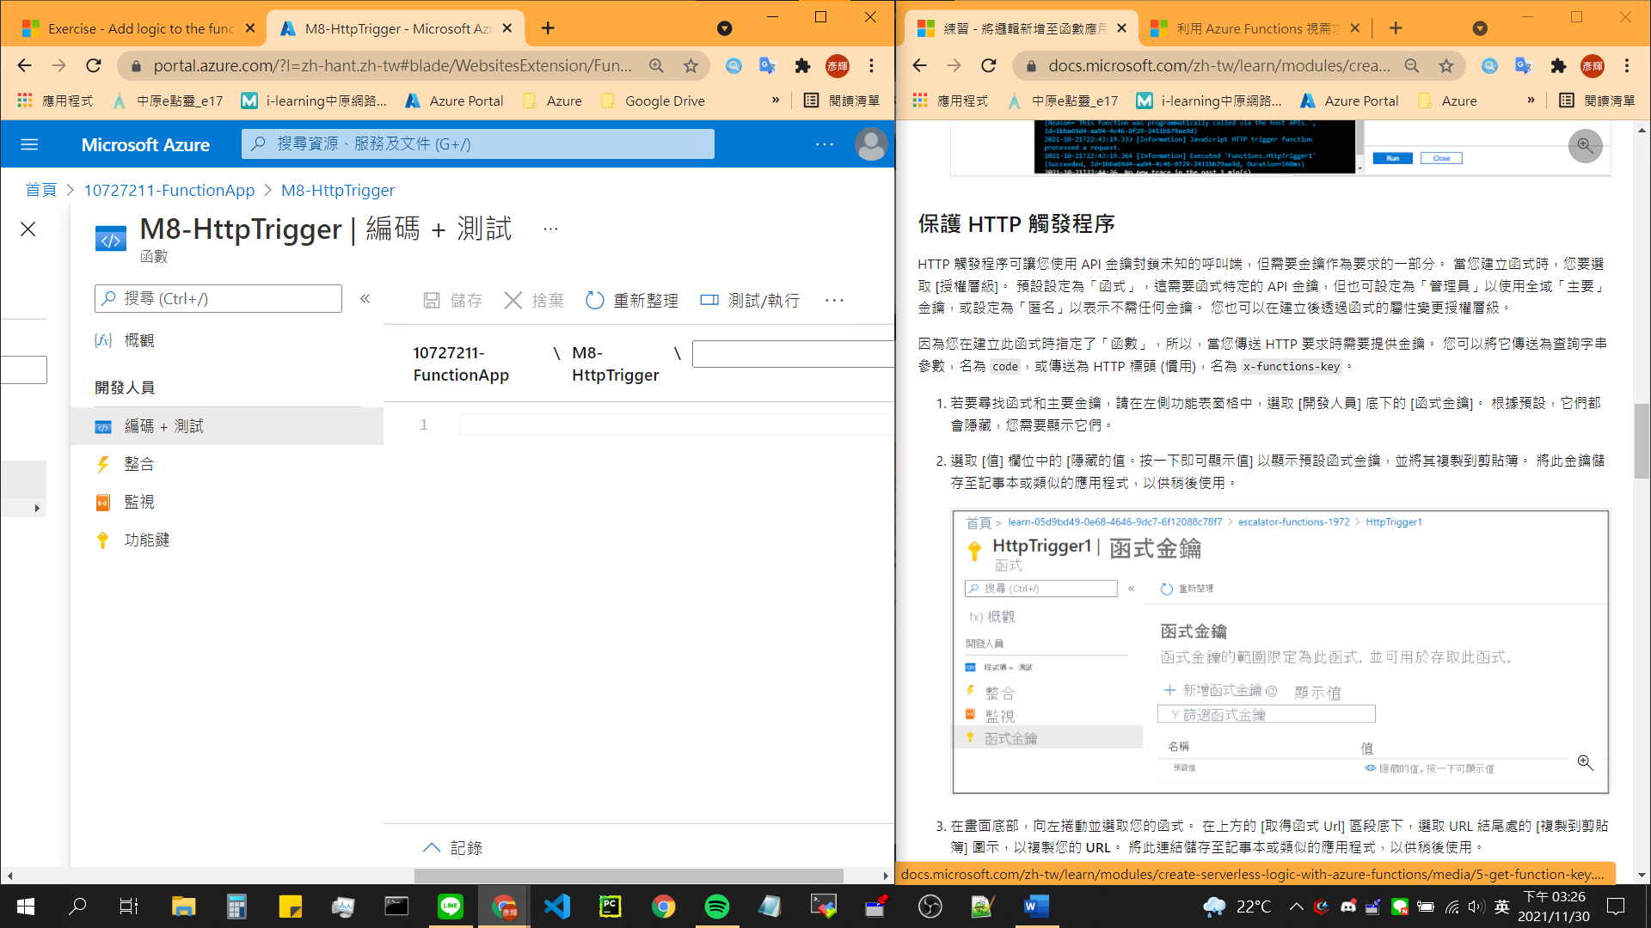

1. Model3 – Unit2

服務名稱要統一英文版本，在Azure Portal上創建名稱時，服務為英文版本。

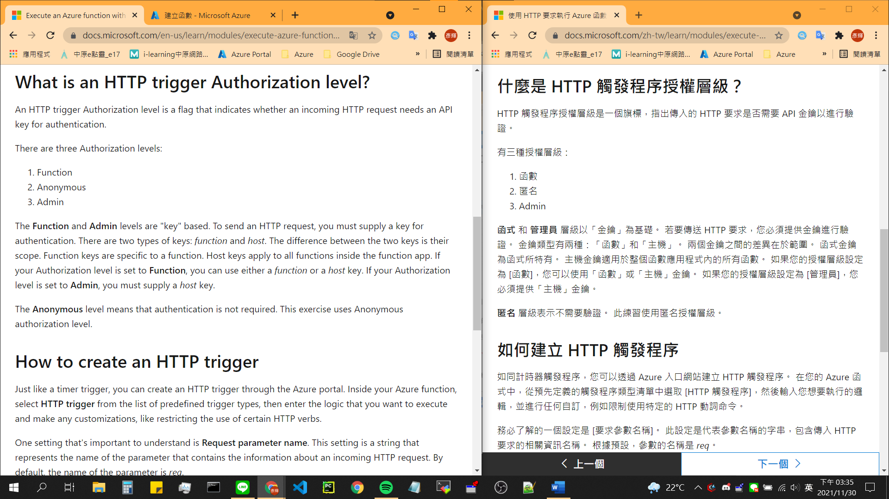

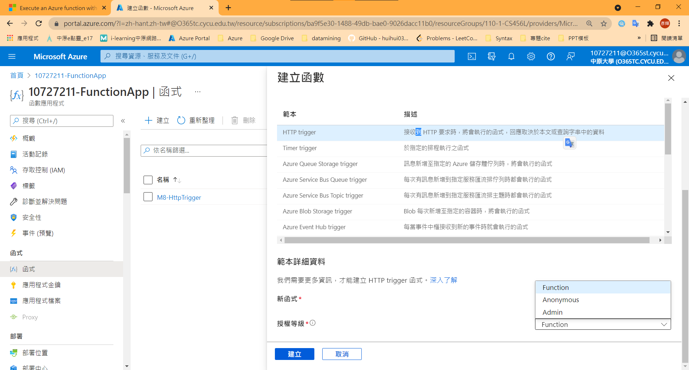

1. Model 3 – Unit7

「管理」也許是個更好的翻譯。

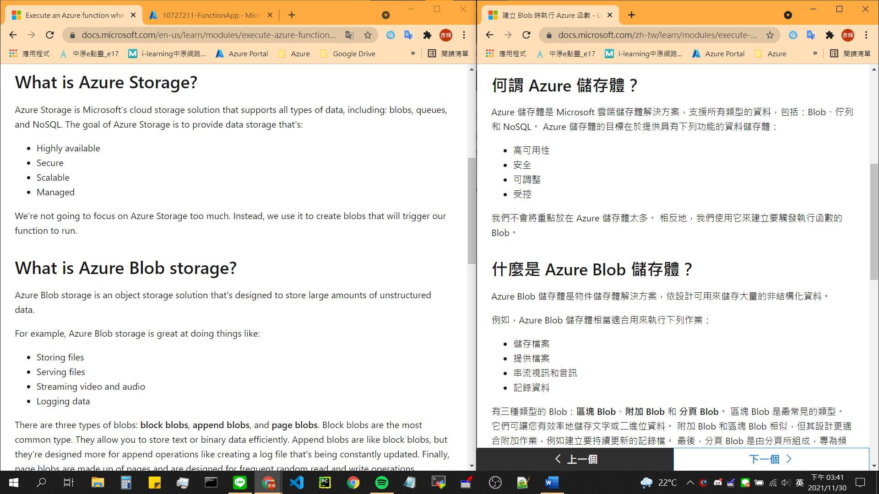

1. Model3 – Unit8

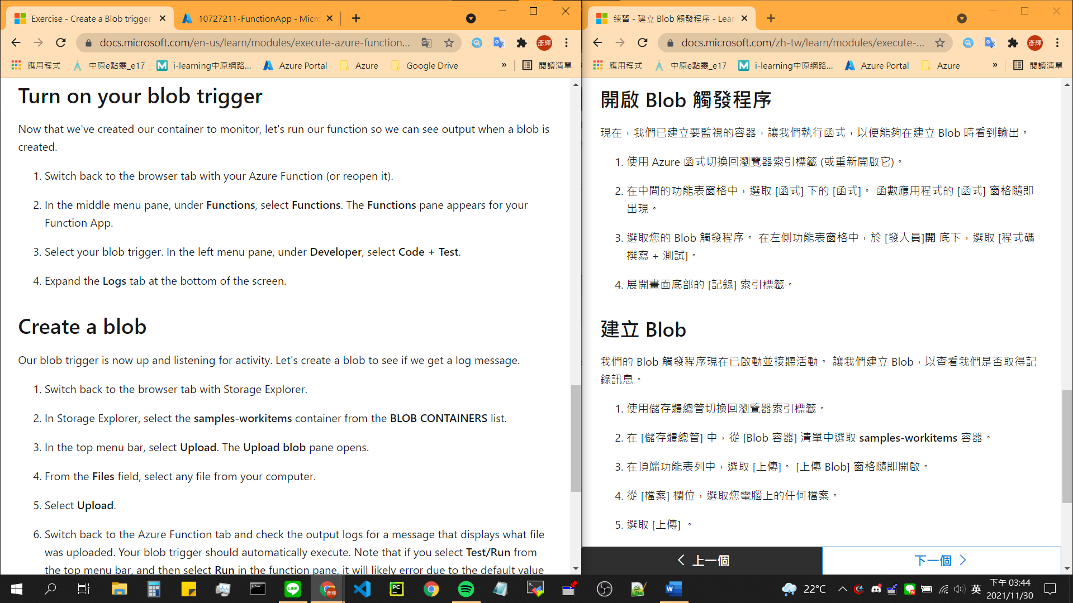

1. Model4 – Unit5

變數名稱不能被翻譯&有部分內容未被翻譯

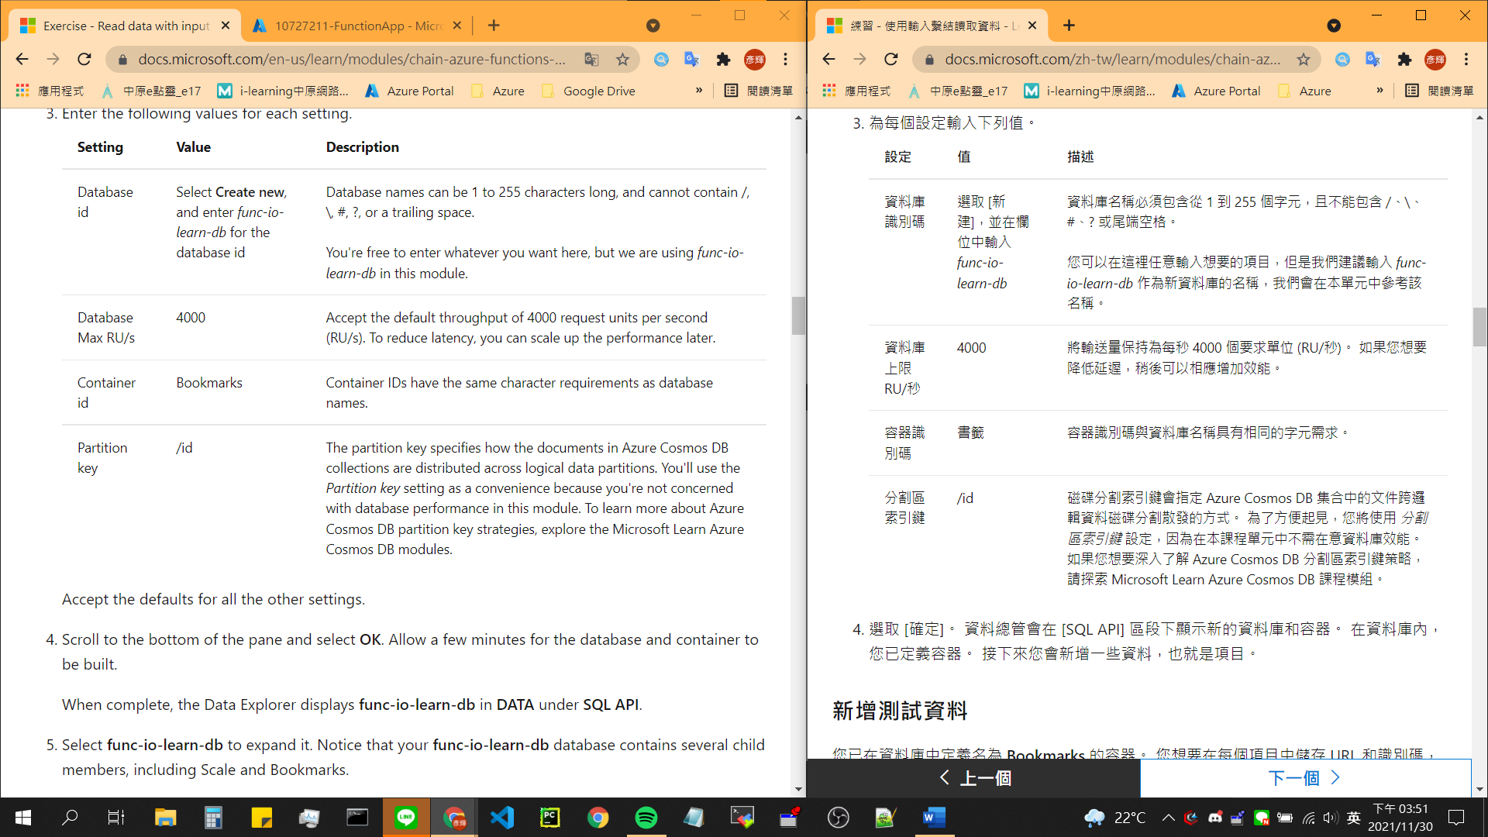

1. Model4 – Unit5

翻譯詞要統一。

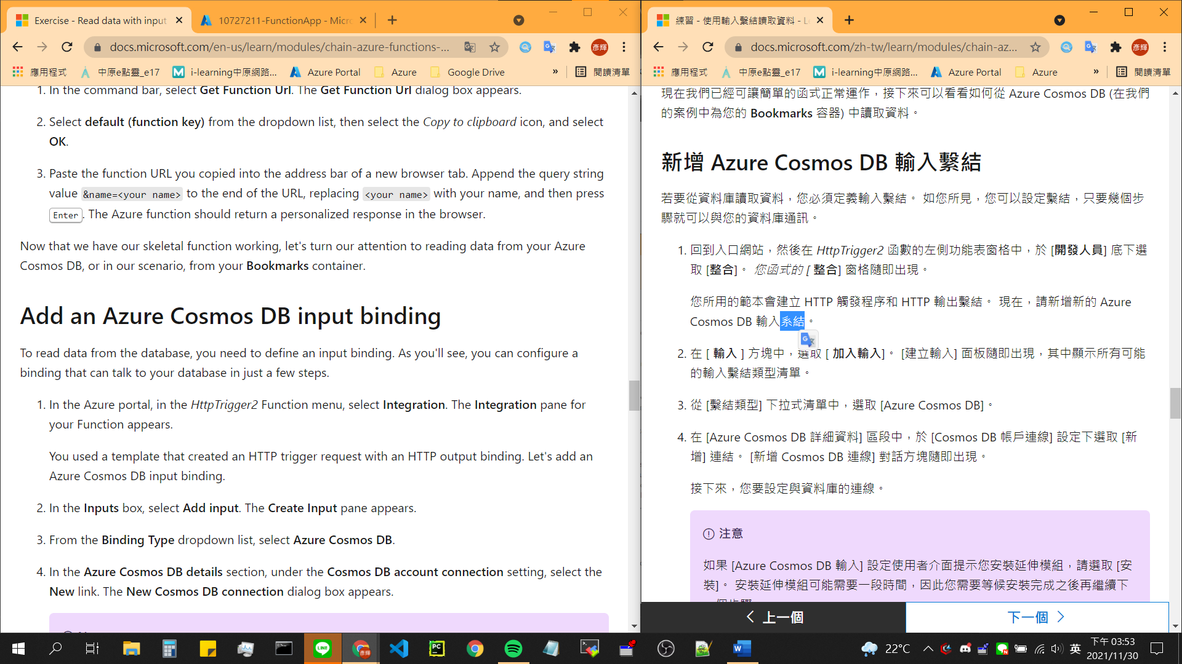

1. Model4 – Unit5

有部分內容未被翻譯。

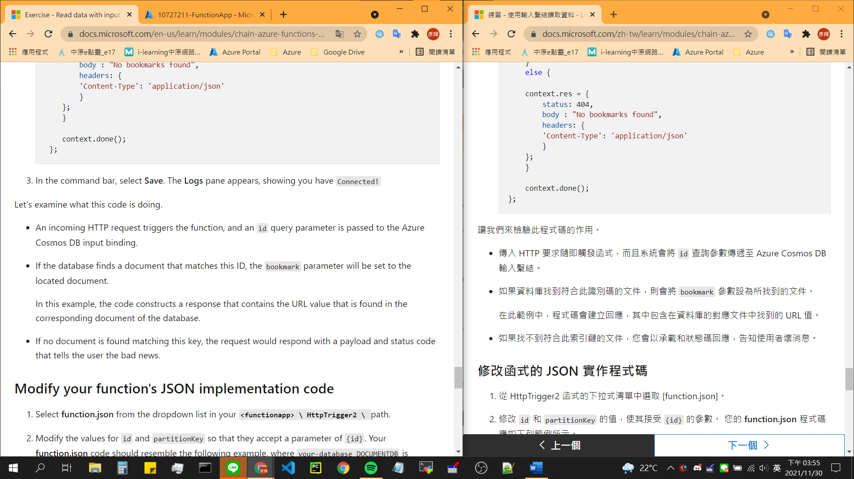

1. Model5 – Unit2

服務名稱要統一英文版本，在Azure Portal上創建名稱時，服務為英文版本。

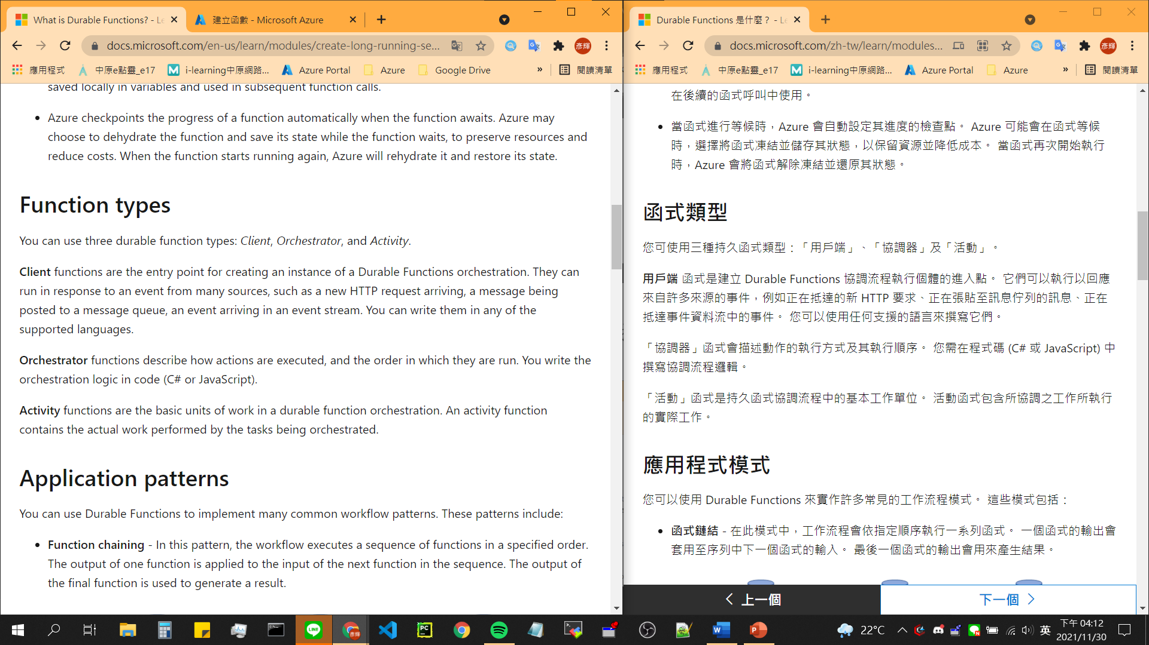

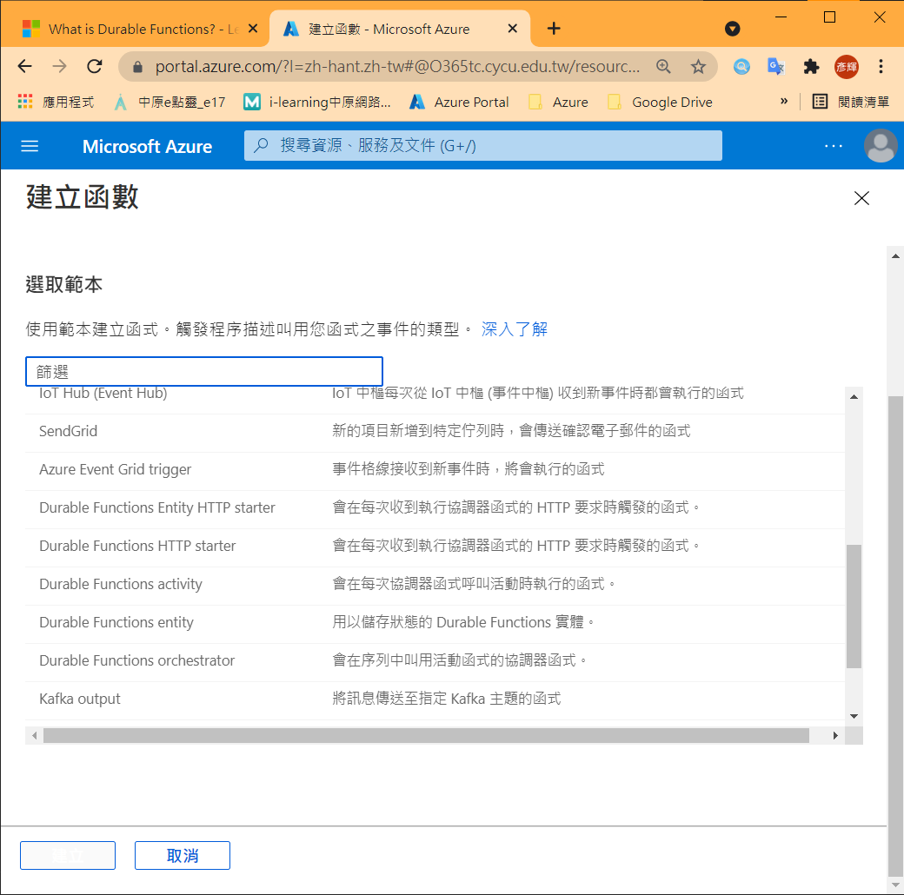

1. Model6 – Unit2

log可以不必翻譯

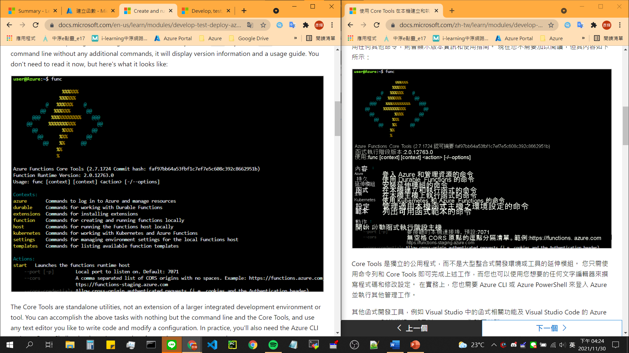

1. Model7 – Unit5

過度翻譯。

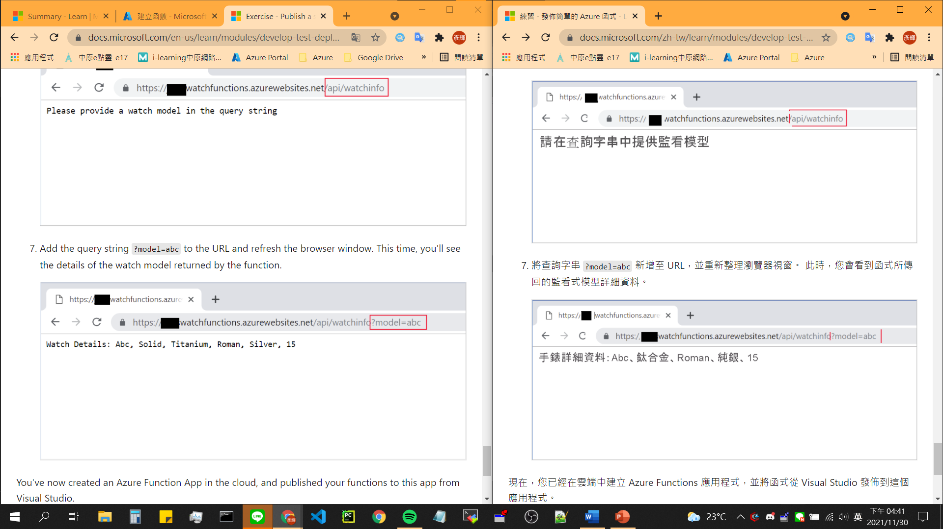

1. Model10 – Unit3

變數名稱不應被翻譯。

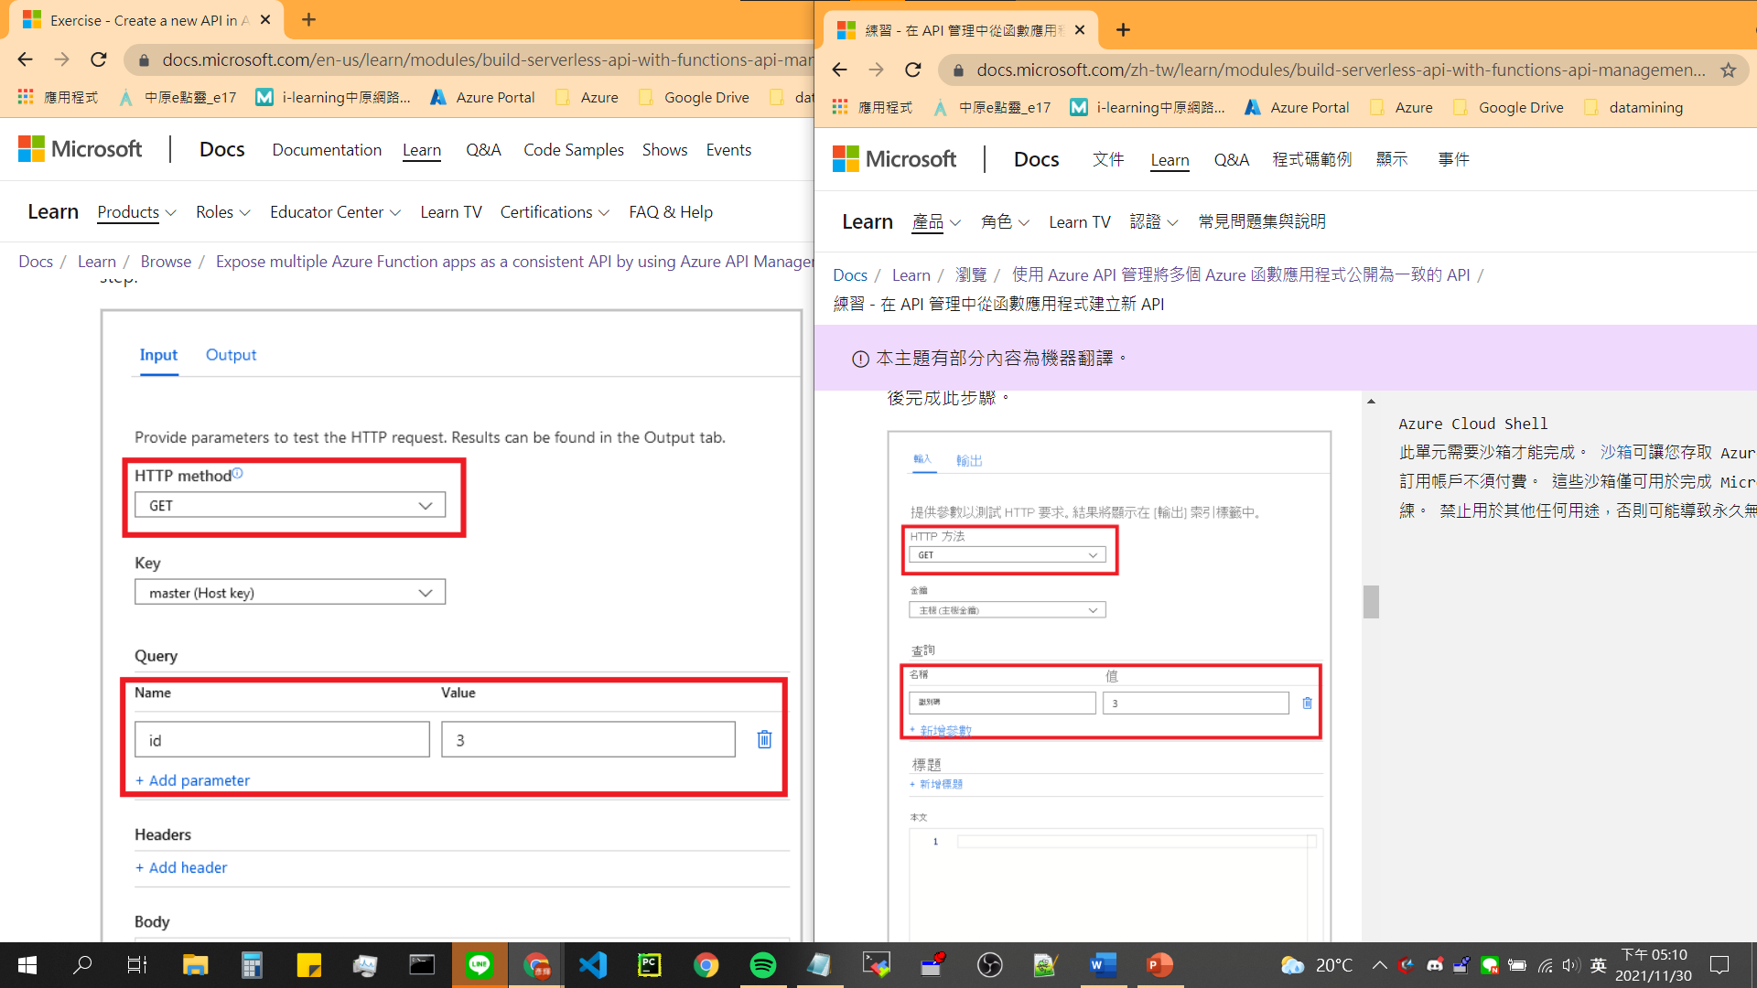

1. Model10 – Unit3

變數名稱不應被翻譯。

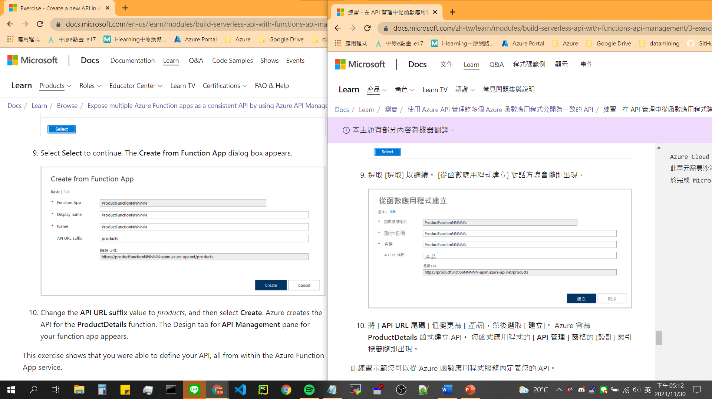

## 網頁Bug

1. Model2 – Unit5

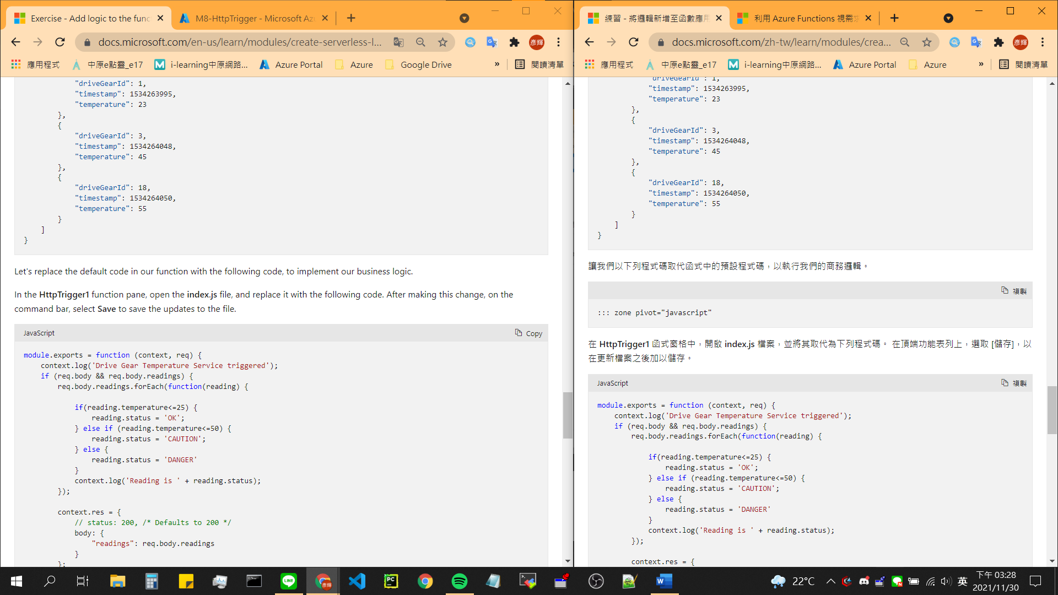

1. Model4 – Unit5

在Unit3 創造的HttpTrigger 並沒有接續著使用，在Unit4又創造一個HttpTrigger & 翻譯錯誤

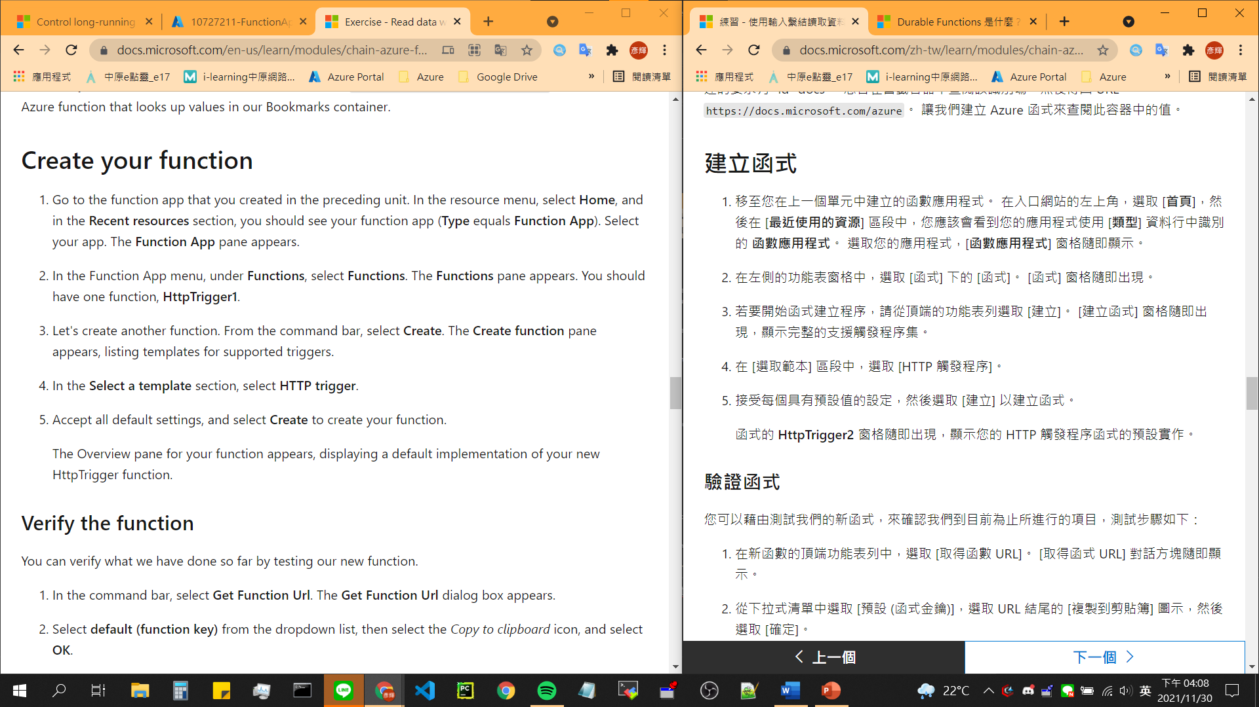

1. Model7 – Unit5

格式錯誤

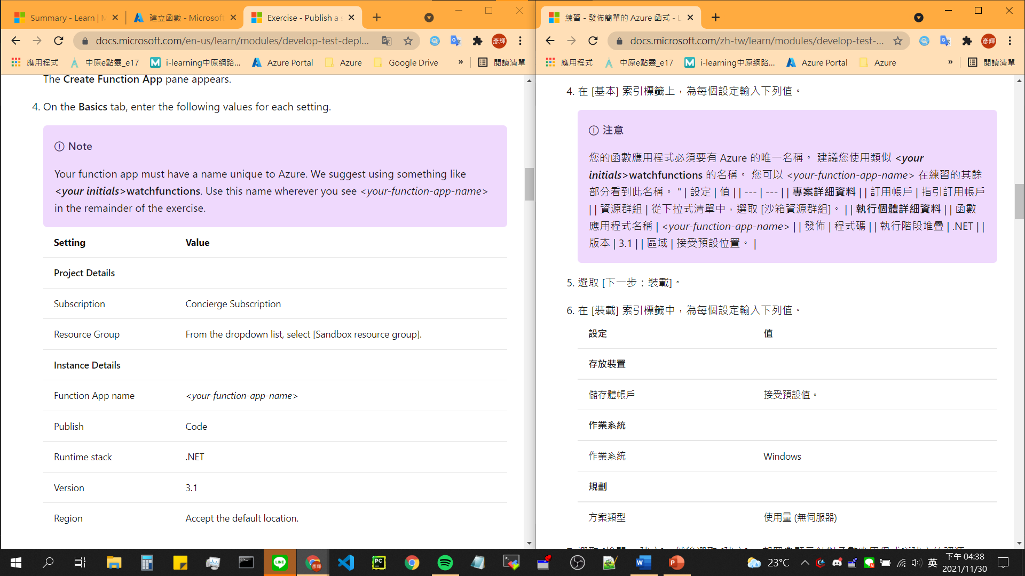

1. Model9 – Unit7

應更正為以下格式

